Tab 1

**PROJECT REPORT**

**PROJECT NAME :**  Workforce Administration Solution (Dev)

**PROJECT TEAM :** Team leader : Tejasri Juvvireddy

Team member : Sivani Chitturi

Team member : A.Rajkumar

**TEAM ID :** LTVIP2025TMID31474

### **1.INTRODUCTION :**

#### 1.1 Project Overview :

Workforce Administration Solution is a software application or platform designed to streamline and automate various aspects of employee’s working on projects and Asset Assignment processes within an organization. It serves as a centralized system for managing employee data, number of projects an employee is working on, tracking employee performance, and keeping record for the assets which they are assigned to.

What we havel learn

1. Real Time Salesforce Project

2. Data Modelling

3. Creating an Application  
4. User Interface Customization  
5. Importing bulk amounts of data  
6. Security in Salesforce  
7. Group Collaboration  
8. Reports & Dashboards

### **2.IDEATION PHASE :**

| Date | 2 June 2025 |
| --- | --- |
| Team ID | LTVIP2025TMID31474 |
| Project Name | Workforce administration solution(dev) |
| Maximum marks | 4 marks |

#### 2.1 Problem Statement :

Managing workforce data and administrative tasks manually can be time-consuming, error-prone, and inefficient. Organizations struggle with tracking employee information, roles, and responsibilities in a streamlined manner. There’s a need for an automated solution that simplifies the administration of workforce-related operations and enhances overall productivity.

#### 2.2 Empathy map canvas :

As part of the ideation phase, we created an Empathy Map Canvas to better understand the needs, thoughts, and behaviors of our primary users—HR personnel and workforce administrators. This tool helped us step into their shoes and empathize with their daily challenges, frustrations, and expectations. By exploring what the user says, thinks, does, and feels, we were able to surface critical pain points like interface complexity and repetitive manual tasks, as well as desired gains like automation and real-time data access. This guided our brainstorming sessions and ensured that our final solution is not only technically sound but also deeply aligned with user experience.

#### Empathy Map :2.3 Brainstorming :

During the ideation phase, several possibilities were explored to solve the challenges identified in the problem statement. The following brainstorming outcomes shaped the direction of the Workforce Administration Solution (Dev) project:

🔍 Understanding User Needs

* Seamless access to centralized employee data
* Simplified user interface for HR teams to enhance usability
* Real-time alerts for compliance tracking
* Compatibility with payroll and performance evaluation systems

🛠️ Feature Ideas

* Role-based dashboards tailored for HR, managers, and employees
* Workflow automation for onboarding/offboarding processes
* Interactive, auto-updated organizational charts
* Notification system for document expiration and certifications

🔄 System Efficiency Improvements

* Drag-and-drop capability for tasks and workflows
* In-depth HR analytics for strategic workforce planning
* API-based integration with existing ERP or attendance systems
* AI-powered assistant for resolving routine HR inquiries

🎨 UX/UI Concepts

* Clean, mobile-friendly interface
* Customizable layout per user role
* Accessibility features like screen reader support and high contrast

📈 Innovation & Differentiators

* Predictive modeling for workforce planning using AI
* Sentiment analysis to monitor employee well-being

### **3.REQUIREMENT ANALYSIS** :

Requirement Analysis is a crucial phase in the development of the Workforce Administration Solution using Salesforce. It involves identifying and documenting both functional and non-functional requirements while mapping out the user journey, data processes, and the technology infrastructure. This process ensures that the system is aligned with real HR operational needs—such as data management, compliance tracking, automation, and integration capabilities. Through tools like the Customer Journey Map and Data Flow Diagram, we gain a clear understanding of how users interact with the system and how data moves through it. This structured analysis helps us design a solution that is both efficient and user-friendly, and one that supports workforce administrators in their daily responsibilities.

#### 3.1 Customer Journey Map :

The customer journey map represents a typical HR administrator’s interaction with the solution, highlighting their goals, actions, emotions, and touchpoints at each stage.



| **Stage** | **User Actions** | **Touchpoints** | **Emotions** | **Opportunities** |
| --- | --- | --- | --- | --- |
| Awareness | Learns about system from internal updates | Salesforce login/dashboard | Curious, hopeful | Offer demo or explainer videos |
| Onboarding | Tries first-time setup and profile input | Guided walkthrough, tooltips | Confused, cautious | Interactive tutorials, live chat support |
| Daily Use | Manages employee data, tasks | Role dashboard, data tables | Efficient, focused | Automation, dashboard customization |
| Problem Handling | Faces technical issue | Support ticket form, knowledge base | Frustrated | In-app help widget, AI chatbot |
| Reporting | Generates compliance and workforce reports | Reports module, export options | Empowered, satisfied | Templates, one-click export to Excel/PDF |

#### 

#### 

#### 3.2 Solution Requirements :

#### 

Functional Requirements

* User Authentication with Role-Based Access
* Add/Edit/Delete Employee Records
* Generate Department-wise and Compliance Reports
* Track Leave Balances and Onboarding Status
* Automated Notifications for Key Milestones (e.g., certifications expiry)
* API Integration with Payroll and Attendance Systems

Non-Functional Requirements

* Platform uptime: 99.9% availability
* Responsive design for web and mobile
* Secure data encryption (AES 256-bit)
* Real-time performance under concurrent usage (up to 100 users)
* Scalable storage for growing employee datasets

### 

### 

#### 3.3 Data Flow Diagram (Level 1) :

A simplified view of how data moves through the system:

[ HR/Admin User ]

↓

[ Login & Auth Module ] ←→ [ User Roles DB ]

↓

[ Workforce Dashboard ]

↓ ↘

[ Employee Module ] → [ Notification Engine ]

↓ ↓

[ Reports Engine ] [ Alerts & Emails ]

↓

[ Export & Analytics Module ]

#### 3.4 Technology Stack :

| **Layer** | **Technology** |
| --- | --- |
| Frontend (UI) | Salesforce Lightning Components |
| Backend (Logic) | Apex (Salesforce's Java-like language) |
| Database | Salesforce Object Model (custom objects, records) |
| Integration Layer | RESTful APIs / Salesforce Connect |
| Automation | Salesforce Flow, Process Builder |
| Reports & Dashboards | Salesforce Reports, Einstein Analytics |
| Security | OAuth 2.0, Field-Level Security, Role Hierarchies |
| Hosting/Cloud | Salesforce Cloud Platform (SaaS) |

### **4. PROJECT DESIGN:**

### 

#### 4.1 Problem–Solution Fit :

The project addresses critical inefficiencies faced by HR teams in managing workforce data through traditional or fragmented systems. By integrating a Salesforce-based solution, we align the **problem** (manual processes, poor user experience, and compliance risks) with a **solution**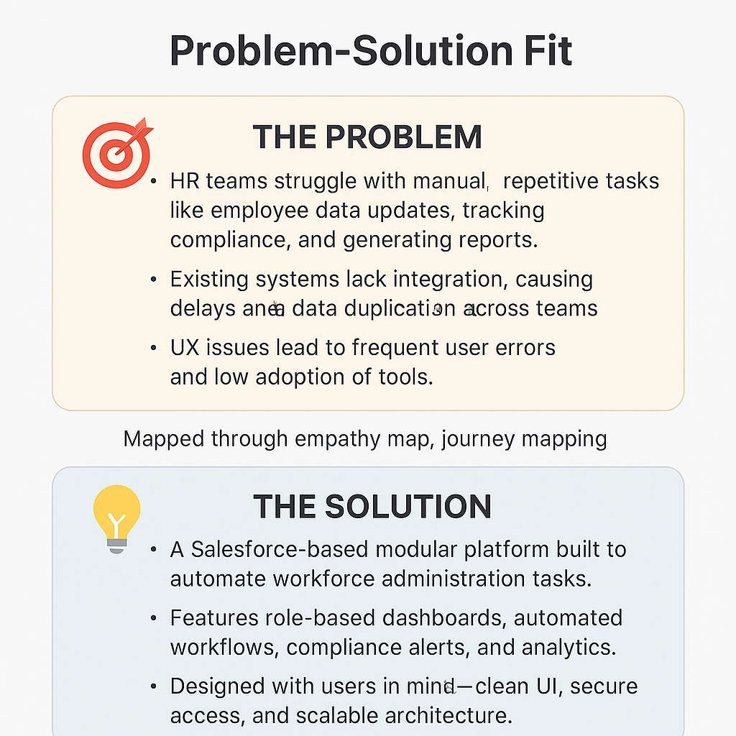

#### 4.2 Proposed Solution :

The **Workforce Administration Solution** proposes a modular system that includes:

* **Employee Management Module** Add, modify, and archive employee details, certifications, and department mapping
* **Compliance Tracker** Automates tracking of policy expirations and generates regulatory reports
* **Onboarding & Offboarding Automation** Task allocation and checklist tracking for smooth transitions
* **Role-Based Dashboards** HR, Managers, and Admins have unique views with relevant widgets
* **Notification Engine** Sends alerts on upcoming deadlines, missing documents, or new compliance rules
* **Data Analytics & Reporting** Offers insights through customizable reports and visual dashboards
* **AI Support Assistant (Optional)** A smart chatbot to answer frequent HR queries and guide new users

#### 4.3 Solution Architecture :

Here’s an overview of how the solution components are layered within the Salesforce environment: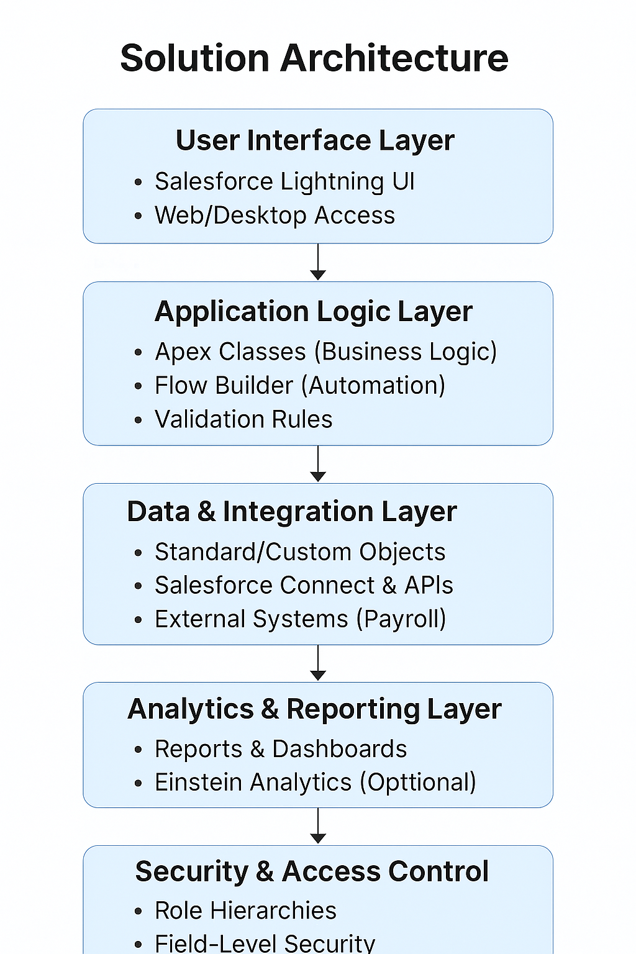

### **5.PROJECT PLANNING PHASE :**

Product Backlog, Sprint Schedule, and Estimation

### 

| **Sprint** | **Functional Requirement (Epic)** | **User Story Number** | **User Story / Task** | **Story Points** | **Priority** | **Team Members** |
| --- | --- | --- | --- | --- | --- | --- |
| Sprint-1 | Registration | USN-1 | As a user, I can register for the application by entering my email, password, and confirming my password. | 2 | High | Tejasri |
| Sprint-1 | Registration | USN-2 | As a user, I will receive a confirmation email once I have registered for the application. | 1 | High | Tejasri |
| Sprint-2 | Registration (Social Login) | USN-3 | As a user, I can register for the application through Facebook. | 2 | Low | Sivani |
| Sprint-1 | Registration (Social Login) | USN-4 | As a user, I can register for the application through Gmail. | 2 | Medium | Sivani |
| Sprint-1 | Login | USN-5 | As a user, I can log into the application by entering email & passw | 1 | high | Tejasri |

Project Tracker, Velocity & Burndown Chart

Sprint Overview

| **Sprint** | **Total Story Points** | **Duration** | **Sprint Start Date** | **Sprint End Date (Planned)** | **Story Points Completed (on Planned End Date)** | **Sprint Release Date (Actual)** |
| --- | --- | --- | --- | --- | --- | --- |
| Sprint-1 | 20 | 6 Days | 24 may 2025 | 29 may 2025 | 20 | 29 may 2025 |
| Sprint-2 | 20 | 6 Days | 31 may 2025 | 05 june 2025 | — | — |
| Sprint-3 | 20 | 6 Days | 07 june 2025 | 12 june 2025 | — | — |
| Sprint-4 | 20 | 6 Days | 14 june 2025 | 19 june 2025 | — | — |

### **6.FUNCTIONAL AND PERFORMANCE TESTING :**

| Date | 25 june 2025 |
| --- | --- |
| Team ID | LTVIP2025TMID31474 |
| Project Name | Workforce administration solution(dev) |
| Maximum Marks |  |

**Model Performance Testing:**

Project team shall fill the following information in the model performance testing template.

| **S.No.** | **Parameter** | **Values** | **Screenshot** |
| --- | --- | --- | --- |
|  | Model Summary | Salesforce automation setup for Data management using Object, Fields and Reports.  **Note :** Import Records if data Match Correctly then Records will Created or Else it will Show Error |  |
|  | Accuracy | Training Accuracy - 98%  Validation Accuracy - 98% |  |
| 3. | Confidence Score (Only Yolo Projects) | Class Detected - If detecting Object and fields name if wrong and other activity  Confidence Score - If the model is 92% sure the object is correctly detected |  |

### **7.RESULTS :**

### **Milestone 1 - Salesforce**

#### **Use Case :**

Creating a Salesforce Developer Edition org allows developers to experiment, innovate, and build customized solutions within a controlled environment. With access to Salesforce's powerful development tools and features, developers can prototype, test, and refine their applications, empowering them to deliver robust and tailored solutions to meet unique business requirements. As a Salesforce Administrator for TheSmartBridge you must have a Salesforce developer edition org in order to do all the required works which the CEO desires for TheSmartBridge.

Before creating our developer account, we must know what are the types of Editions Salesforce offers.

#### **Activity 1: Creating Developer Account**

Creating a developer org in salesforce.

1. Go to <https://developer.salesforce.com/signup>

2. On the sign up form, enter the following details :

1) First name & Last name

2) Email

3) Role : Developer  
4) Company : College Name  
5) County : India  
6) Postal Code : pin code  
7) Username : should be a combination of your name and company  
8) Click on Sign me up.

This need not be an actual email id, you can give anything in the format : username@organization.com

Click on sign me up after filling these.

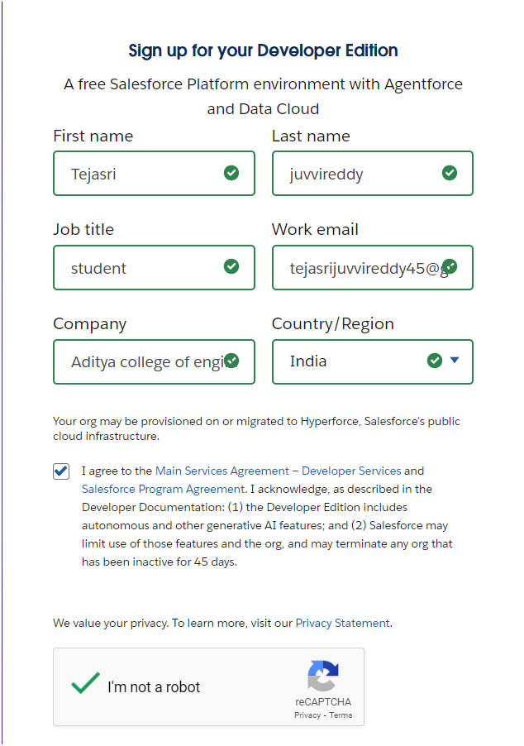

#### **Activity 2: Account Activation**

1. Go to the inbox of the email that you used while signing up. Click on the verify account to activate your account. The email may take 5-10mins.

2. Click on Verify Account

3. Give a password and answer a security question and click on change password.

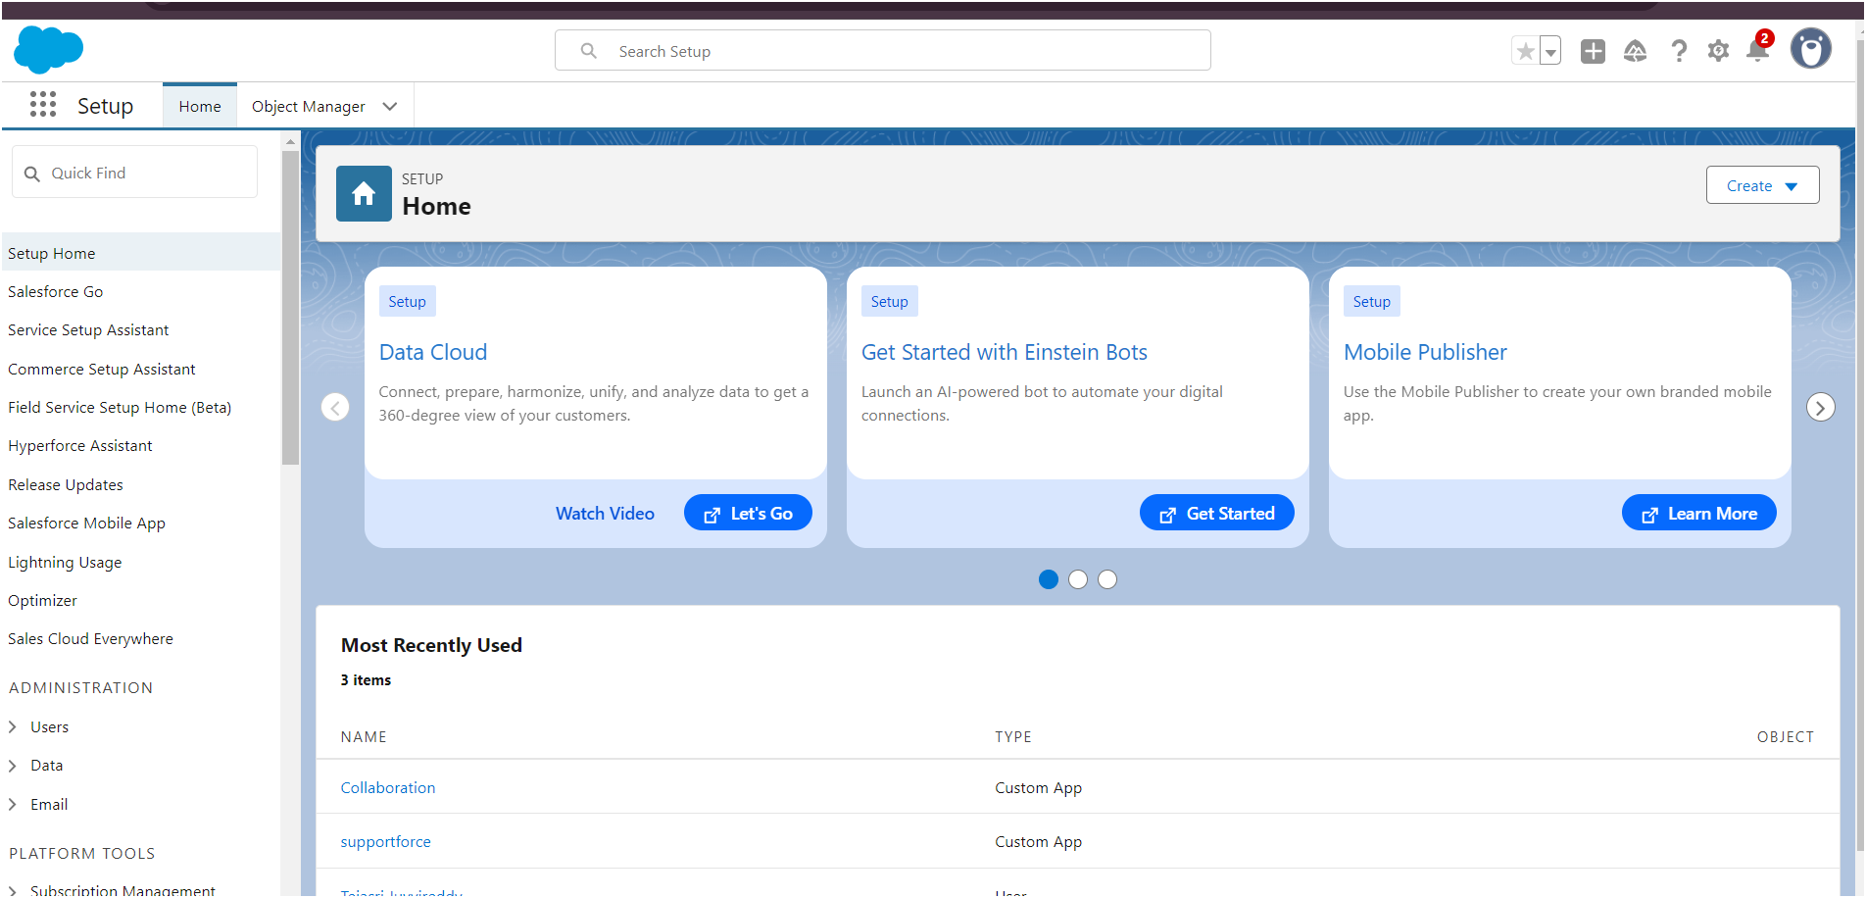 4. Then you will redirect to your salesforce setup page.

### **Milestone 2 -Object**

#### **Use Case :**

Creating an object in Salesforce organization is essential for efficient data management and process automation. By defining custom objects, businesses can structure and store data specific to their needs, enabling streamlined workflows, personalized reporting, and enhanced user experiences. Objects serve as the foundation for organizing and leveraging critical information within Salesforce. As an Admin for TheSmartBridge, It’s your responsibility to store the data as per the organization needs.

To Navigate to Setup page:

Click on gear icon --> click setup.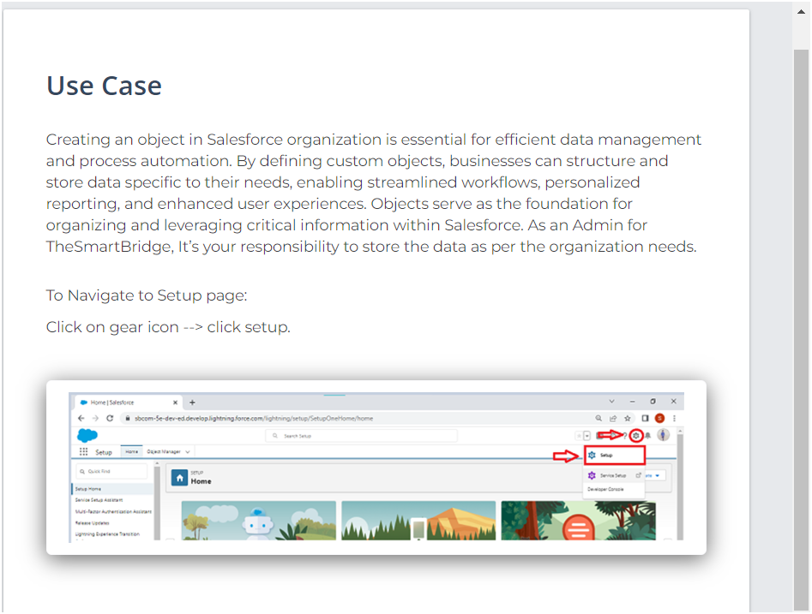

#### **Activity 1: Create Employee Object**

To create an object:

1. From the setup page --> Click on Object Manager --> Click on Create -->  
    Click on Custom Object.

1) Enter the label name: Employee

2) Plural label name: Employees

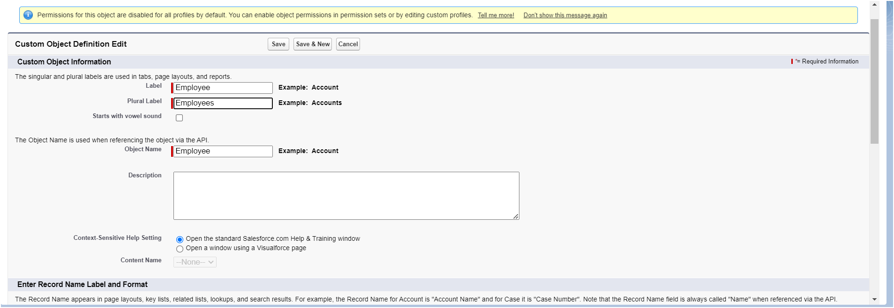

3) Enter Record Name Label and Format

1.Record Name : Employee ID

2.Data Type : Auto Number

3.Display Format : EMS-{0000}

4.Starting Number : 1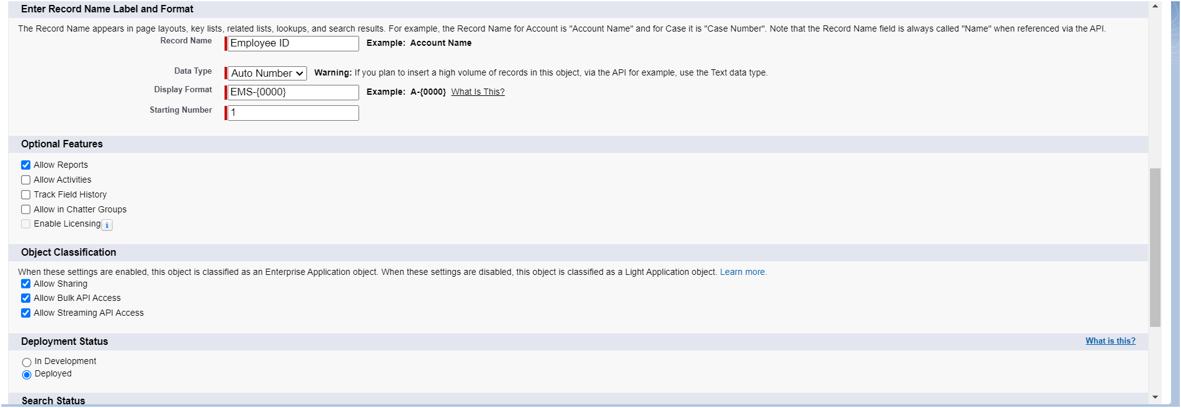

1. Click on Allow reports,
2. Allow search --> Save

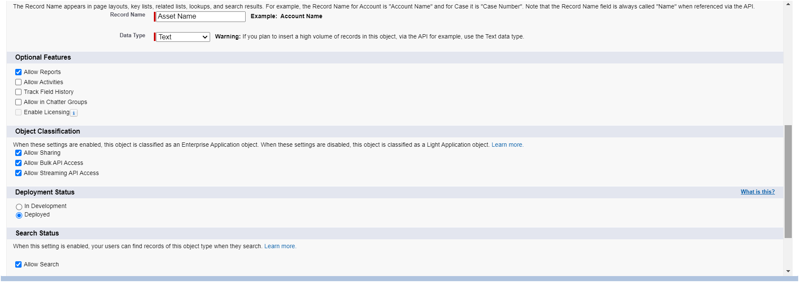

#### **Activity 2: Create Project Object**

The purpose of creating a project object is to have detailed information about the on-going and completed projects in the organization.

To create an object:

1. From the setup page --> Click on Object Manager --> Click on Create --> Click on Custom Object.

1) Enter the label name--> Project  
2) Plural label name--> Projects  
3) Enter Record Name Label and Format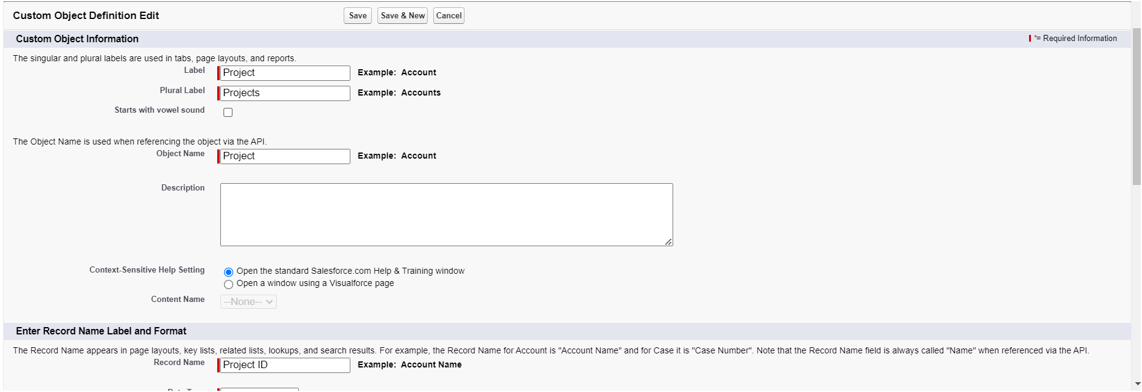

1. Record Name : Project ID

2. Data Type : Auto Number

3. Display Format : Proj-{0000}

4. Starting Number : 1

2. Click on Allow reports,

3. Allow search --> Save.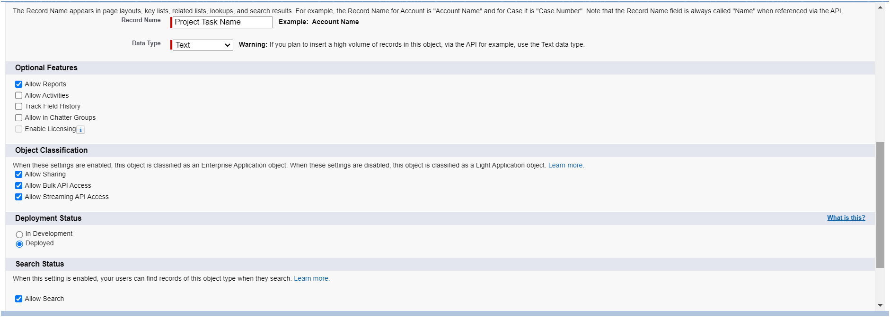

#### **Activity 3: Create 3 More Objects With Label Names As ProjectTask, Asset, Asset Service.**

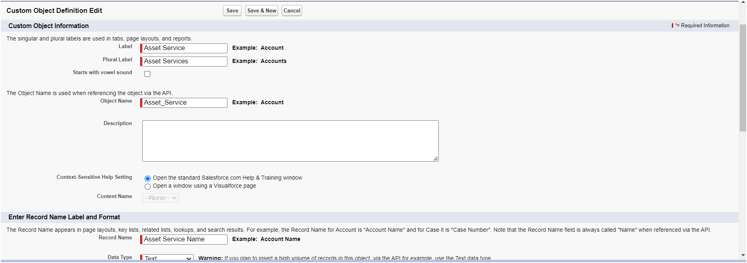

### **Milestone 3 -Tabs**

#### **Use Case :**

Creating Objects and storing TheSmartBridge organization’s data is the very first step in the requirements they want. Now to access the stored data by an employee from the organization Admin needs to create Tabs. By designing a dedicated Tab, businesses can improve user experience, simplify navigation, and provide quick access to critical information, enhancing productivity and ensuring efficient utilization of Salesforce's capabilities.

#### **Activity 1: Creating A Custom Tab (Employee)**

#### 

To create a Tab:(Employee)

1. Go to setup page --> type Tabs in Quick Find bar --> click on tabs --> New (under custom object tab )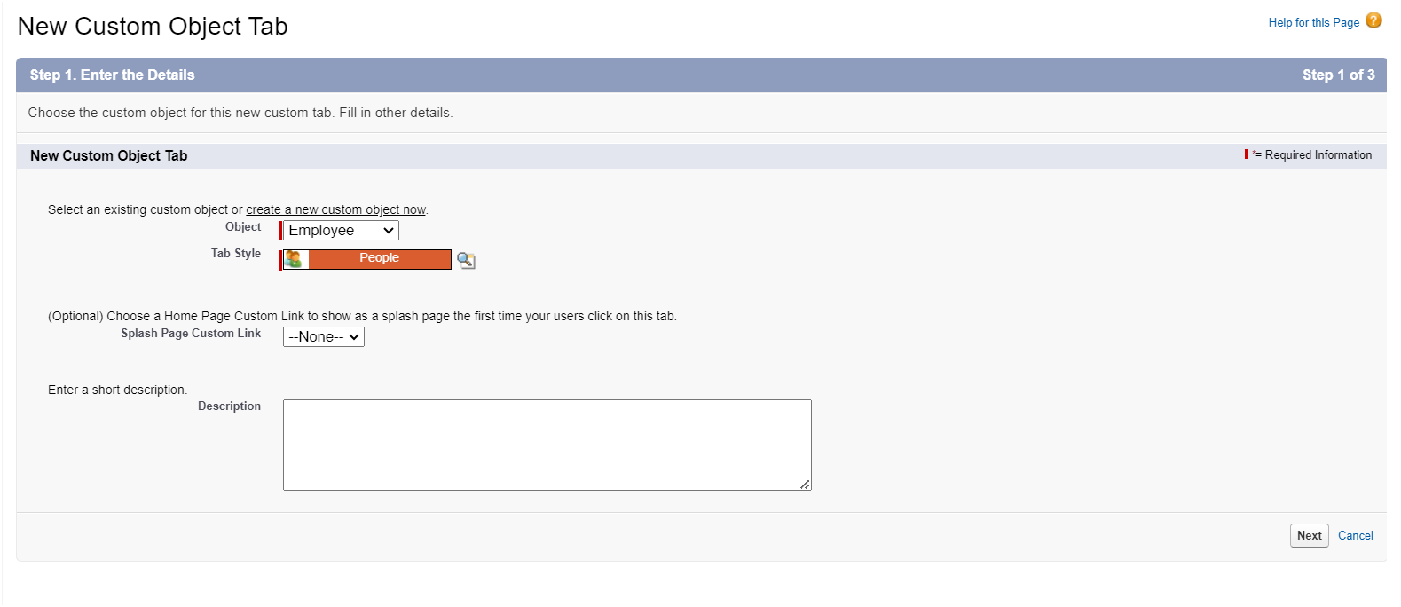

2. Select Object(Employee) --> Select any tab style --> Next (Add to profiles page)

keep it as default --> Next (Add to Custom App) keep it as default --> Save.

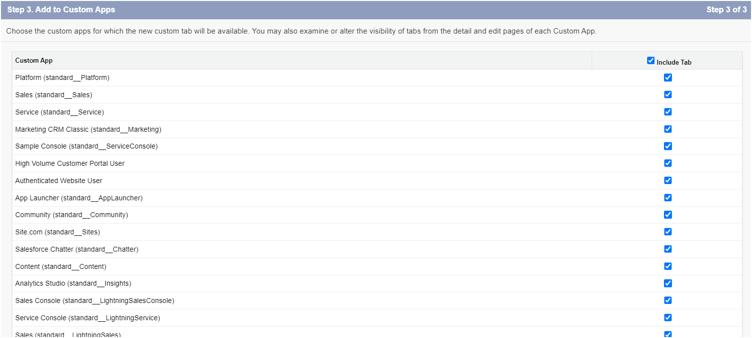

#### **Activity 2: Creating A Custom Tab (Project)**

1. Go to setup page --> type Tabs in Quick Find bar --> click on tabs --> New (under custom object tab)

2. Select Object(Project) --> Select the tab style ?--> Next (Add to profiles page) keep it as default --> Next (Add to Custom App) keep it as default --> Save.

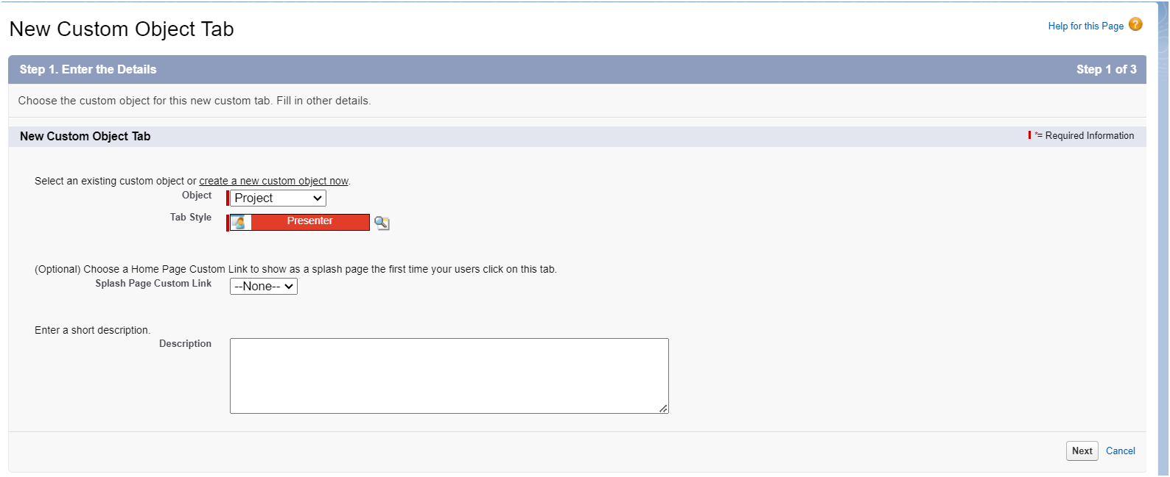

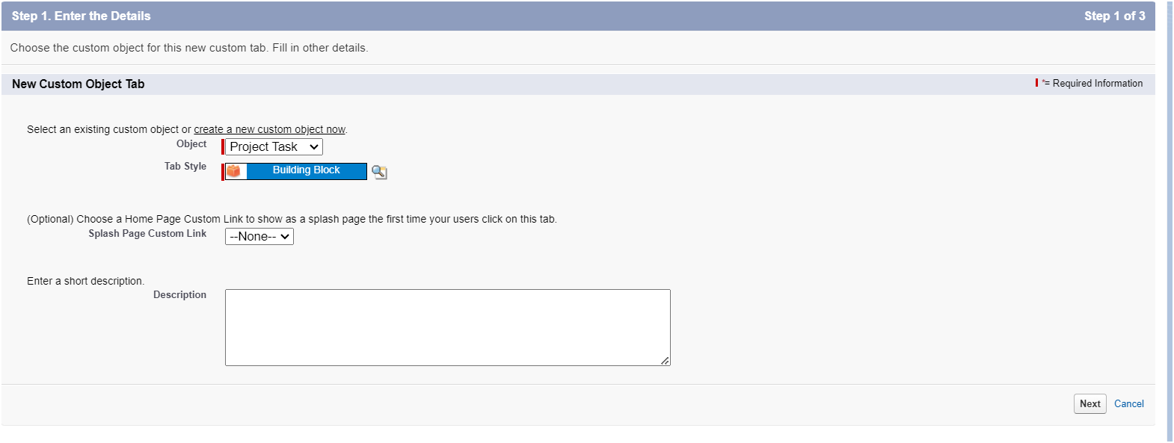

#### **Activity 3: Creating Tabs For Remaining Objects**

ASSET :

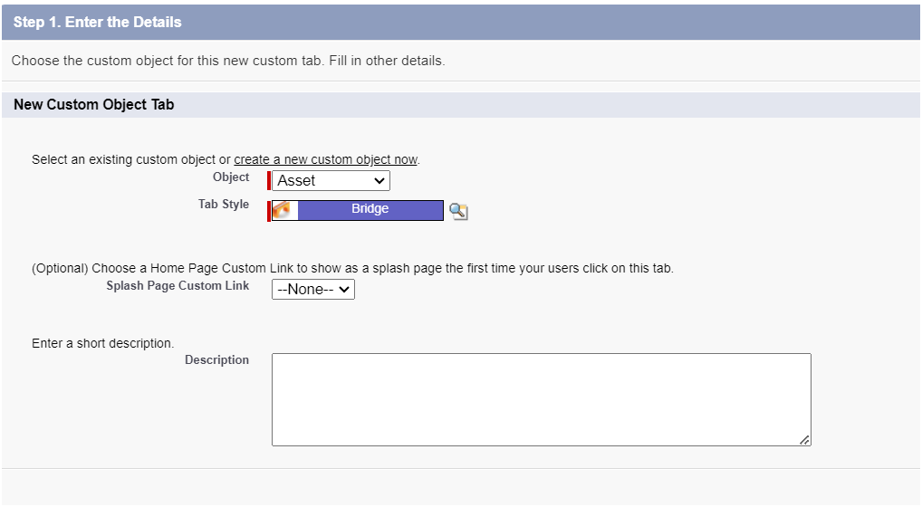

ASSET SERVICES :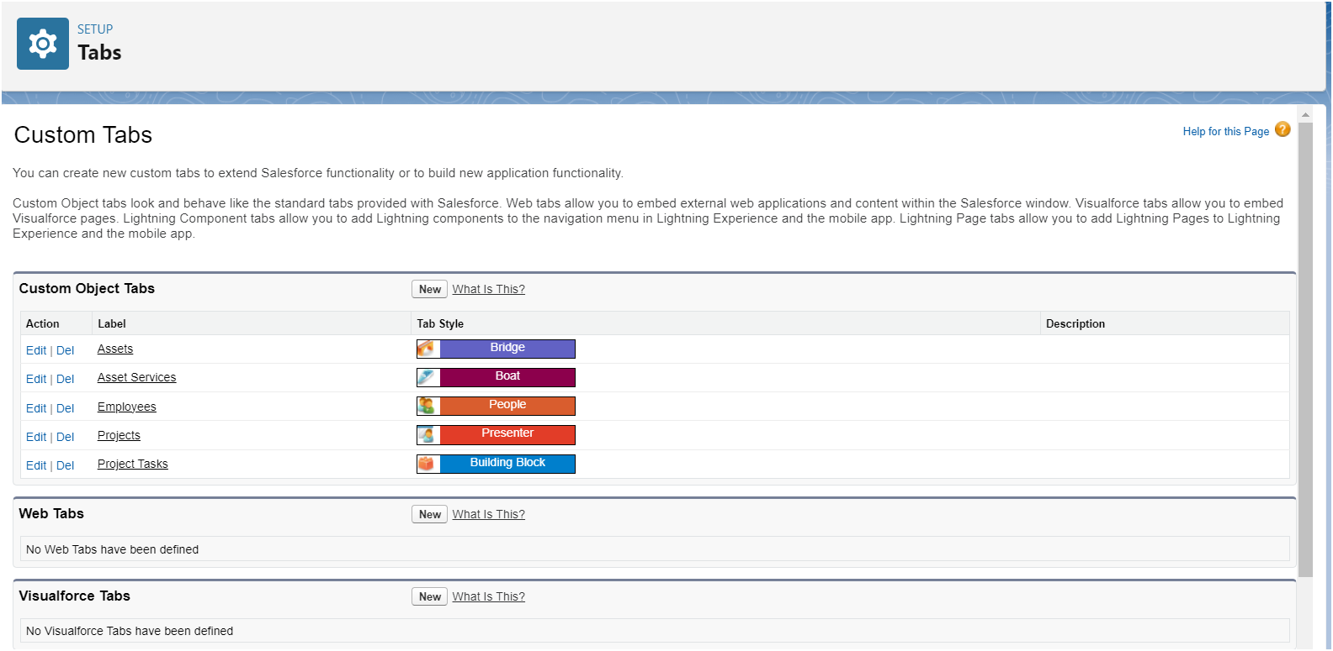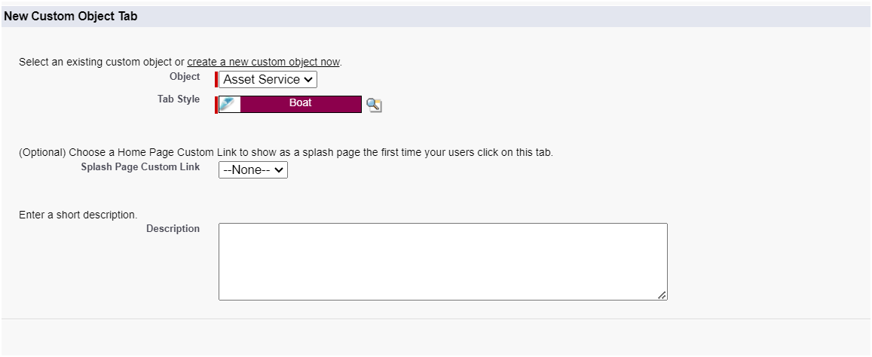

### **Milestone 4 - The Lightning App**

#### Use Case

Well done you have reached close to your organizational requirement by creating the objects to store the organization’s data. Making a database for an organization is just not enough to reach out the requirements, the task is how the users at the organization can access the objects you have created for them. As an Admin for the TheSmartBridge organization it's your duty to make sure every user of the organization is able to access the data modeling structure.

#### **Activity 1: Create A Lightning App**

To create a lightning app page:

1. Go to setup page --> search “app manager” in quick find --> select “app manager” --> click on New lightning App.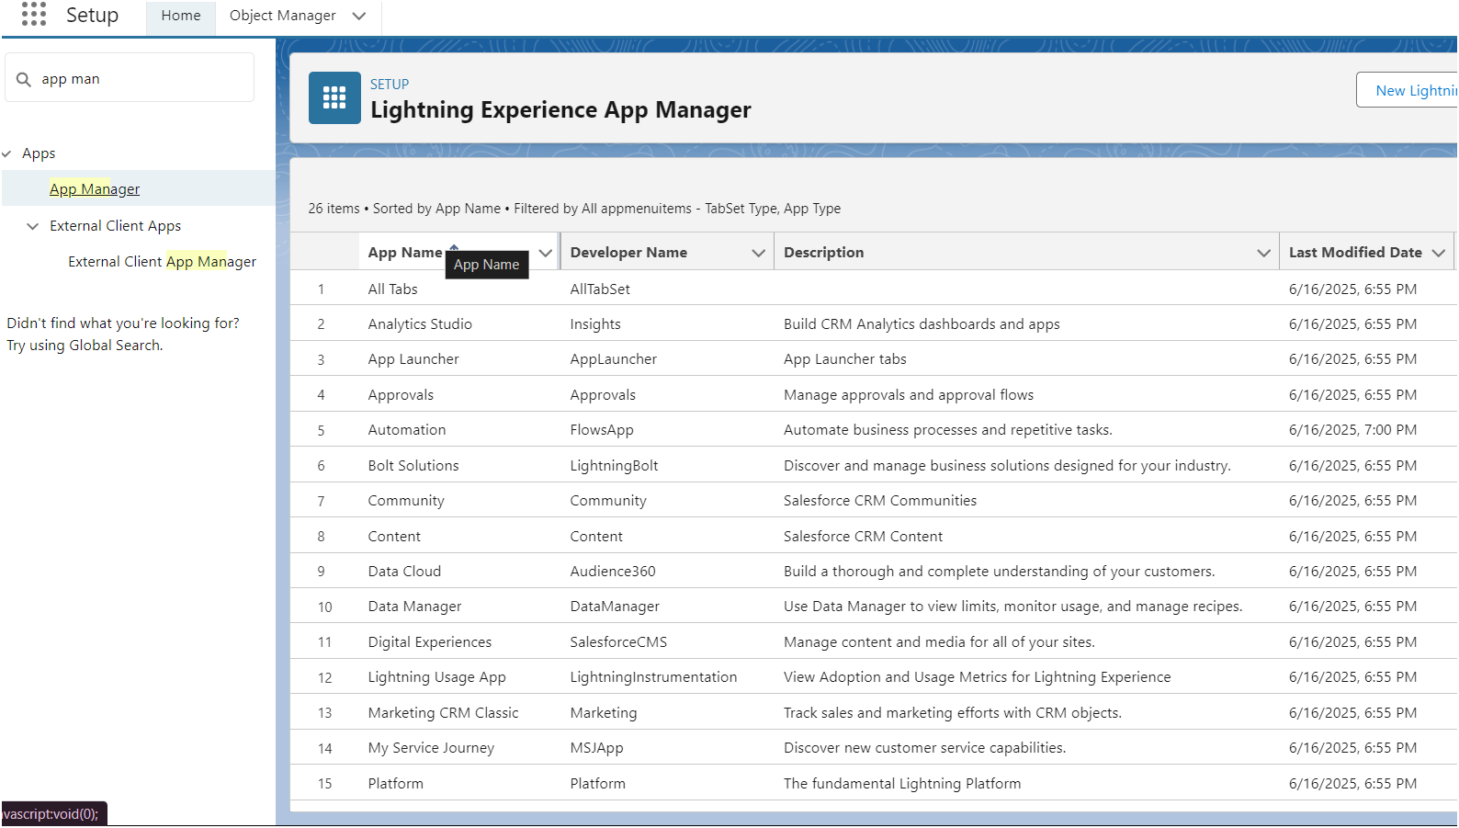

2. Fill the app name in app details and branding as follow

App Name : Workforce Administrator Solution  
Developer Name : this will auto populated  
Description : Give a meaningful description  
Image : optional (if you want to give any image you can otherwise not mandatory)  
Primary color hex value : keep this default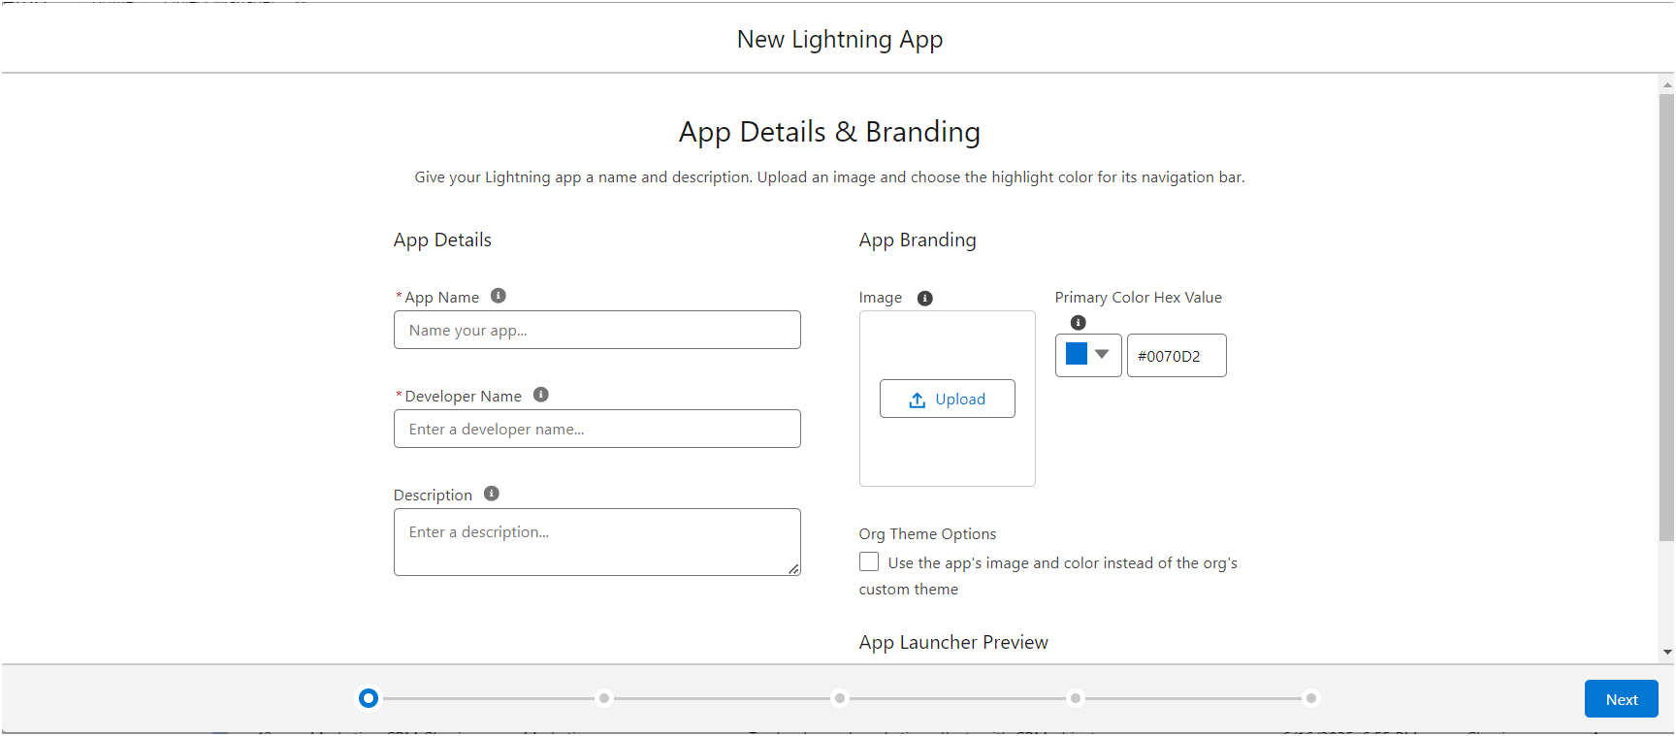

3. Then click Next --> (App option page) keep it as default --> Next --> (Utility Items) keep it as default --> Next.

4. To Add Navigation Items:

Search the items in the search bar(Employees, Projects, ProjectTask, Assets, Asset Services, Reports, Dashboard) from the search bar and move it using the arrow button --> Next.

Note: select asset the custom object which we have created in the previous activity.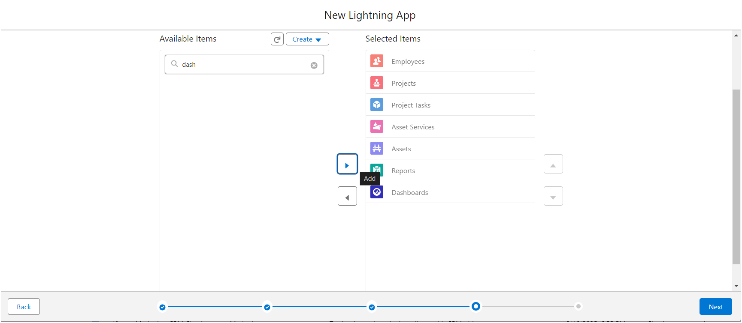  
  
5. To Add User Profiles: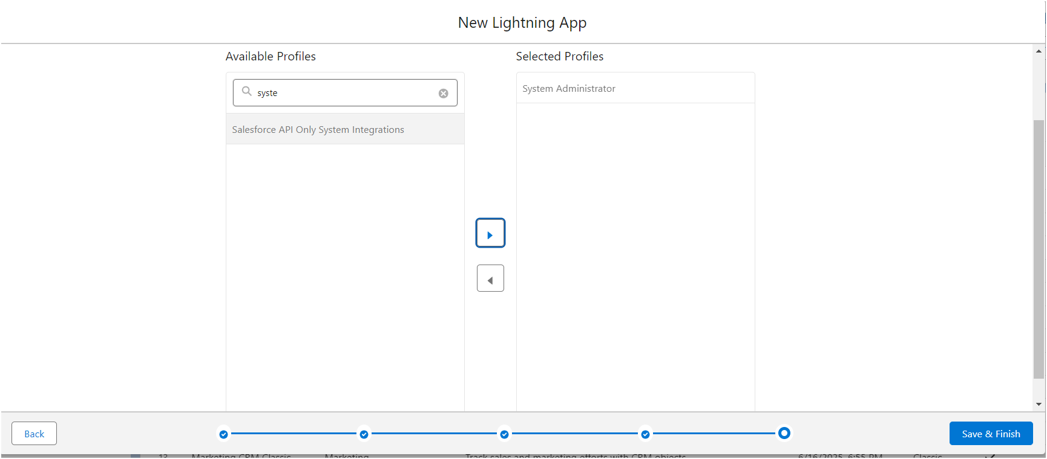

Search profiles (System administrator) in the search bar --> click on the arrow button --> save & finish.

### **Milestone 5 - Fields and relationships**

#### Use case :

#### **Activity : Creating Text Field In Employee Object**

To create fields in an object:

1. Go to setup --> click on Object Manager --> type object name(Employee) in quick find bar --> click on the object.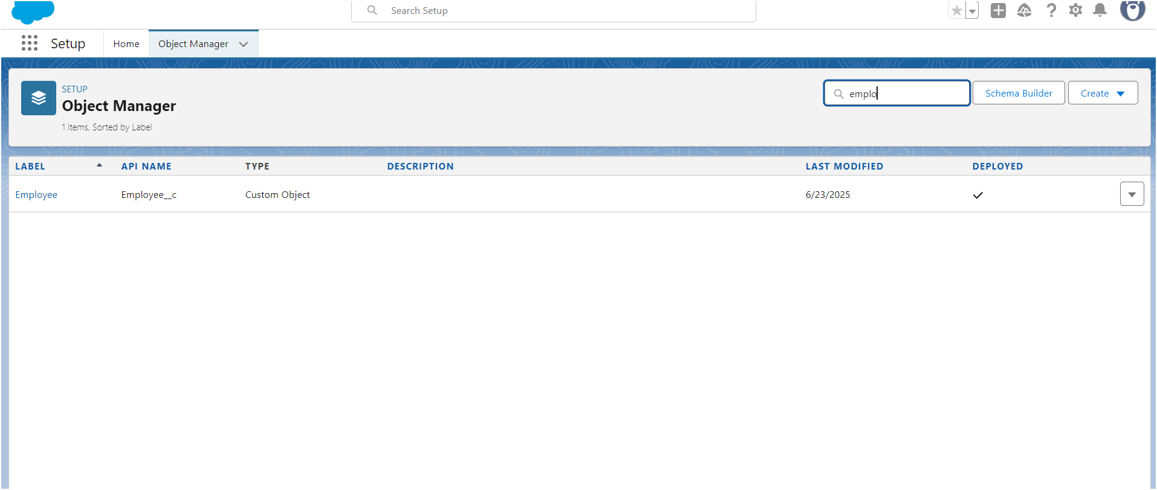

2. Now click on “Fields & Relationships” --> New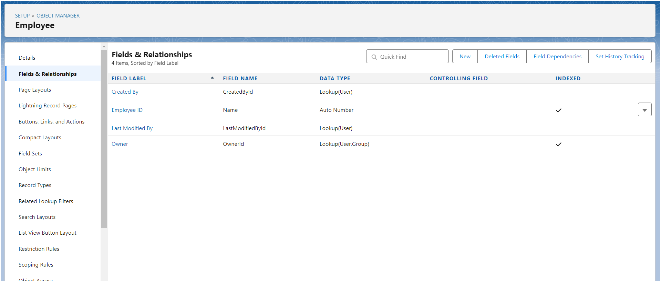

3. Select Data type as “Text”.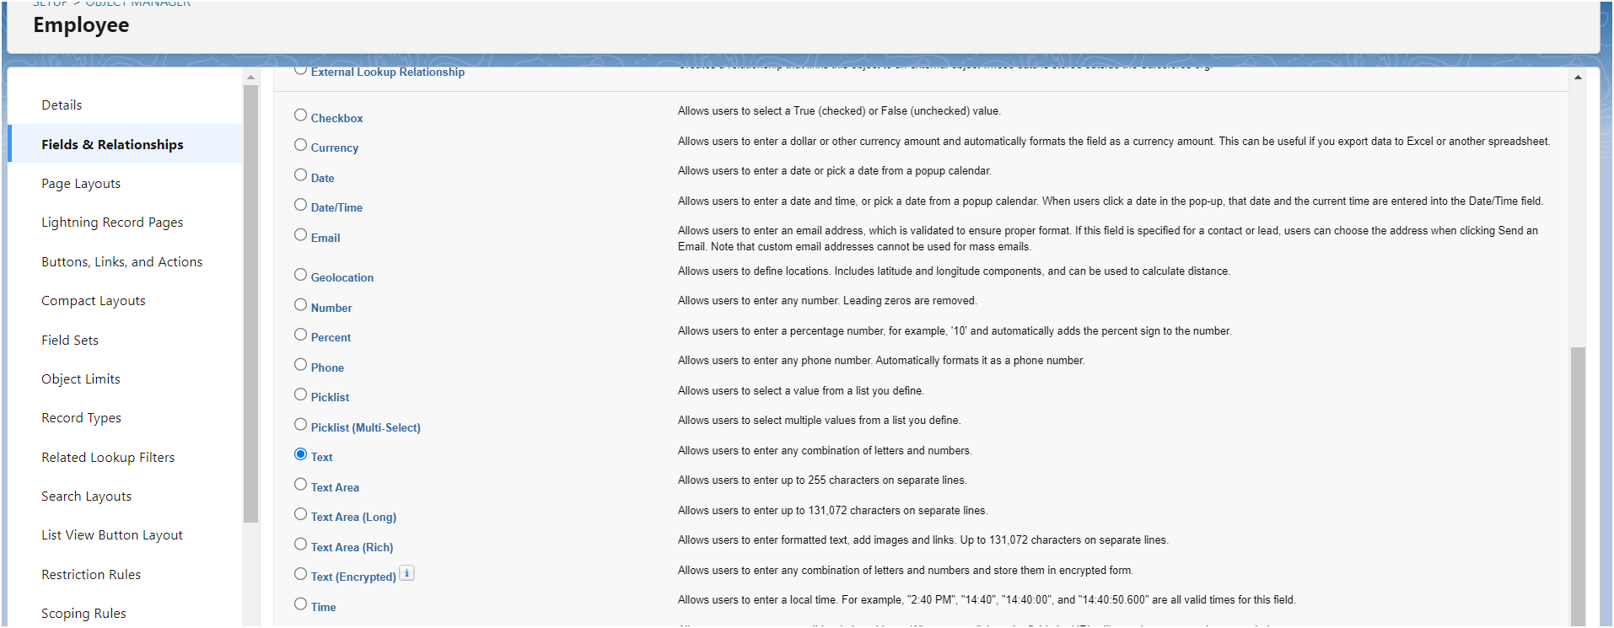

4. Click on Next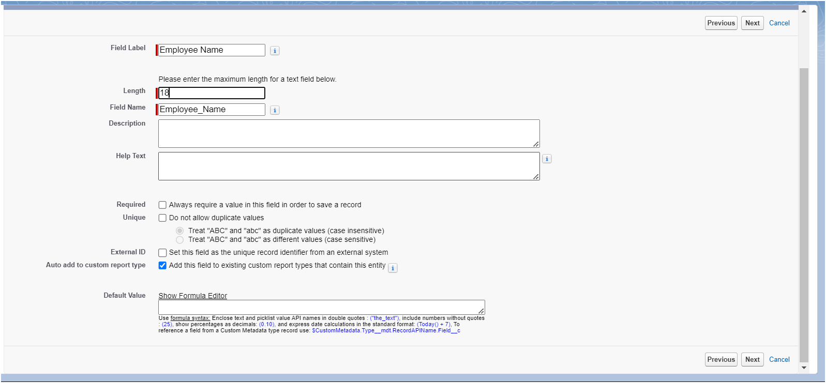

5. Fill the above as following:

1) Field Label: Employee Name  
2) Length : 18  
3) Field Name : gets auto generated  
4) Click on Next --> Next --> Save and new.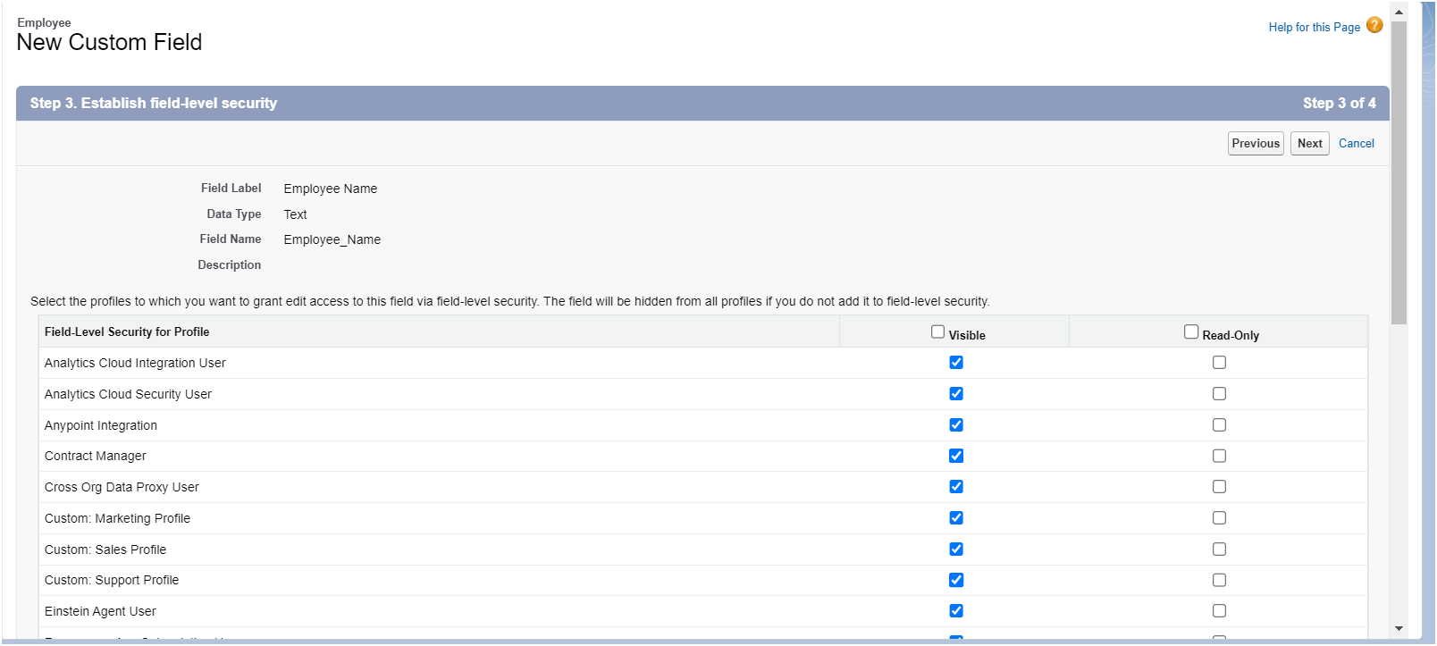

**FINISHED ALL OTHER ACTIVITIES OF FIELDS AND RELATIONSHIP AND UPLOADED THEM IN BELOW LINK / FILE.**

**C:\Users\TEJASRI\OneDrive\Documents\APSCHE PROJECT SS\Fields and Relationships**

### **Milestone 6 - Setting OWD**

#### **Use Case**

Data is the most precious thing of any organization and keeping it safe is the first most priority of any Admin in the organization. As an Admin, to ensure data privacy and compliance with regulations, you need to restrict access to sensitive customer information using OWD.

### 

#### **Activity 1: Create OWD Setting**

1. Go to Set Up --> in the Quick Find box type "Sharing Settings" --> click on it.
2. Click Edit in the Organization-Wide Defaults area.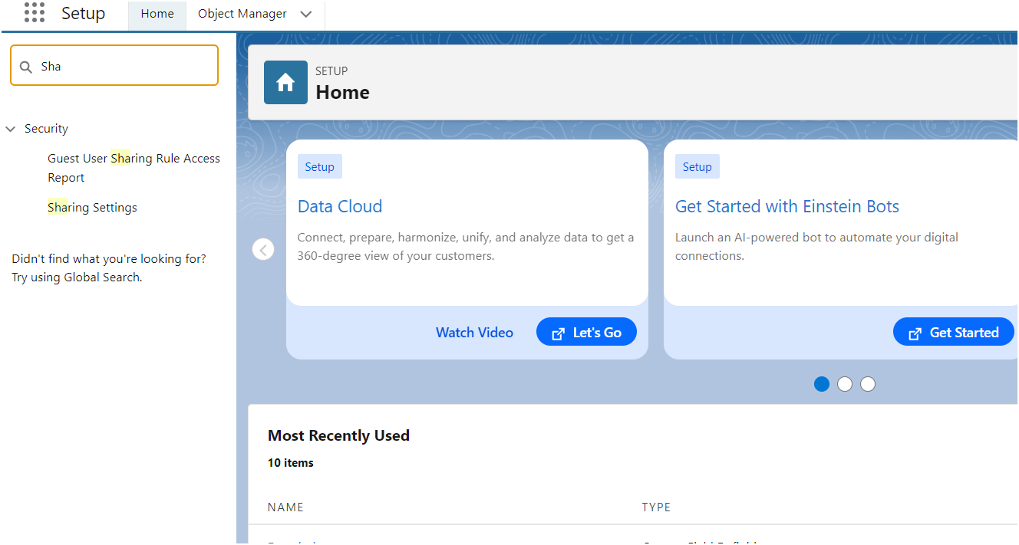
3. Search for the Employee object.
4. Under default internal access and default external access change the options to “Private” and under grant access using hierarchies select the check box.
5. Click on save.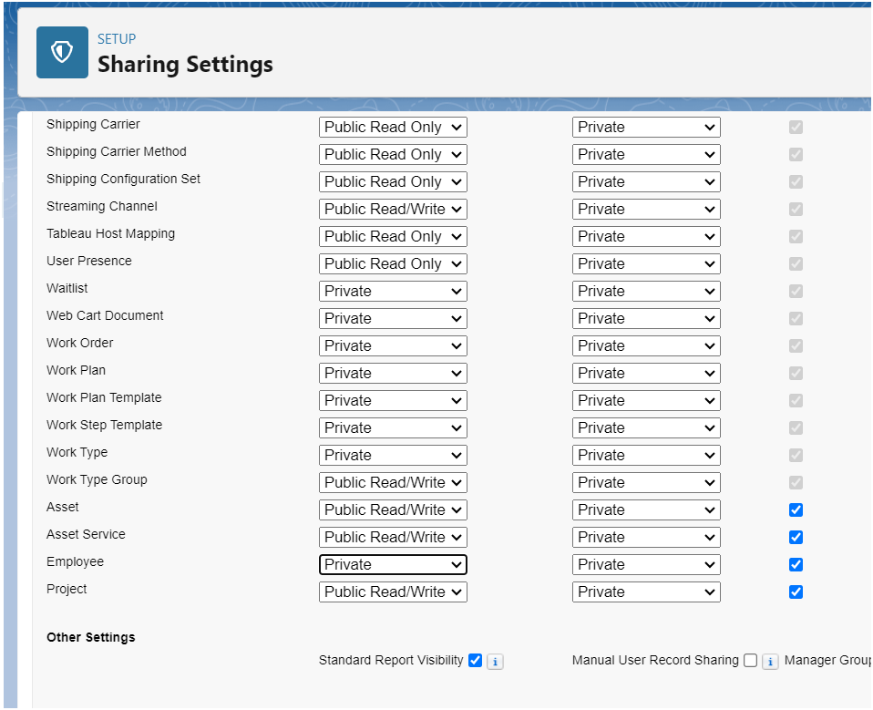
6. This Setting is for all the Users Which have been Created.

#### **Activity 2:**

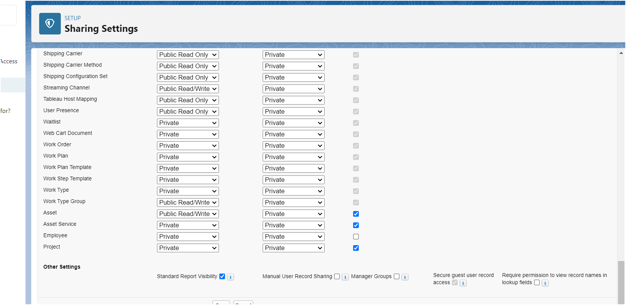

### **Milestone 7 -User Adoption**

#### **Use Case:**

As a new Administrator, you perform user management tasks like creating and editing users, resetting passwords, granting permissions, configuring data access, and much more. In this unit, you will learn about users and how you add users to your Salesforce org.

#### **Activity 1: Create a Record (Employee)**

1. Click on App Launcher on the left side of the screen.
2. Search Employee Management System & click on it.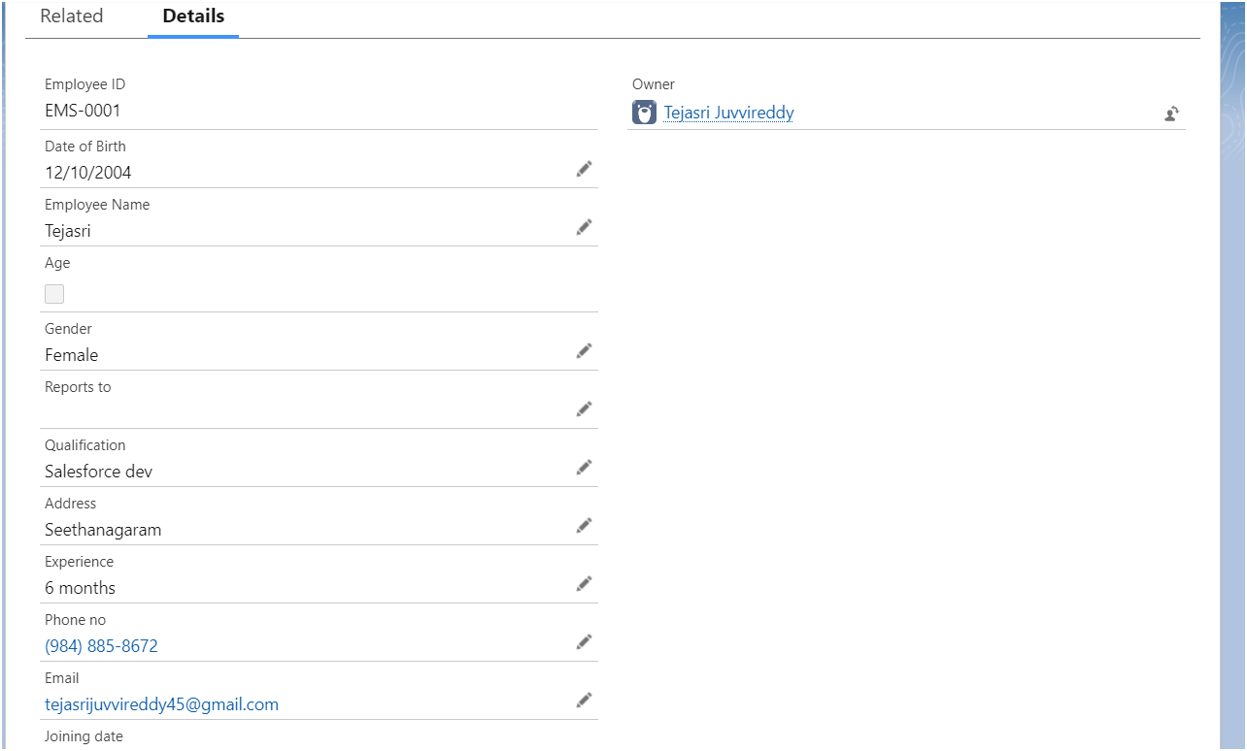
3. Click on the Employee tab.
4. Click New.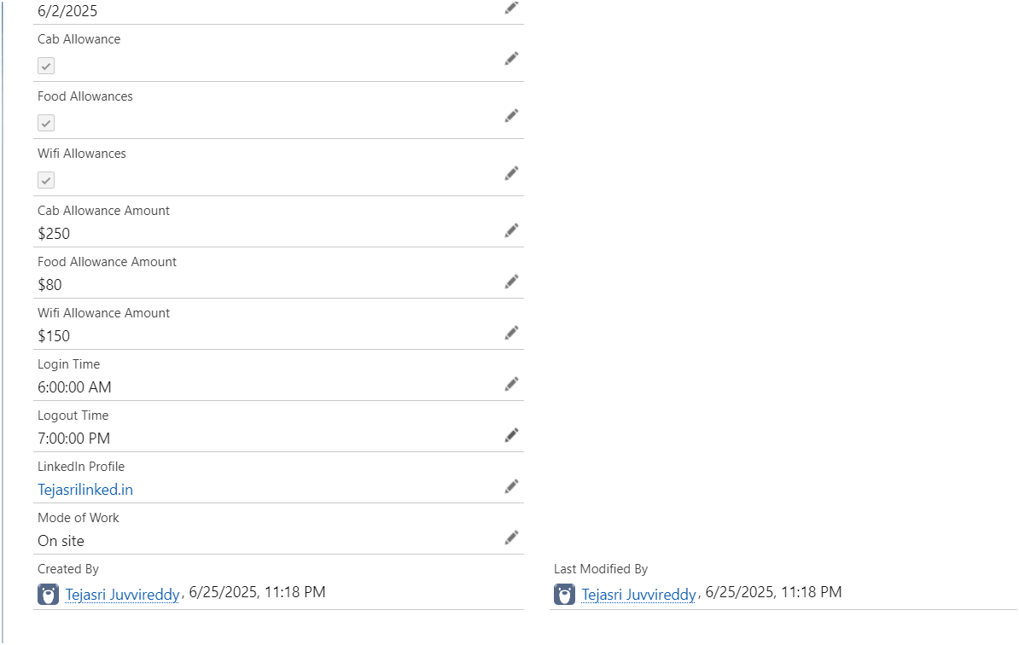
5. Fill the Details and click on Save.

#### **Activity 2: View a Record (Employee)**

1. Click on App Launcher on the left side of the screen.
2. Search Employee Management System & click on it.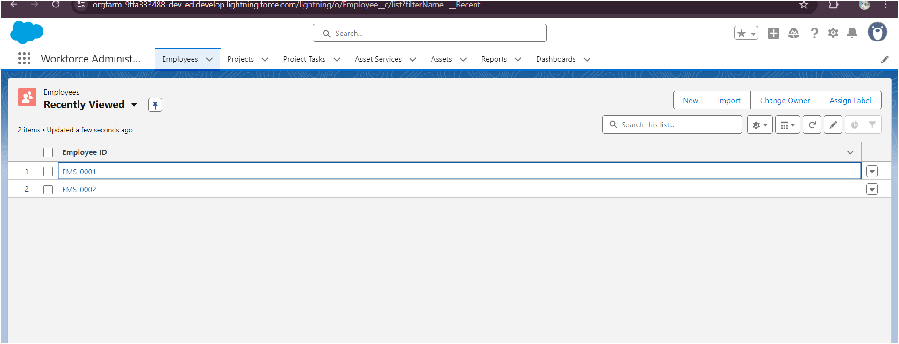
3. Click on the Employee Tab.
4. Click on any record name. you can see the details of the Employee 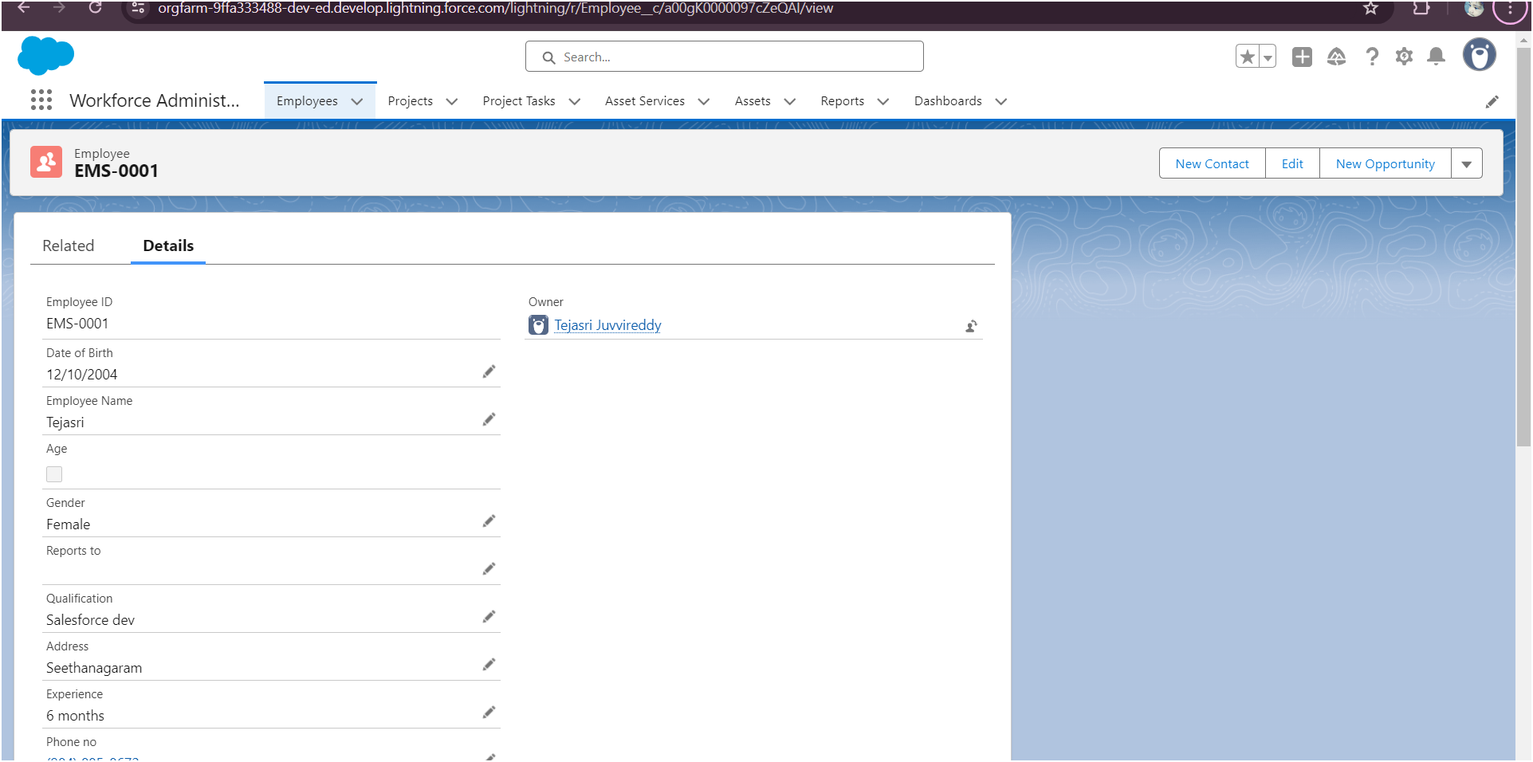

#### **Activity 3: Delete a Record (Employee)**

1. Click on App Launcher on the left side of the screen.
2. Search Employee Management System & click on it.
3. Click on the Employee Tab.
4. Click on Arrow at right hand side on that Particular record.
5. Click delete.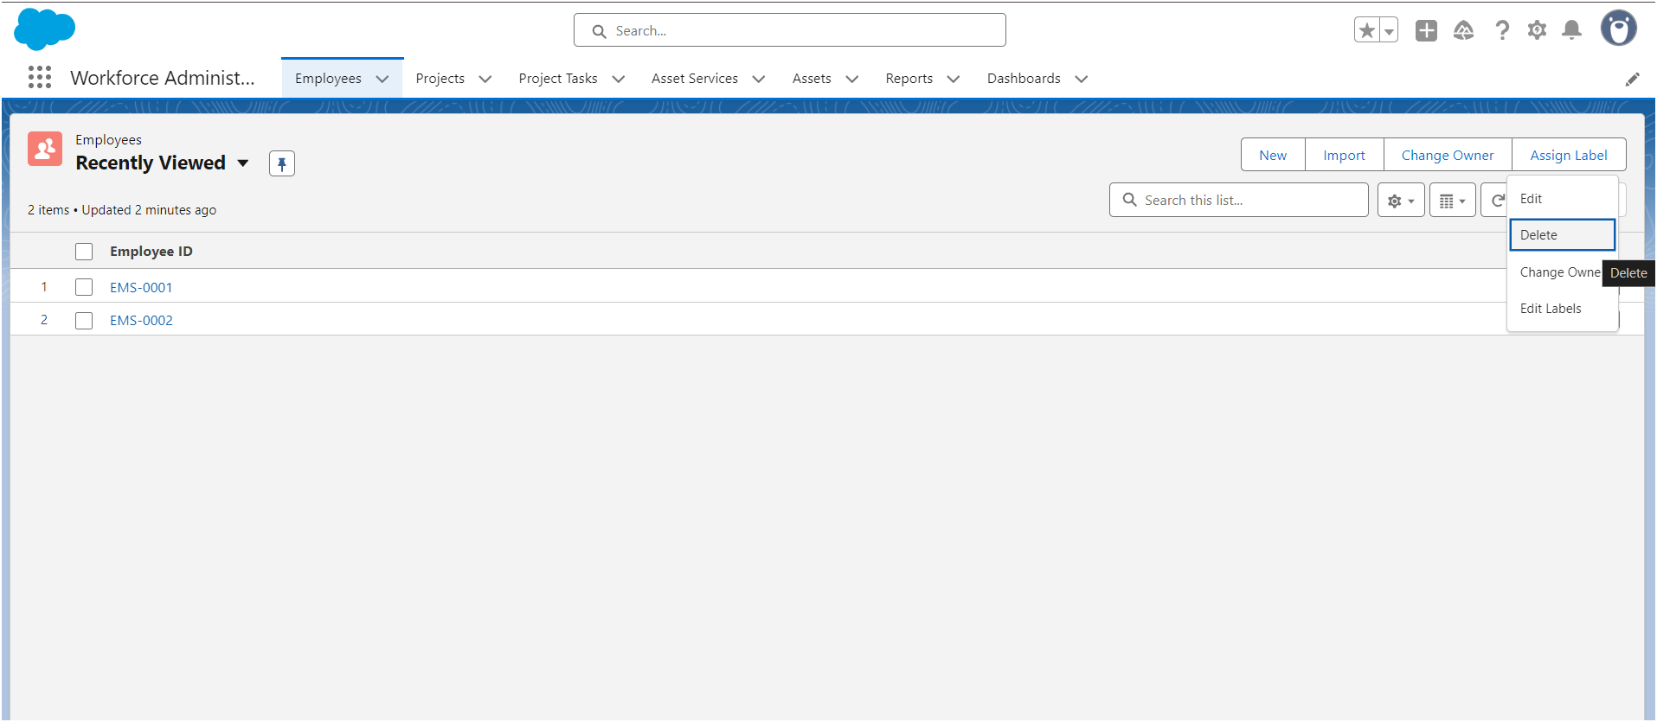

### **Milestone 8 - Import data**

#### **Use Case**

Congrats you have successfully made an app with all the default settings for the organization. Now here comes the real admin work, to import the old data of TheSmartBridge organization which was in CSV format into the salesforce org without failing any of the record.

Note in real time you might also facing some additional task such as data cleaning, elimination of duplicate values or records, etc.,

#### **Activity-1: Importing data using Data Wizard**

1. From Setup, click the Home tab.
2. In the Quick Find box, enter Data Import and select Data Import Wizard.

3. Click Launch Wizard!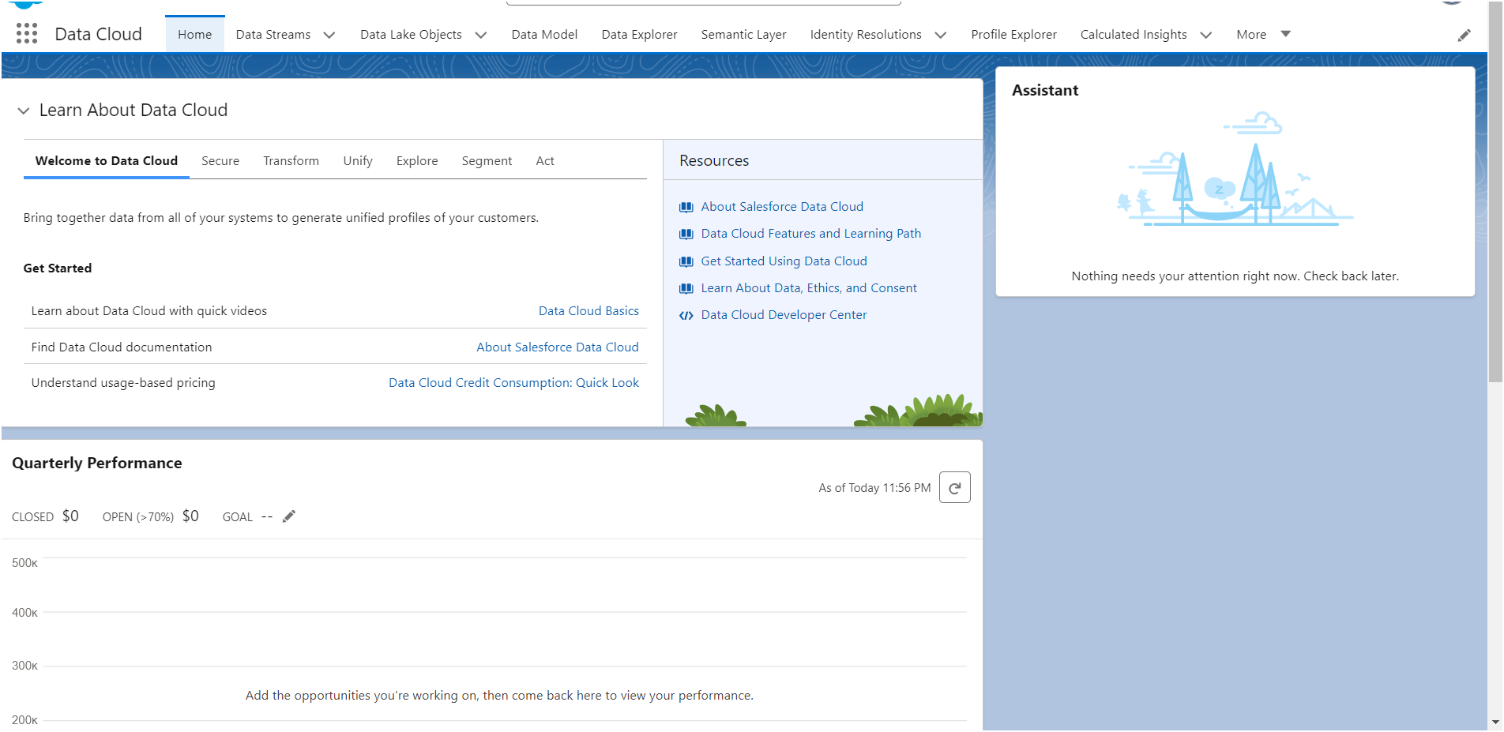

4. Click the Custom Objects tab and select the Employee object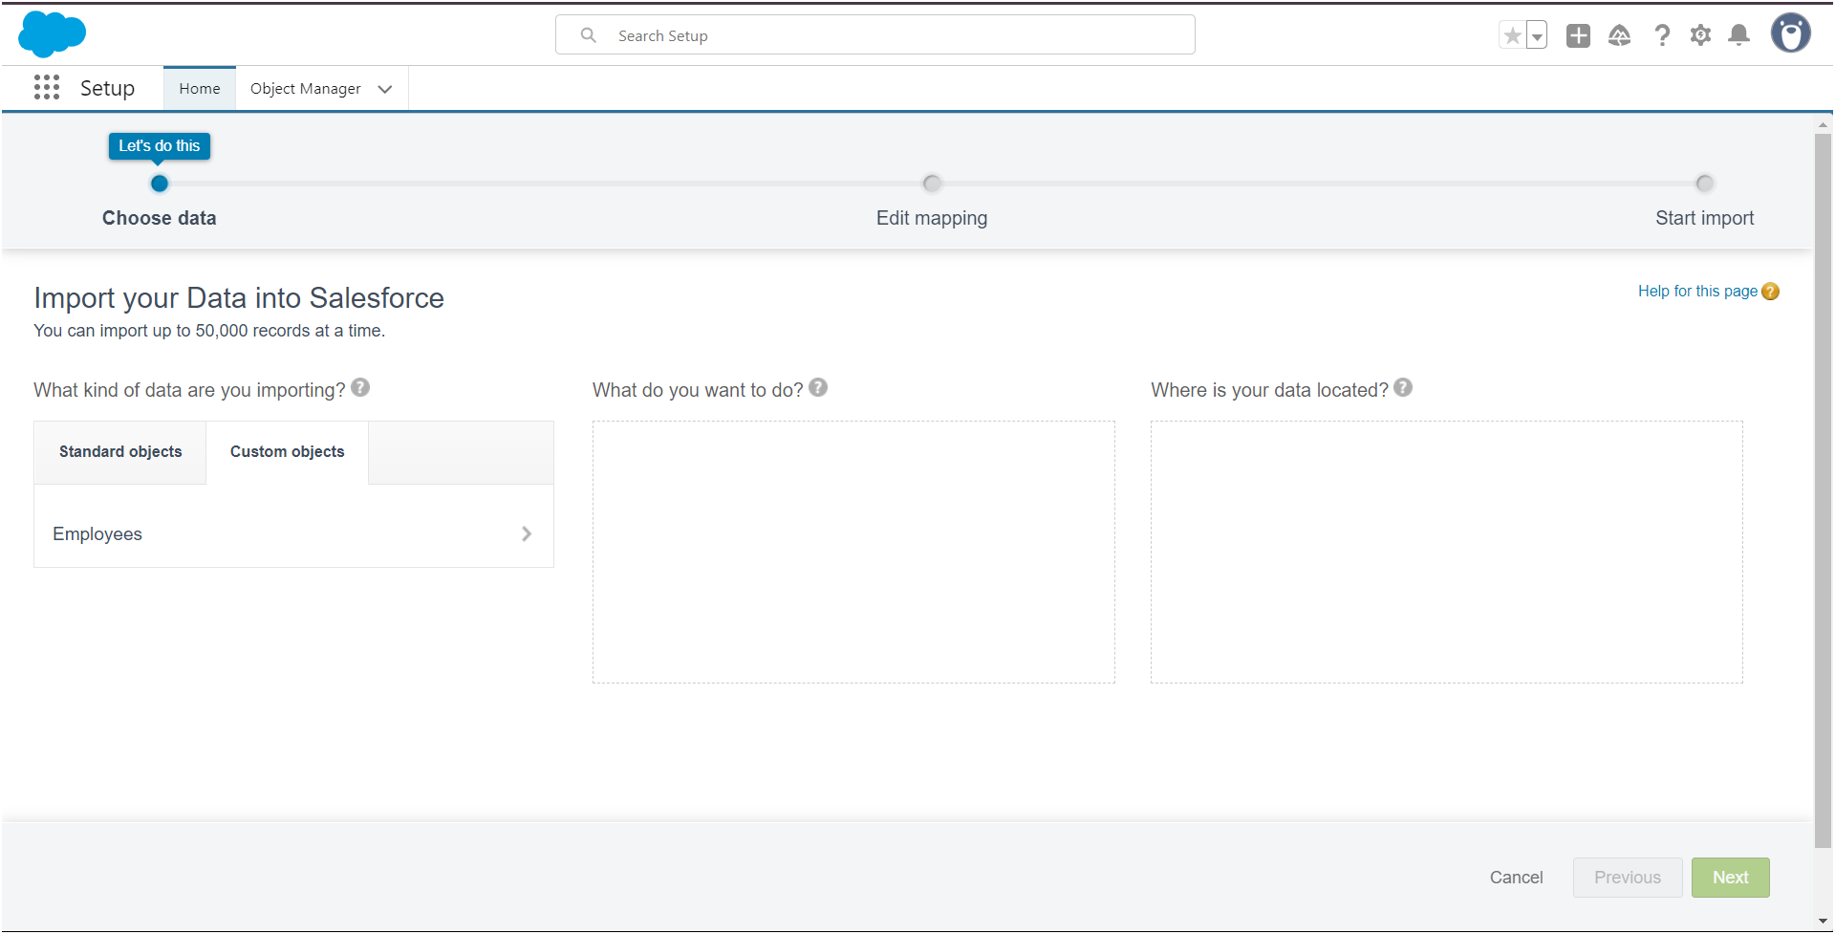

5. Select Add new records.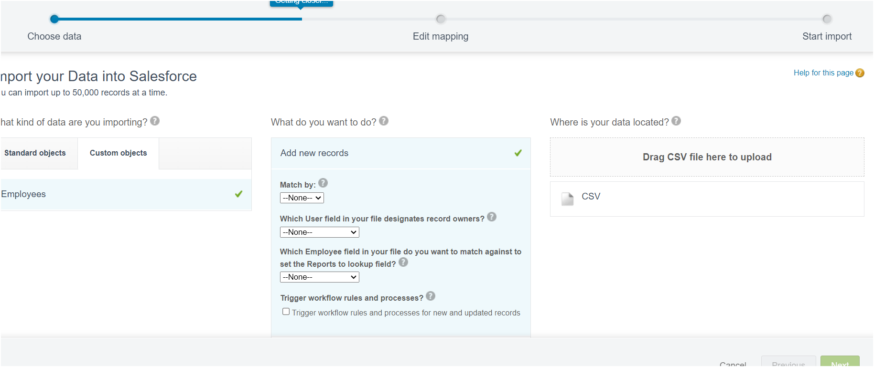

6. Click CSV and choose file Employee_CSV which we made earlier. Click Next.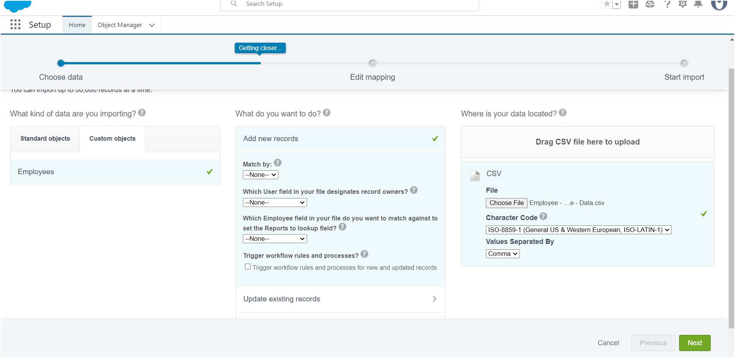

7. Since the field names in the CSV file (CSV Header) are the same as the field name

in your object (Mapped Salesforce Object), the fields are automatically mapped.

Click Next.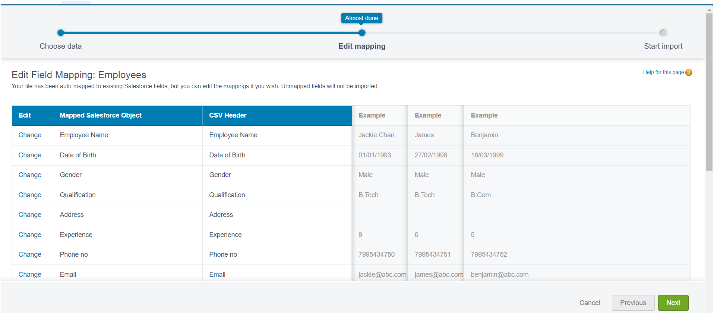

8. The next screen gives you a summary of your data import. Click Start Import.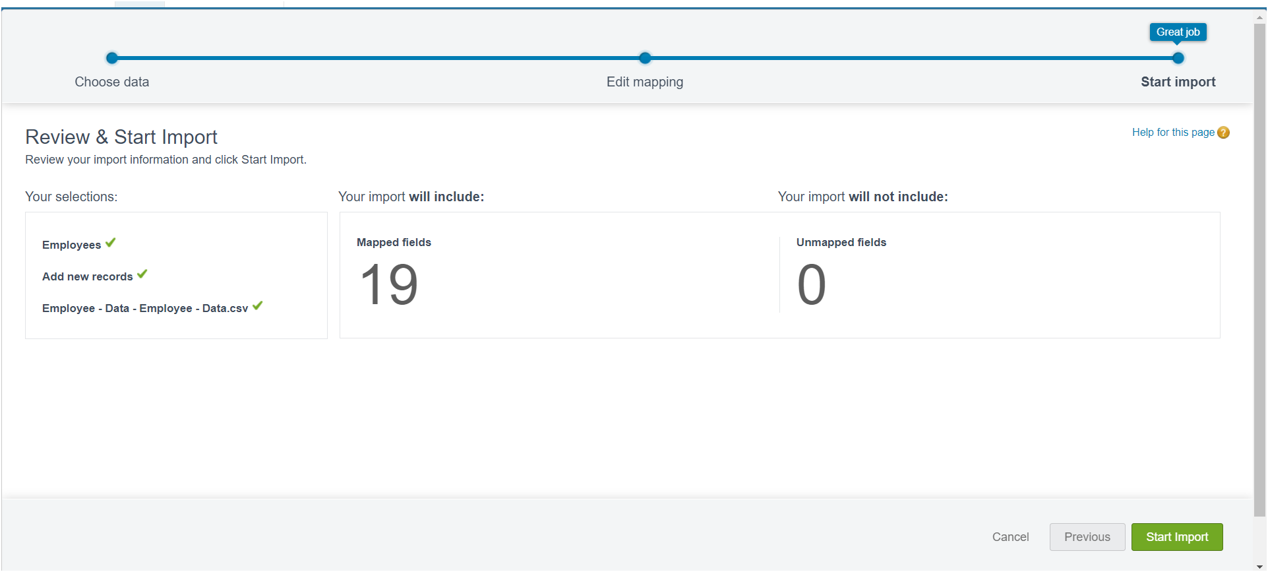

9 .Click OK on the popup.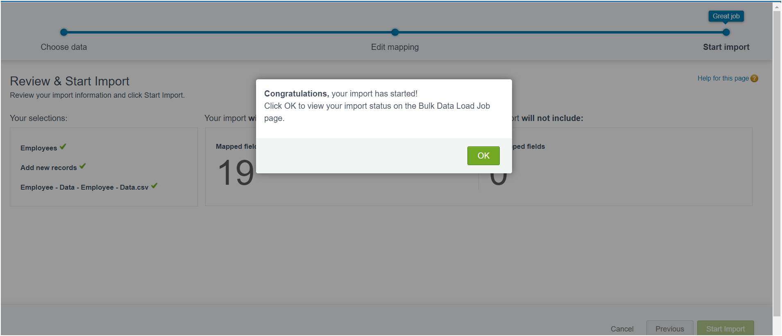

10. Make sure you have 0 records under the records failed column.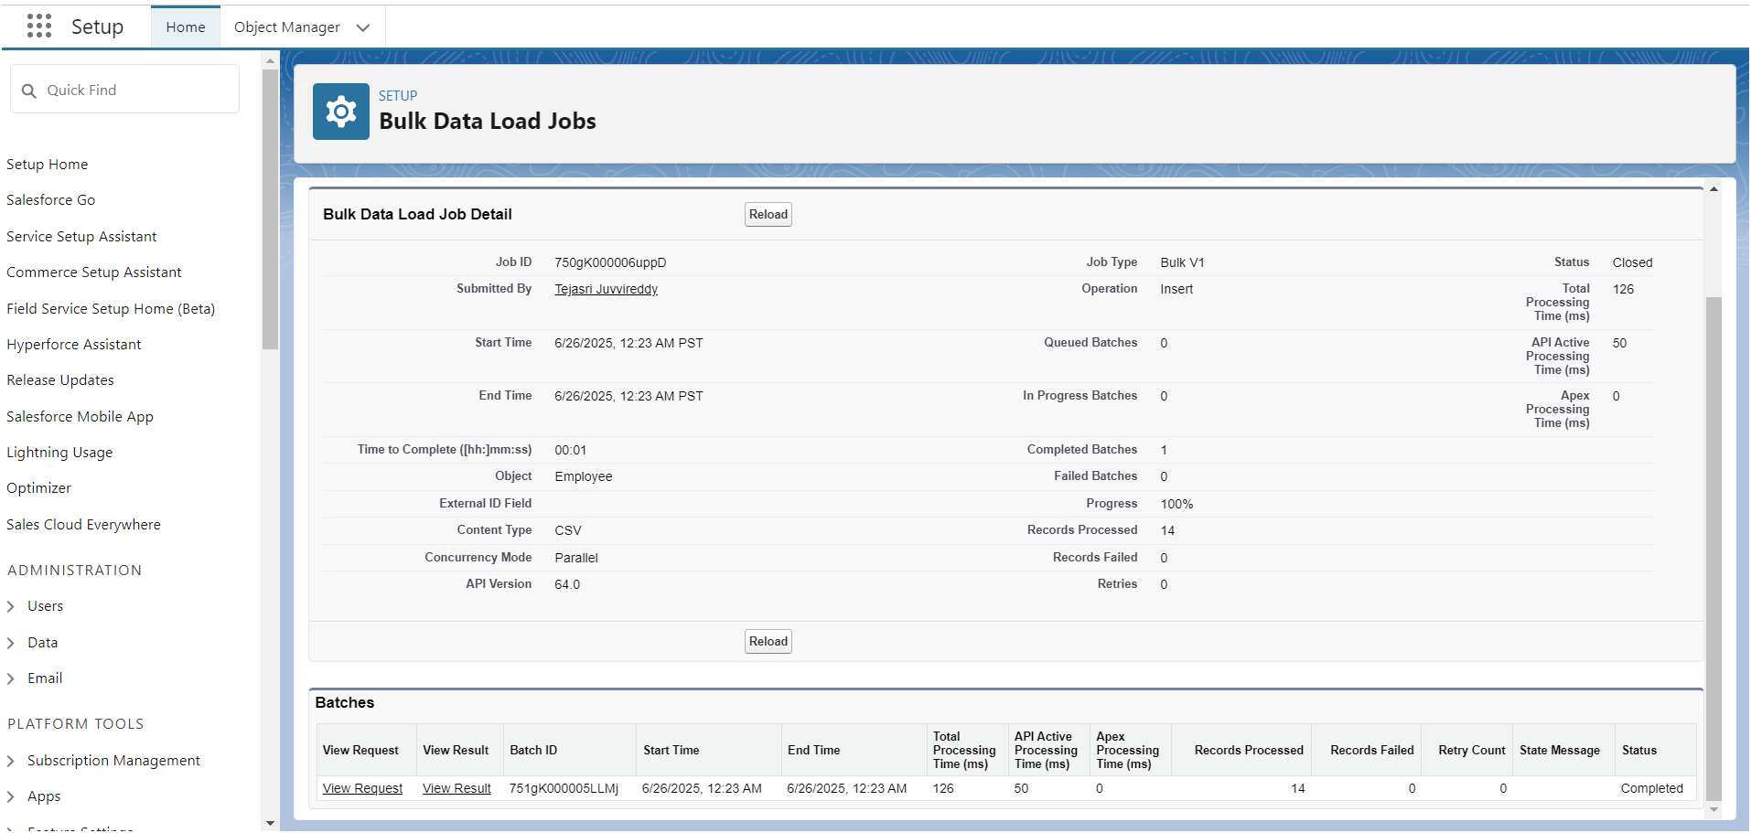

### **Milestone 9 - Profiles**

#### **Use Case**

Great work Admin, you have done so good till now. TheSmartBridge CEO wants you to differentiate the users based on their functionalities, position and based on this those users need to have the minimum access to the database object in the organization. Now it's time to use your Admin skills to focus on the users, their functionality and position in the organization in order to achieve the CEO requirements.

#### **Activity 1: HR Profile**

To create a new profile:

1. Go to setup --> type profiles in quick find box --> click on profiles --> clone the desired profile (Standard user) --> enter profile name (HR) --> Save.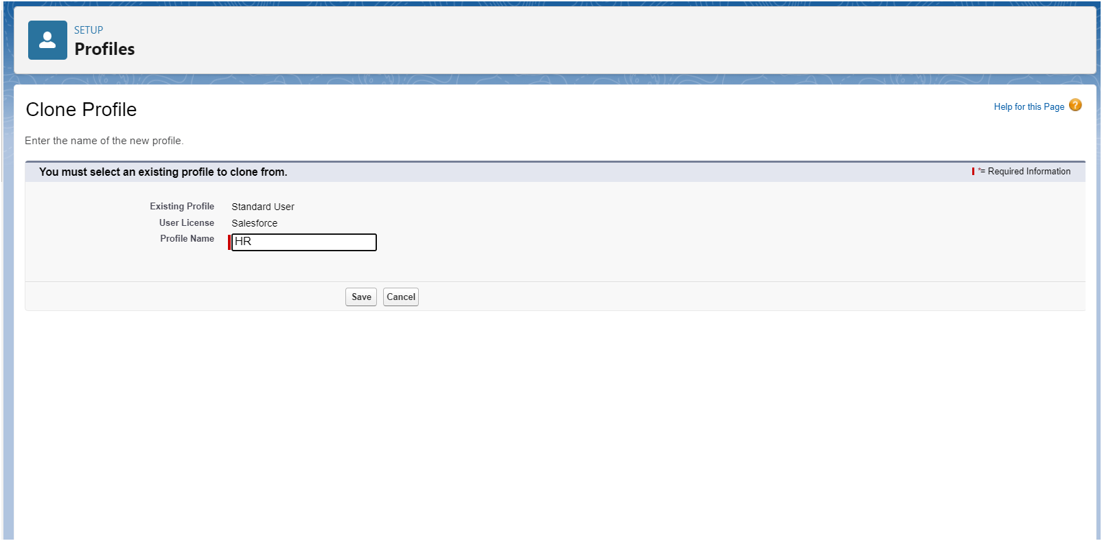

2. While still on the profile page, then click Edit.

3. Scroll down to Custom Object Permissions and Give access permissions for Assets and Asset Services objects.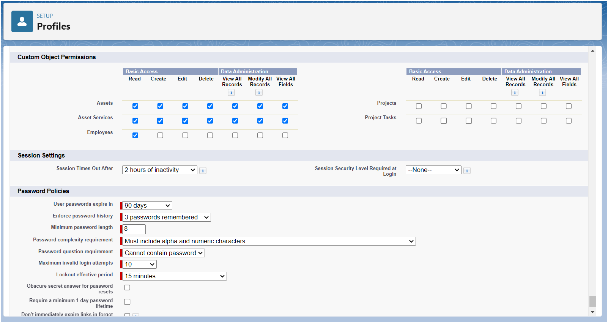

4. Scroll down and Click on Save.

#### **Activity 2: Manager Profile**

1. Go to setup --> type profiles in quick find box --> click on profiles --> clone the desired profile (Salesforce Platform User) --> enter profile name (Manager) --> Save.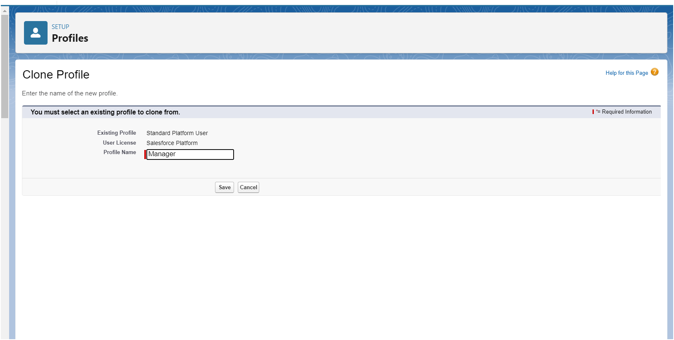  
2. While still on the profile page, then click Edit.  
3. Scroll down to Custom Object Permissions and Give access permissions for Employee, Project and Project Task objects.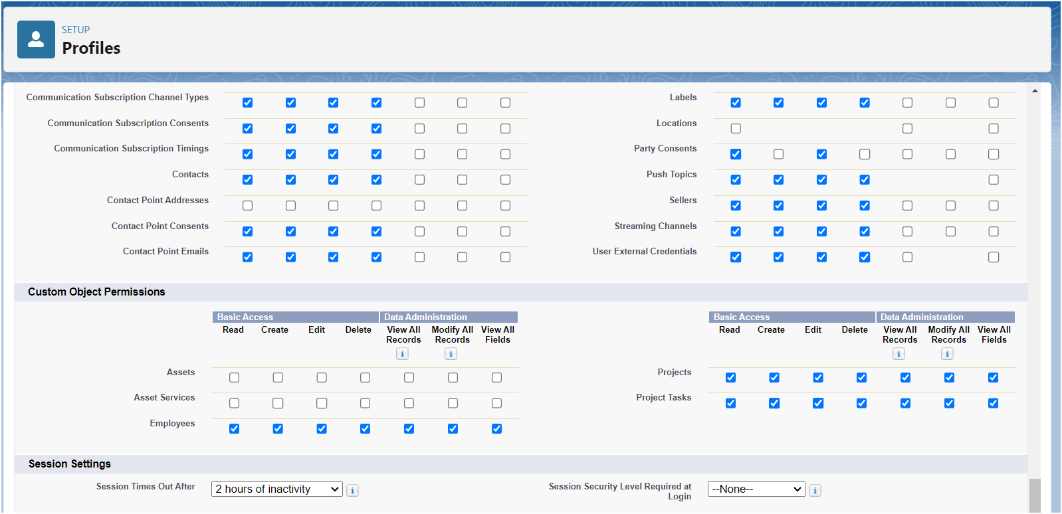  
4. Scroll down and Click on Save.

### **Milestone 10 - Role**

#### **Use Case**

You have successfully fulfilled the 1st requirement i.e., differentiating the users based on the functionality. Now comes the 2nd task of differentiating the users based on their position, using your excellent admin skills and expanding the custom roles for the organization and assigning it to the users.

#### **Activity 1: Creating HR Role**

1. Go to quick find --> Search for Roles --> click on set up roles.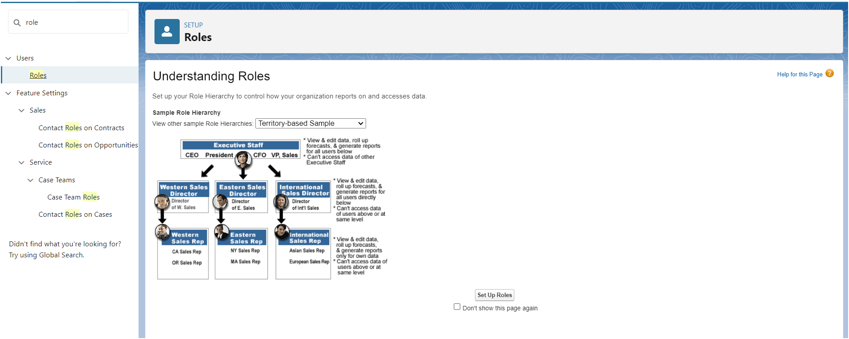

2. Click on Expand All and click on add role under whom this role works.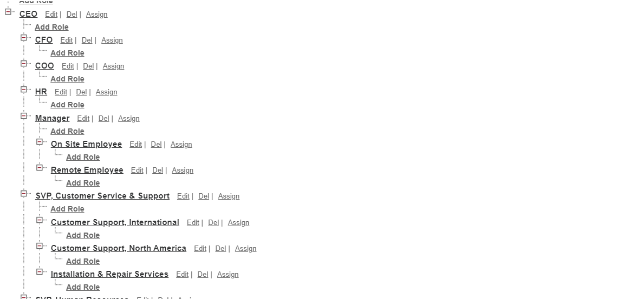

3. Give Label as “HR” and Role name gets auto populated. Check to whom this role (HR) reports. Then click on Save.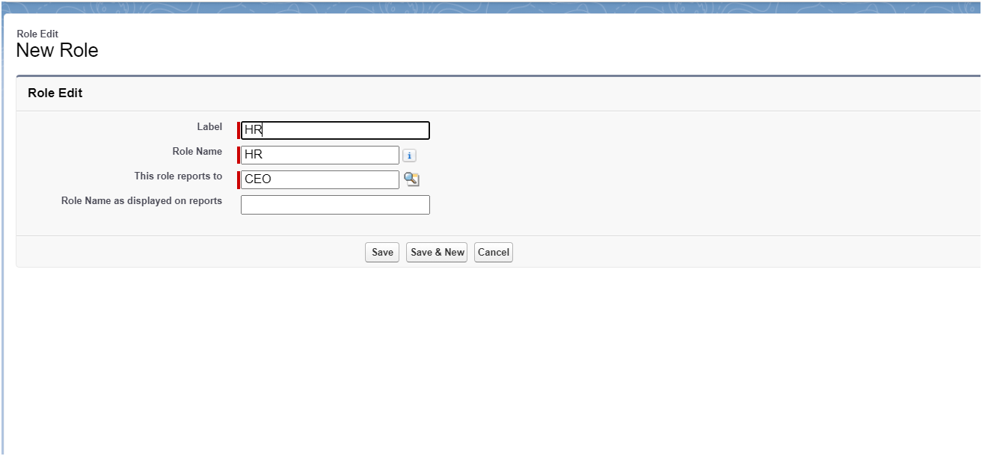  
4. Refer the below diagram to understand which role reports to which role.

#### **Activity 2: Creating more roles**

### 

### **Milestone 11 - Users**

#### **Use Case**

TheSmartBridge is all set to move with the Salesforce platform. As this platform is very new to the employees in the organization it’s up to you to enlight every employee in it.

#### **Activity 1: Create User**

1. Go to setup --> type users in quick find box --> select users --> click New user.  
2. Fill in the fields

1. First Name : Niklaus  
2. Last Name : Mikaelson  
3. Alias : Give a Alias Name  
4. Email id : Give your Personal Email id  
5. Username : Username should be in this form: text@text.text  
6. Nick Name : Give a Nickname  
7. Role : HR  
8. User license: Salesforce  
9. Profiles : HR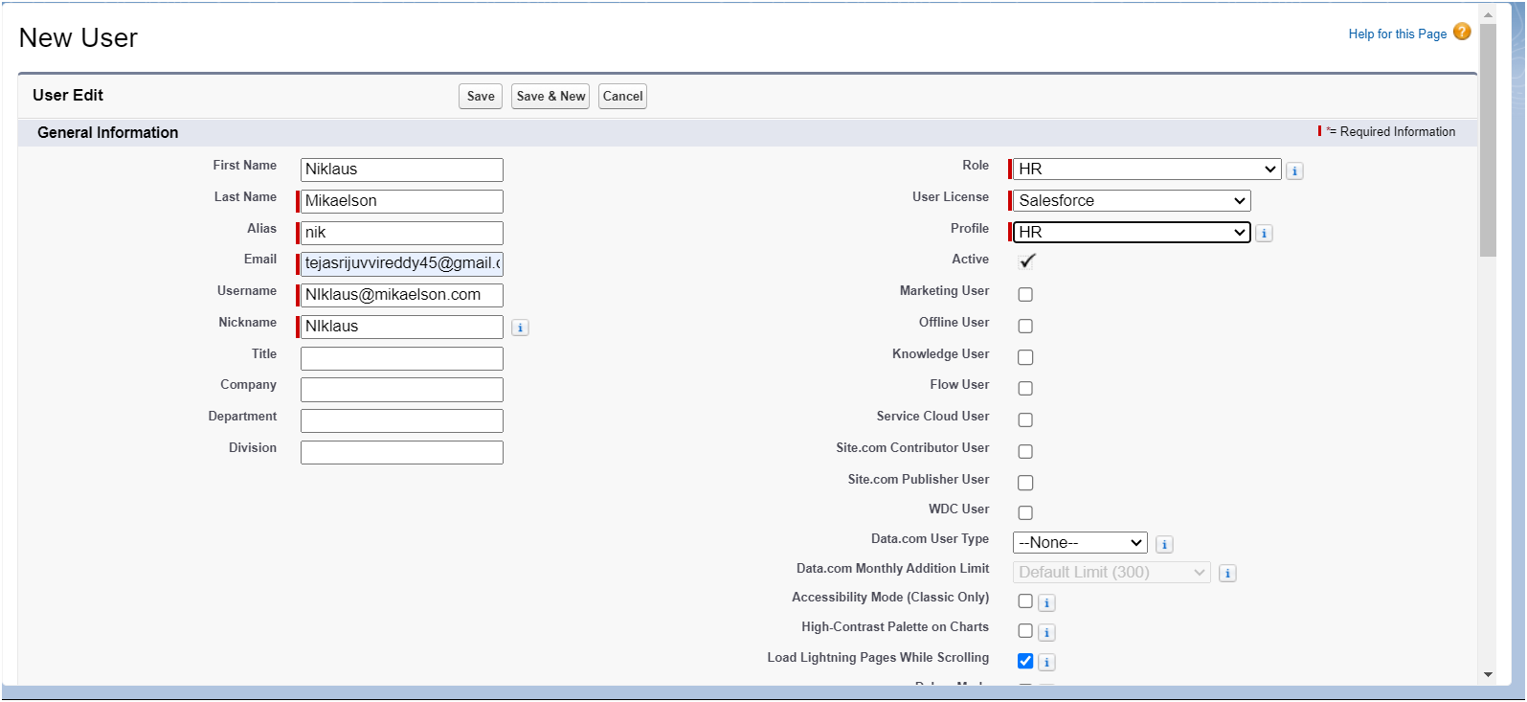

3. Save.

#### **Activity 2: Creating another user**

1. Go to setup --> type users in quick find box --> select users --> click New user.

2. Fill in the fields

1) First Name : Kol  
2) Last Name : Mikaelson  
3) Alias : Give a Alias Name  
4) Email id : Give your Personal Email id  
5) Username : Username should be in this form: text@text.text  
6) Nick Name : Give a Nickname  
7) Role : Manager  
8) User license : Salesforce Platform  
9) Profiles : Manager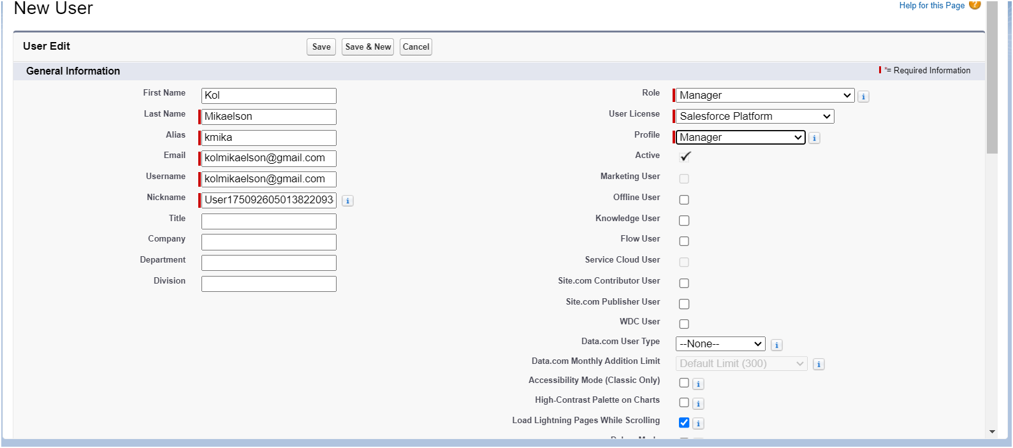

3. Save.

#### **Activity 3: Creating more users**

### **Milestone 12 - Page Layouts**

#### **Use Case**

Hurray!! you have completed the data model structure for your organization but while looking at the detailed and edit pages it seems to be so clumsy, so decide to organize the page in a pleasant way for the sake of good and pleasant appearance and assembling all different kinds of information in different sections.

#### **Activity 1 : creating a page layout for Employee object**

To Create a Page layout:

1. Go to Setup --> Click on Object Manager --> Search for the object (Employee) --> From drop down click on Edit.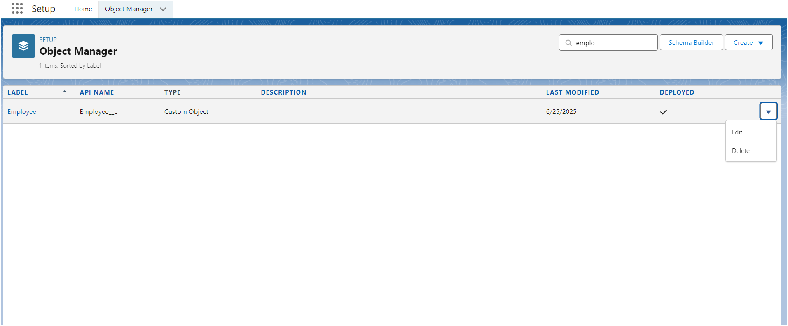

2. Click on Page layout --> Click on New.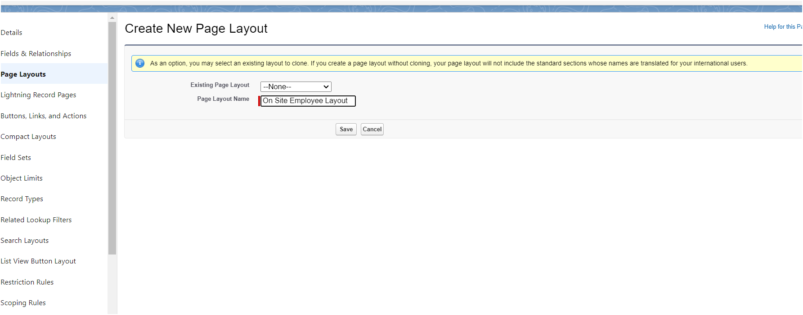

3. Give Page layout Name as “On Site Employee Layout” and click on Save.

1. Drag and drop the Section from the highlight panel below the Information and name it as “Personal Information” and click Ok.
2. Drag Date of Birth, Address and Age fields from Employee Information to Personal Information section.
3. Similarly perform the above step to create “Allowances” and add allowances fields in it as shown below.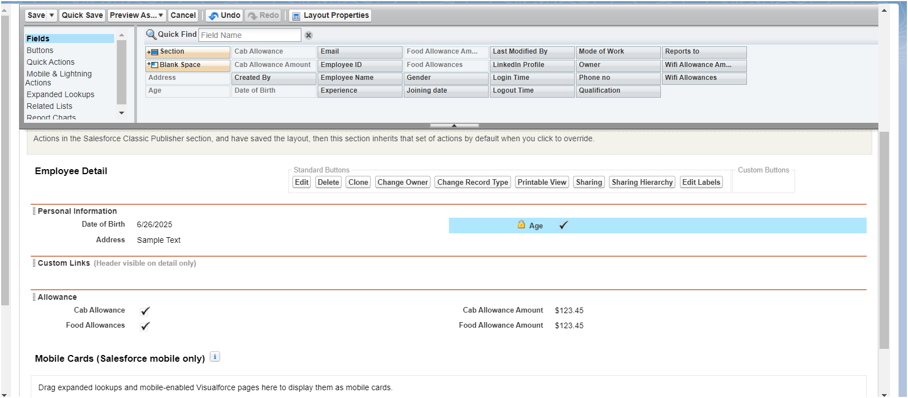
4. Click Save.
5. Make sure your page layout looks like the picture above.

#### **Activity 2 : Creating another page layout**

Create another page layout and name it as “Remote Employee Layout”, and in the allowances section use only Wifi Allowance and Wifi Allowances Amount fields.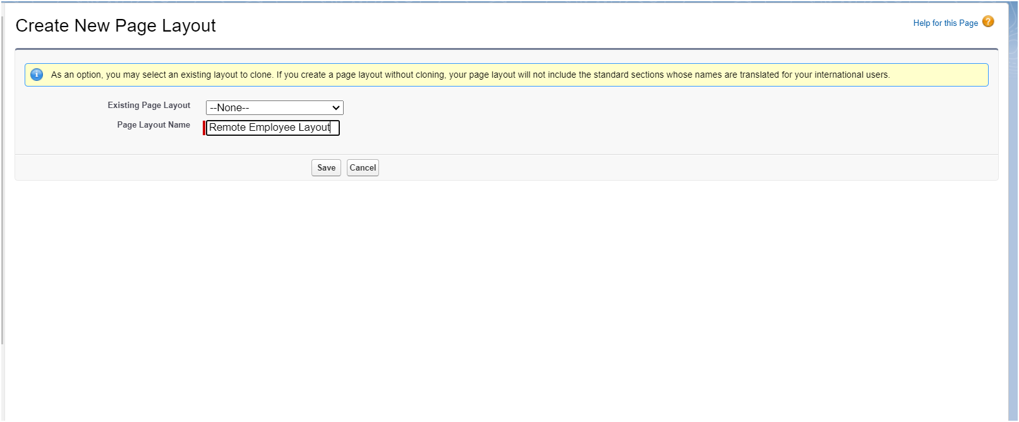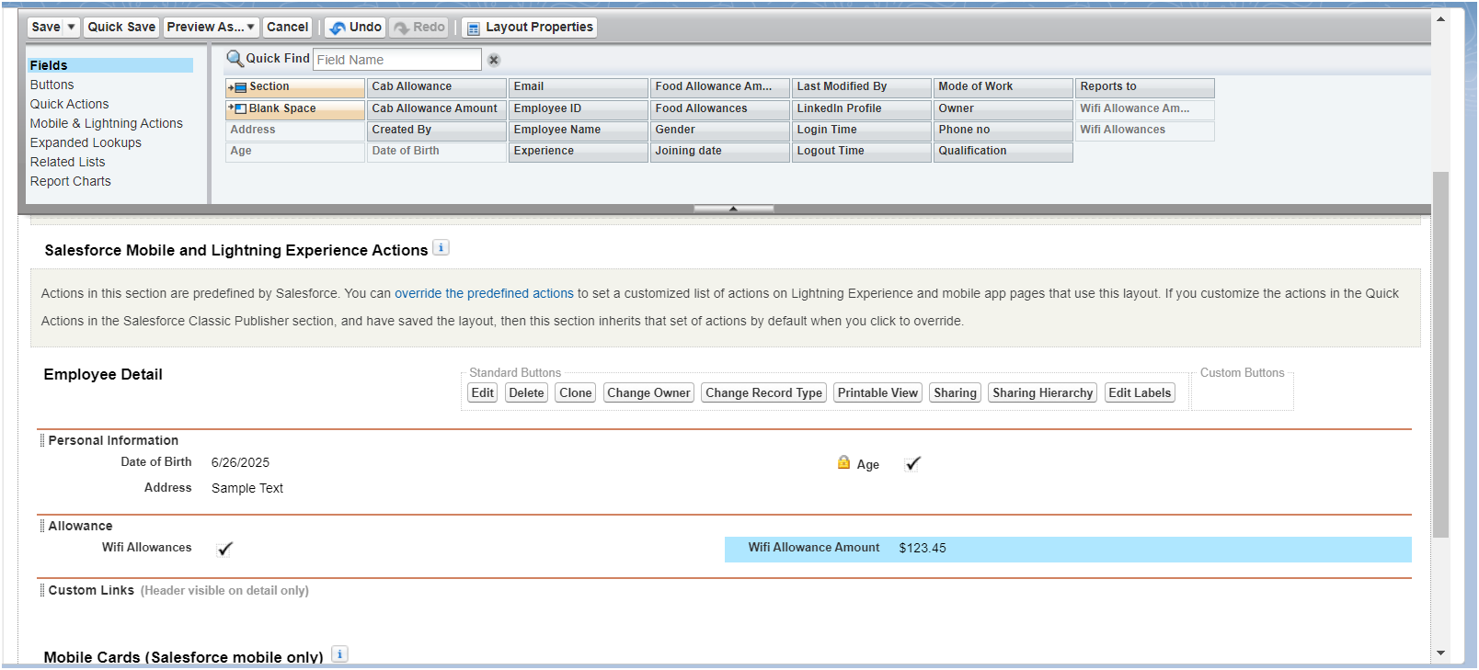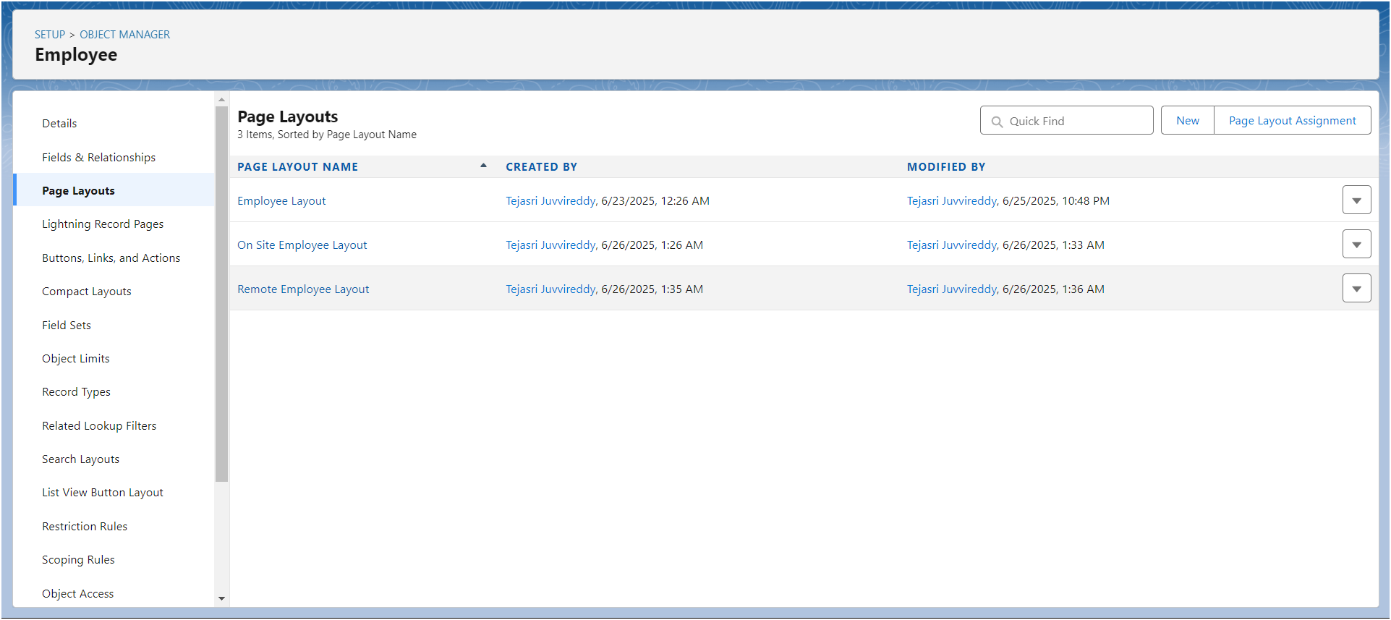

### **Milestone 13 - Chatter Group**

#### **Use Case**

Congratulations Admin you have made the job done for the organization, Amar The Founder of the organization and Jai Prakash The COO are very impressed with your work. But still there are some updates which your COO wants in your organization. So he comes to you with the idea that all the employees should have a common group for work discussion inside the salesforce. You know how to get this done with your admin skills.

#### **Activity 1 : Creating a chatter group for your organization.**

To Create a chatter group:

1. Click the App Launcher.
2. Enter Groups in the Search apps and items... box and select Groups.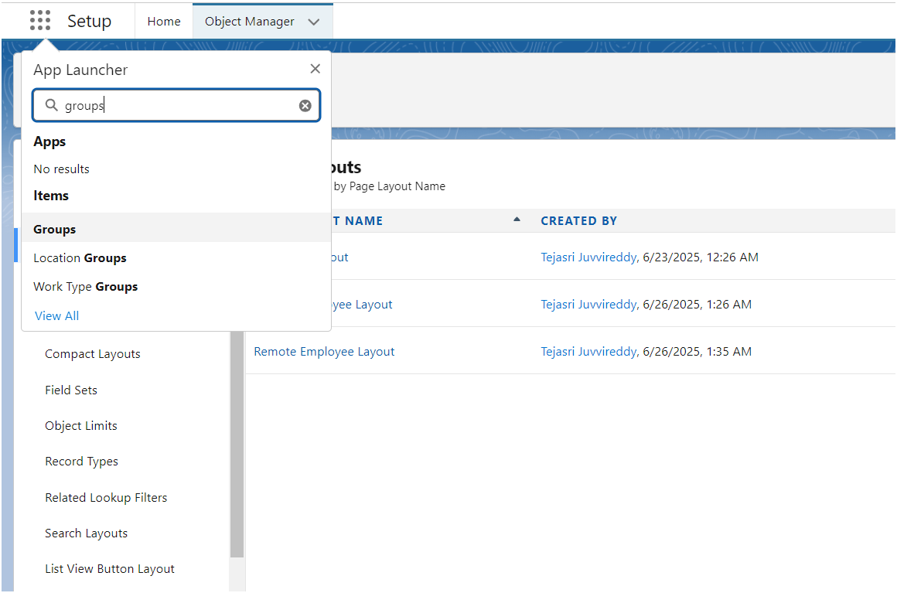
3. Click New.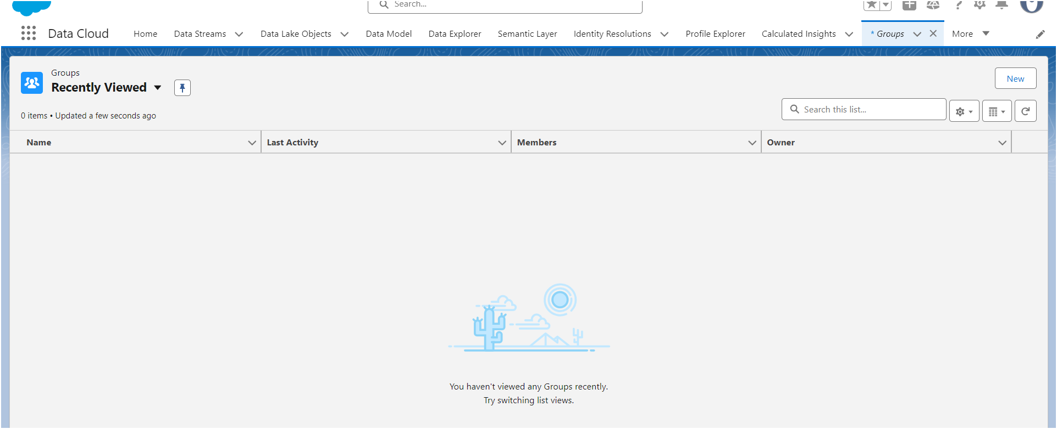
4. Fill in the new group information with these details:

| Field | Value |
| --- | --- |
| 1. Group Name  2. Description  3. Access Type  4. Allow Customers | Internal Discussion  Give a understanding Description on your own  Private  Checked |

1. Click Save & Next. Skip the Upload Picture section and click Next.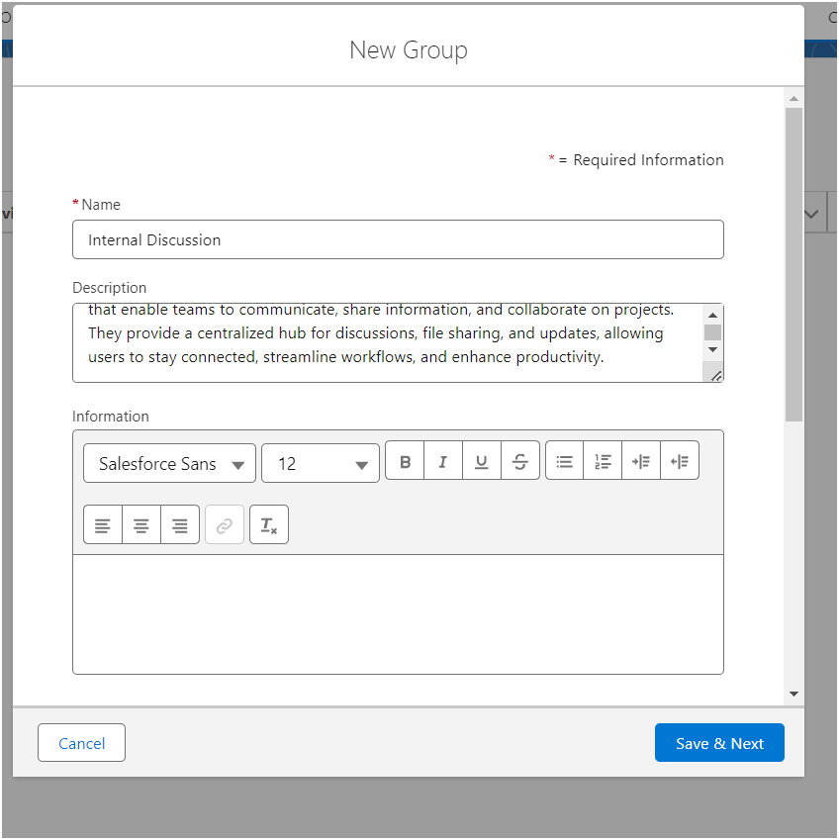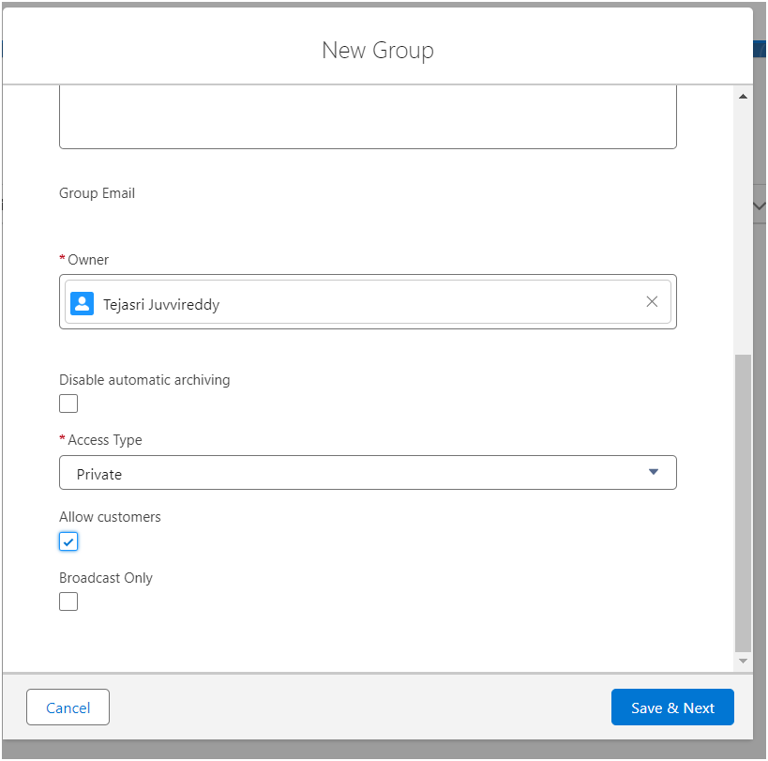
2. On the Manage Members screen, click Add next to users you created in the previous activity.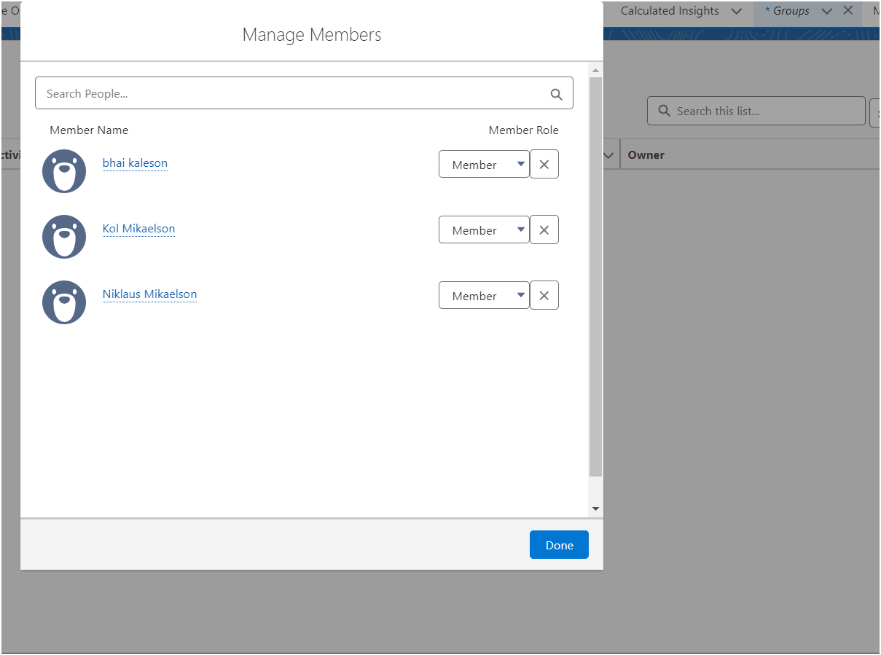
3. Click Done.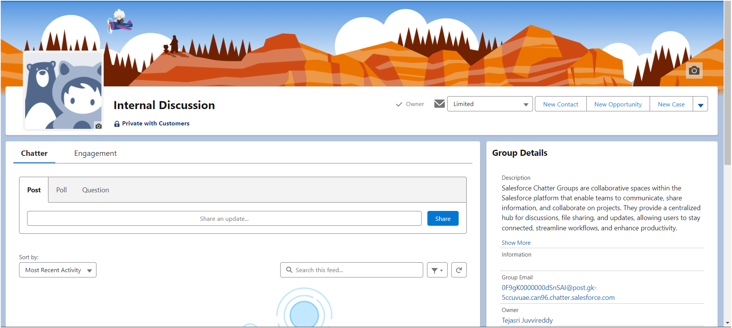
4. This is how your group interface looks like.
5. Where it says Share an update, post this message to the group: Welcome to the Internal Discussion Group, here you can post anything which is related to ongoing projects.
6. Click Share.

### **Milestone 14 - Record Types**

#### **Use Case**

All things done for the organization. But some of the organization employees feel it difficult to fill up all the details while creating an employee record, so Jai Prakash (COO) assigned you a task to create different forms for employee records based on their mode of work. As an Admin, you know how to achieve this.

#### **Activity 1: Creating On Site Employee Record Type**

To create a Record Type:

1. Go to Setup --> click on Object Manager --> Search for the object (Employee) --> from drop down click Edit.

2. From the left panel click Record Types --> New.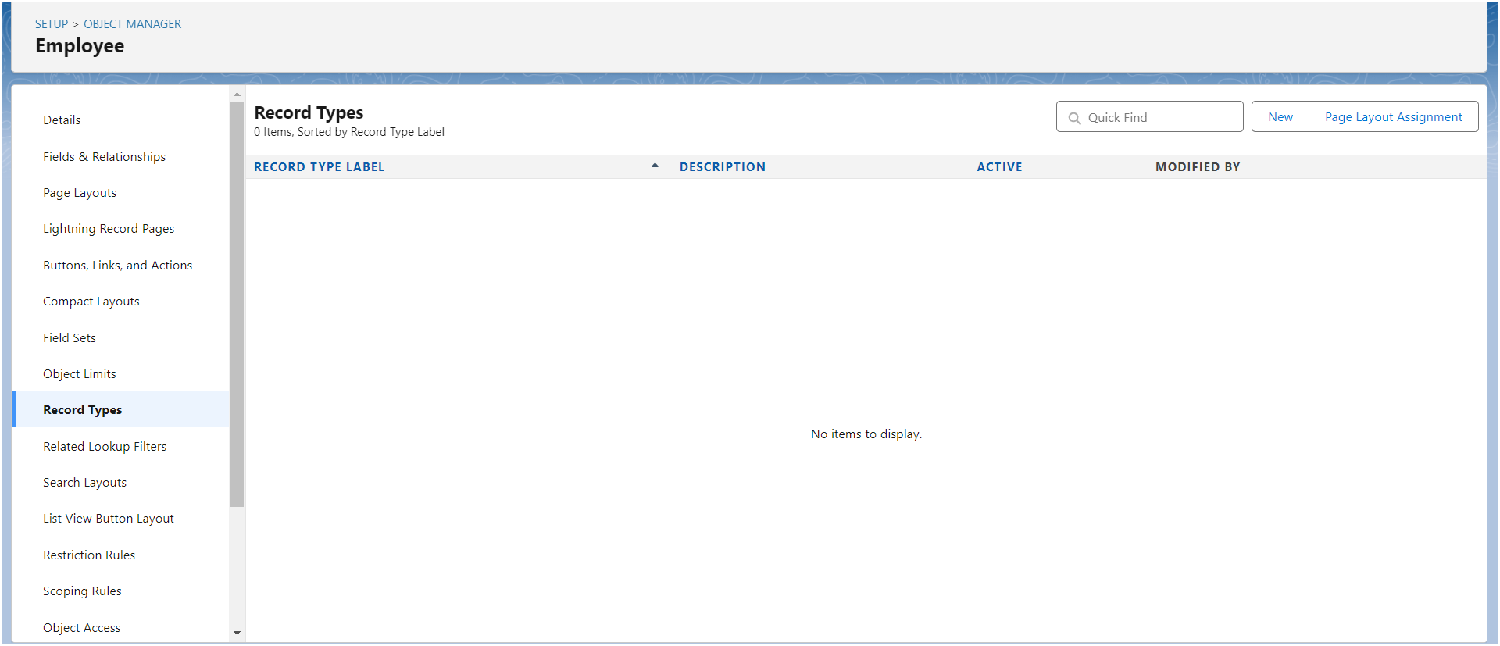

3. Give Record Type Label as “On Site Employee” and make it active.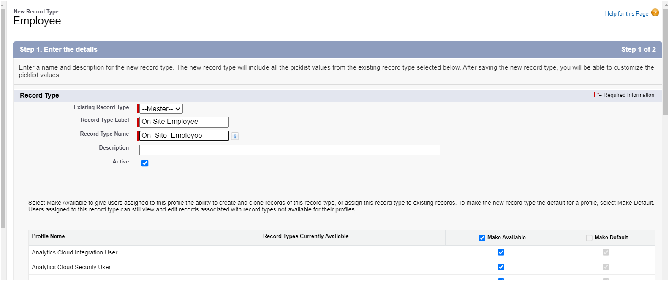

4. Uncheck for “Make Available”.

5. Scroll down and check for the Manager & System Administrator profile

and click on Next.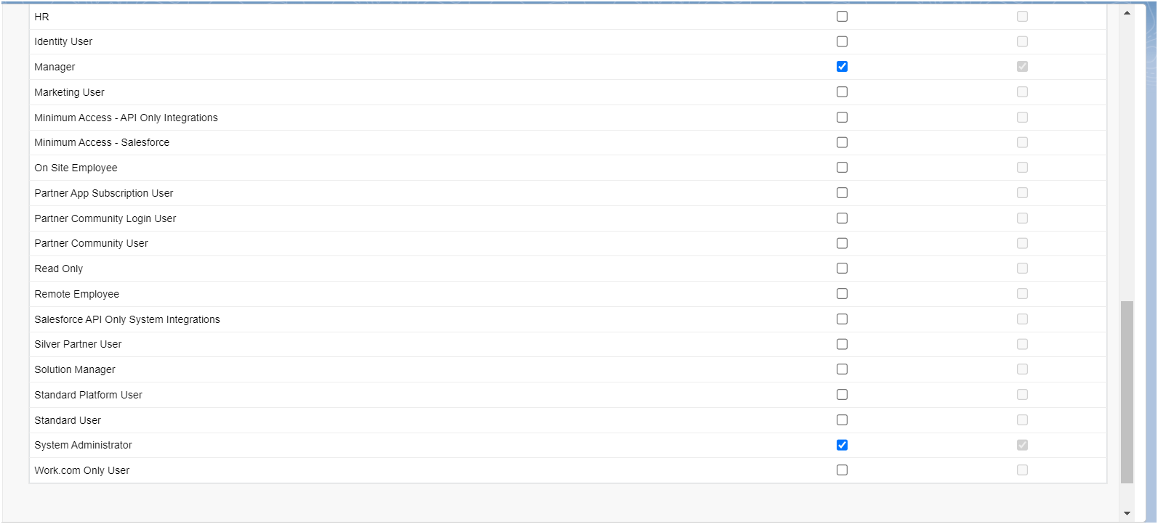

6. Select “Apply a different layout for each profile”, and change page layout

to On Site Employee Layout for manager profile and System Administrator.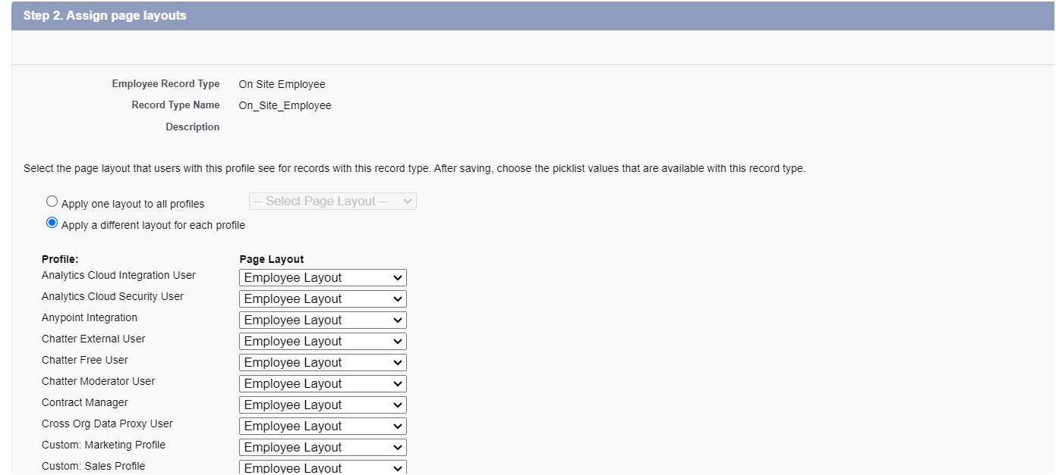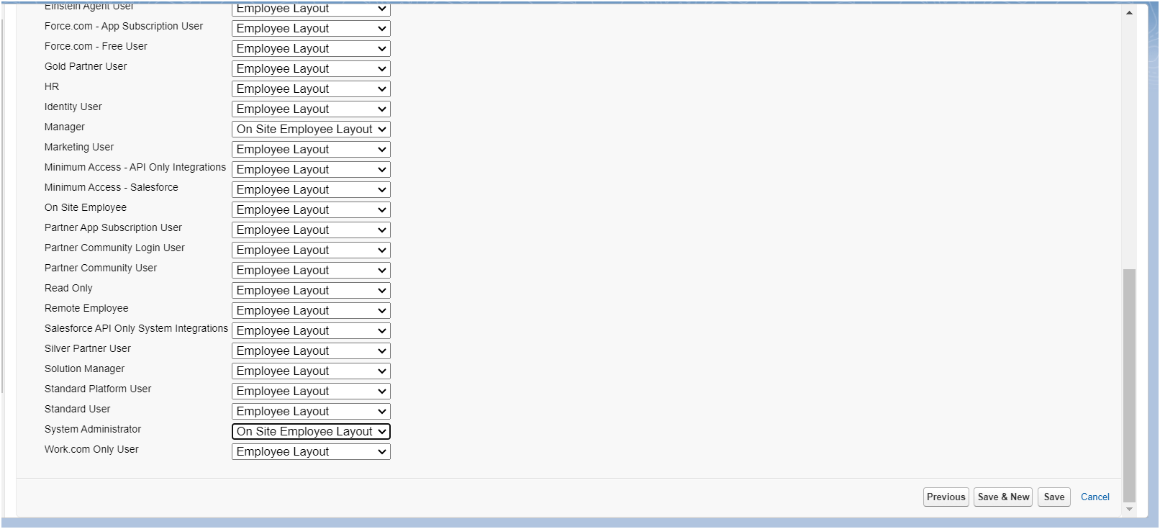

7. click Save.

#### **Activity 2: Creating "Remote Employee" Record Type**

Create another Record Type with name “Remote Employee” following the step from activity 1.

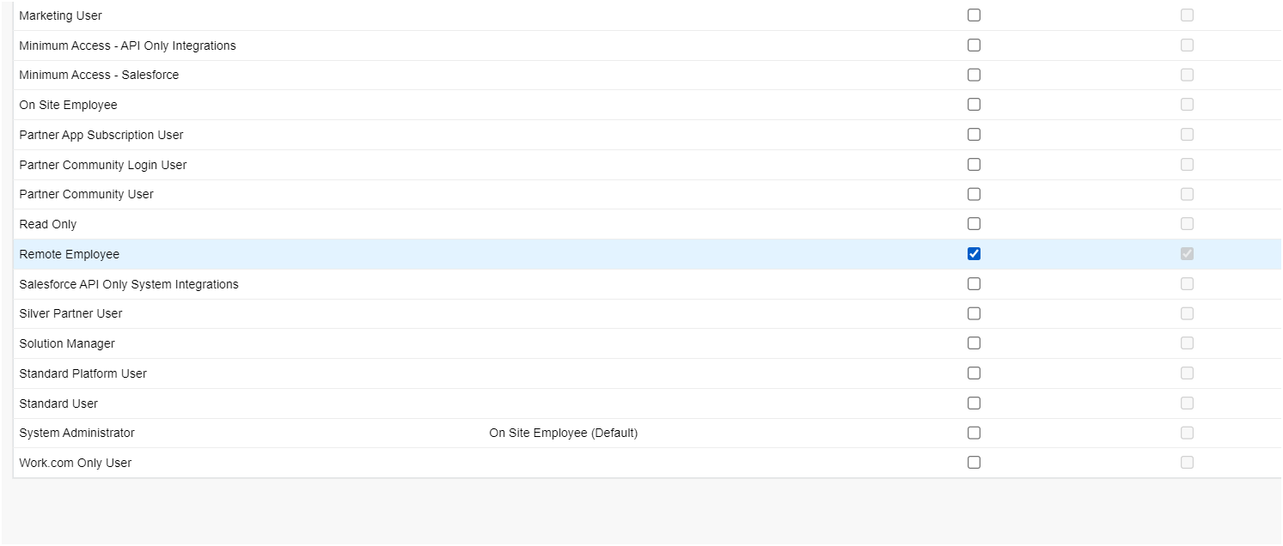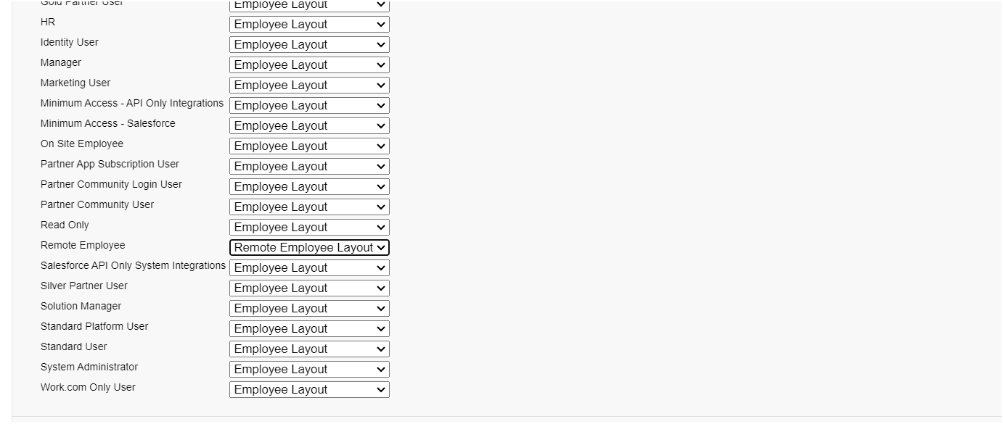

### **Milestone 15 - Permission Sets**

#### **Use Case**

Every day is a war for Admin with some unique challenges. A new challenge awaits as you enter the office. After you arrive in office you came to know that the manger is on leave and there’s a lot work pending at his desk generally there are numbers of employee records that the manager have to enter in the salesforce org and no other person have the permission to create those records except him and your CEO wants it to be done by the end of the day, as it’s not possible to create the same profile and assigned it to some other person in the org. So using your admin knowledge you came up with the idea to create a permission set and assign it to someone who doesn’t have the access to do that job.

Let’s create a permission set.

#### **Activity 1: Create Report**

To Create a Report:

1. Go to the app --> click on the reports tab

2. Click New Report.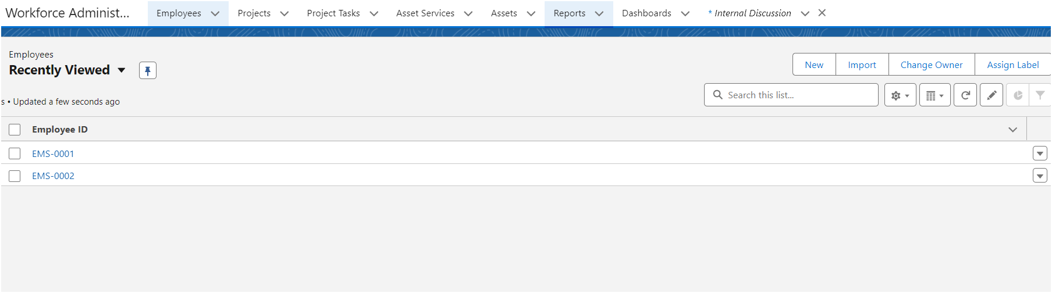

3. Select report type from category or from report type panel or from search panel -->

click on start report.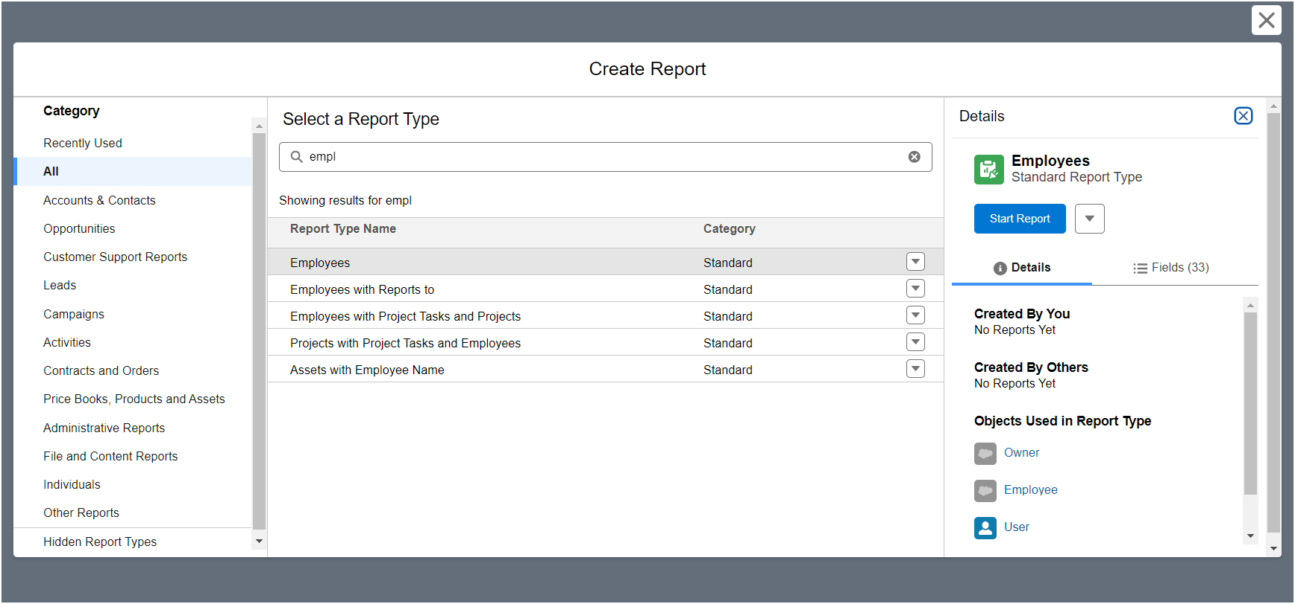

4. Customize your report

--> Add fields from left pane as shown below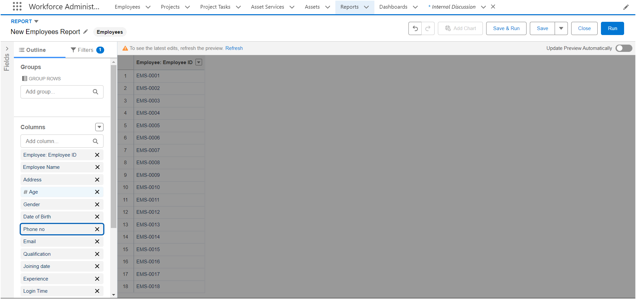

5. Save or run it.

#### **Activity 2: Create 2 more Report**

1. Create a report with report type: “Employees with ProjectTasks and Projects”.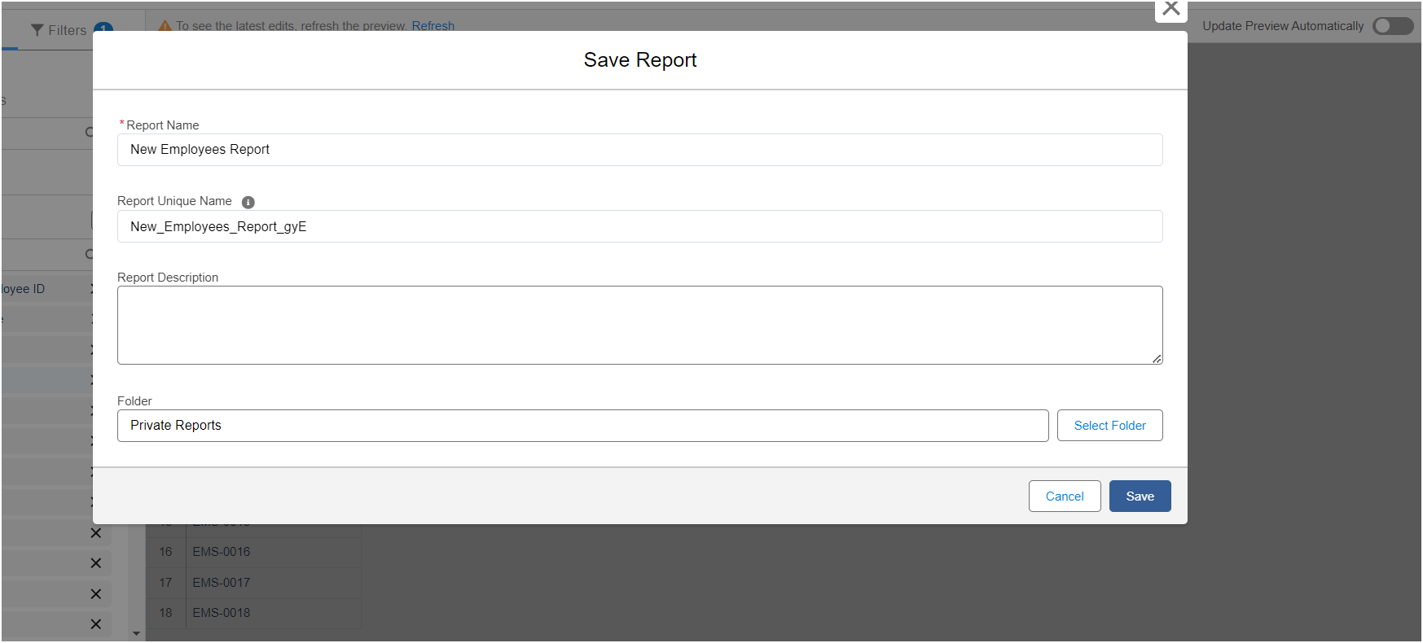  
2. Create a report with report type: “Employees with Assets”.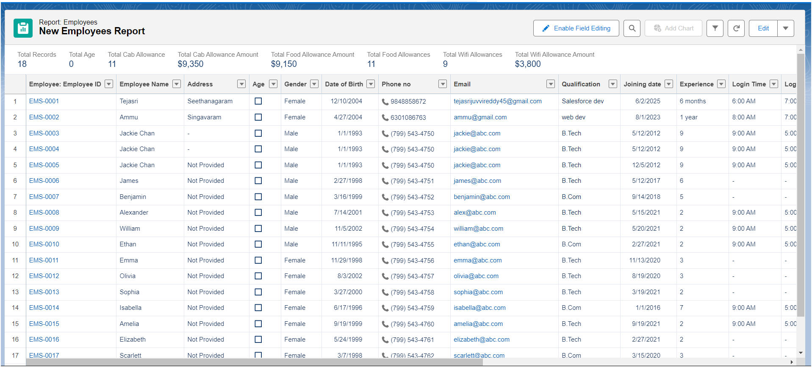

### **Milestone 16 - Dashboards**

#### 

#### **Use Case**

As an Admin for the organization you keep pushing yourself to reach out the business requirements to take the organization to peak heights and all your superiors are very much impressed with your efforts and work dedication. In addition with reports you make an ease for the CEO in viewing the reports with data visualization. So he doesn't have to search for the data he wants during the meetings.

#### **Activity 1: Create Dashboard**

To Create a Dashboard

1. Go to the app --> click on the Dashboards tabs.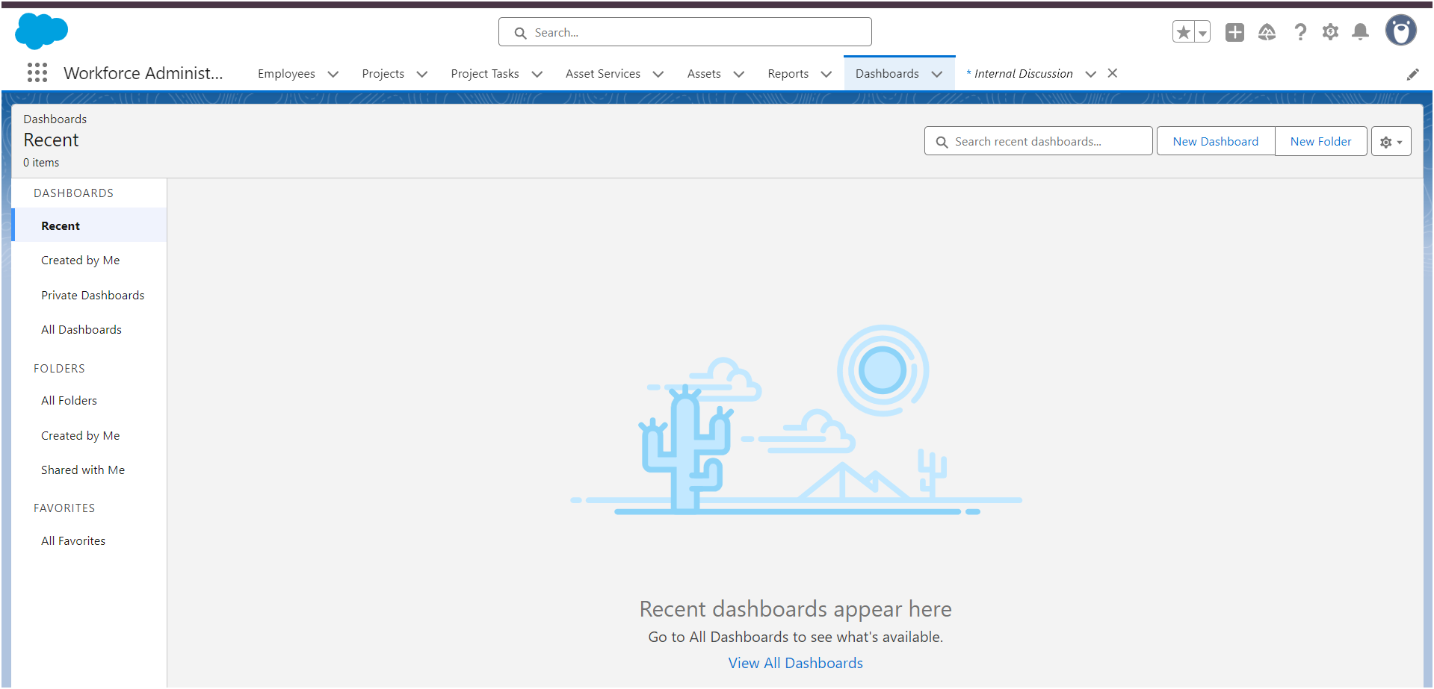

2. Give a Name and click on Create.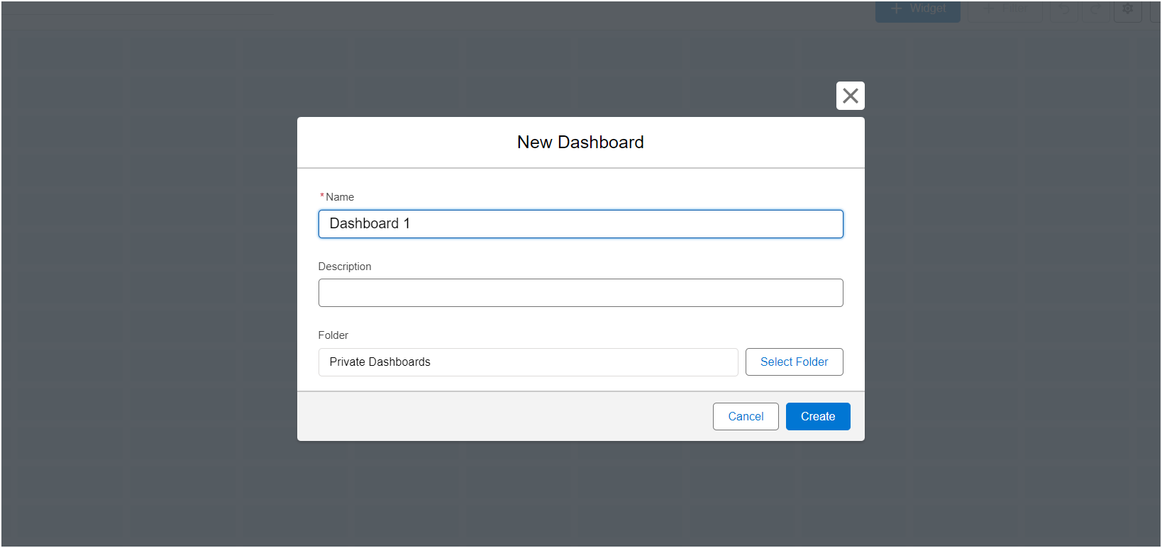

3. Select add component.

4. Select a Report and click on select.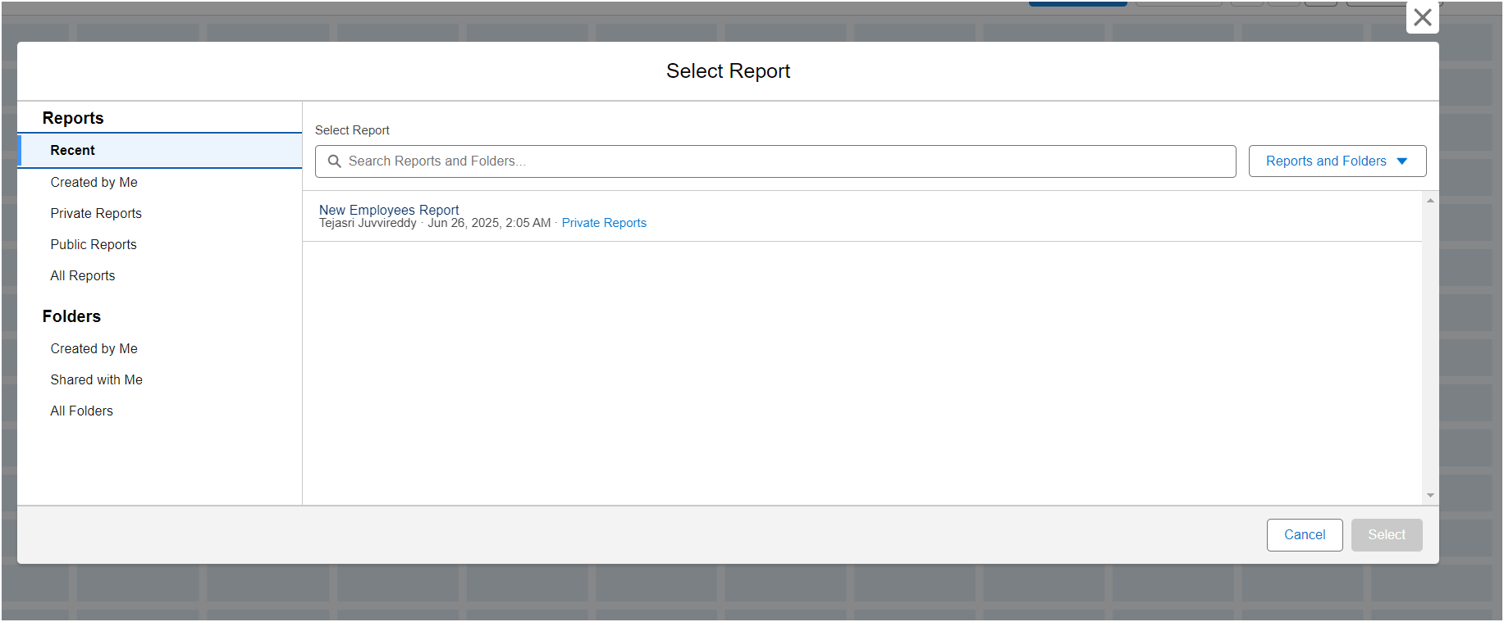

5. Click Add then click on Save and then click on Done.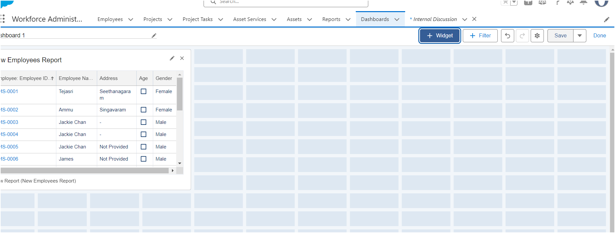

#### **Activity 2:**

Create another Dashboard as we discussed in activity 1.

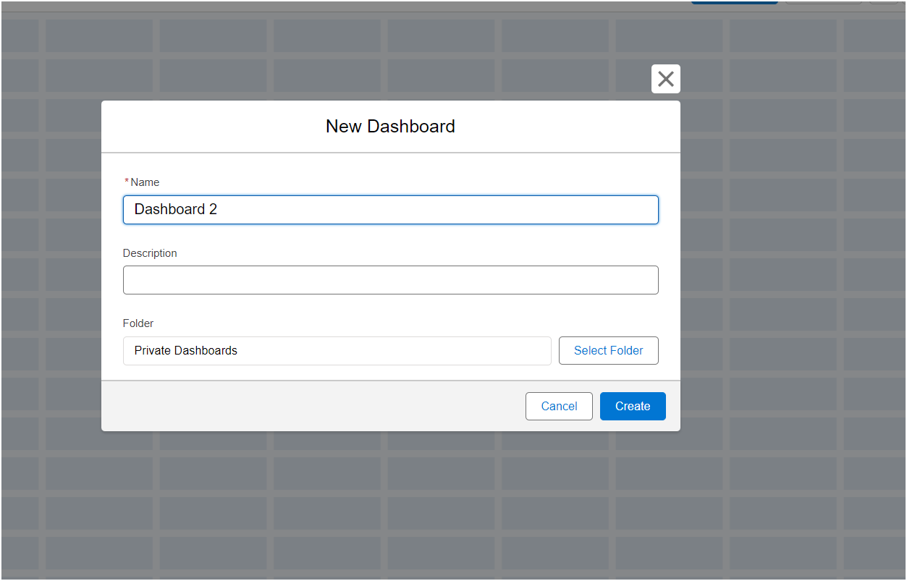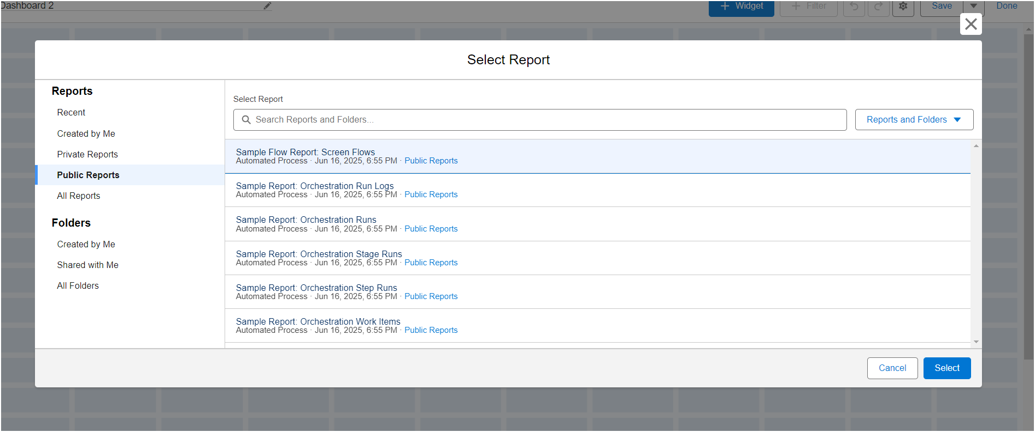

### **Milestone 17 - Approval Processes**

#### **Activity 1**

## Prerequisites:

Create the leave object with the following fields.

| Object | Fields | Datatype |
| --- | --- | --- |
| Leave | Employee Name  No. of Days  Subject  Description Status | Lookup with Employee object  Number  Text  Text Area(Rich)  Picklist: values as follows   | Submitted  Approved  Rejected | | --- |   Note: Make sure the Status field is read only for everyone. (Give read only permission in step 3 while creating the field) |

Create the tab for the leave object.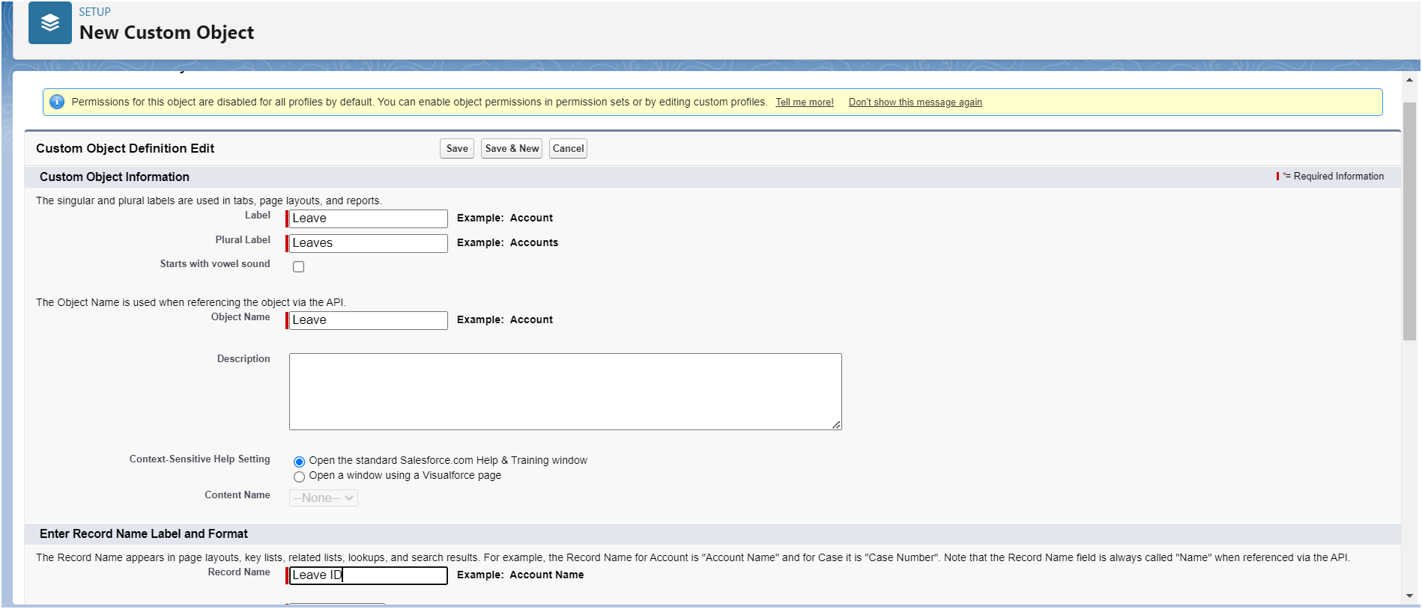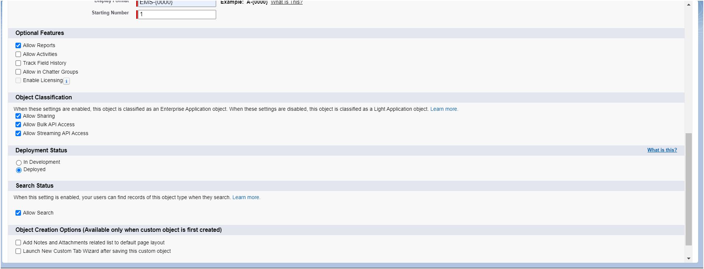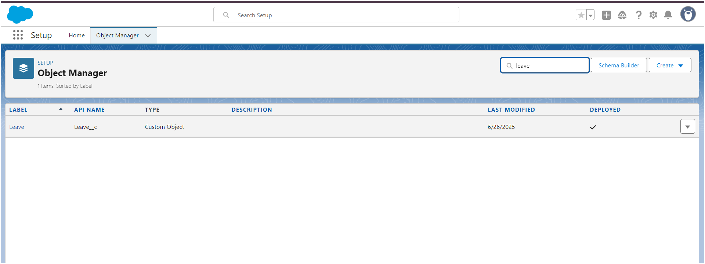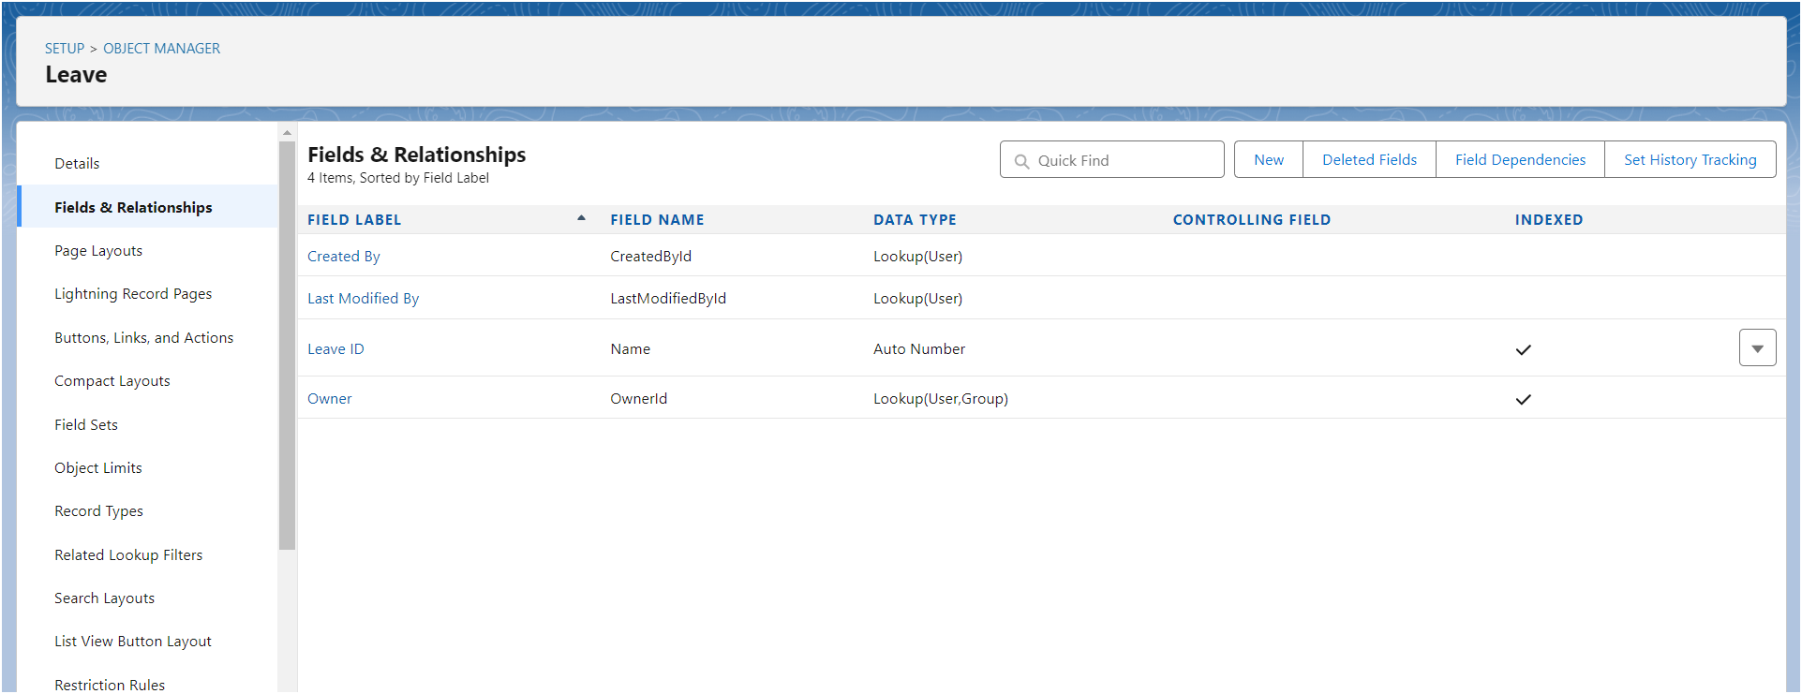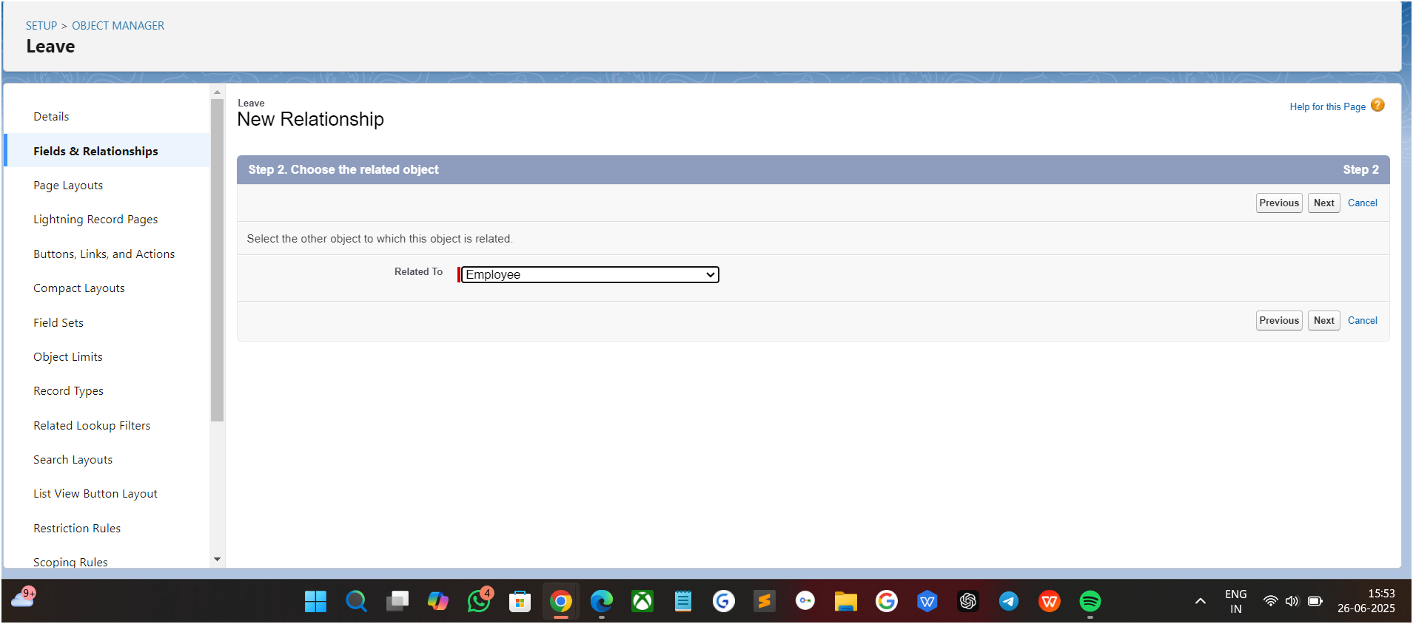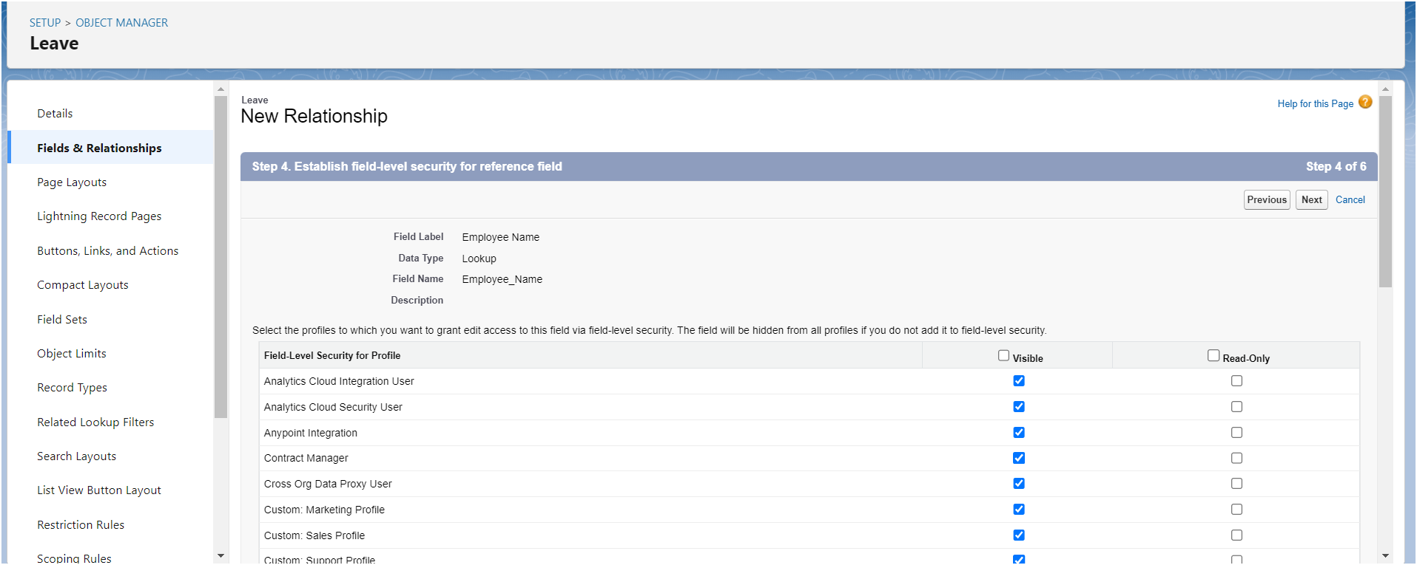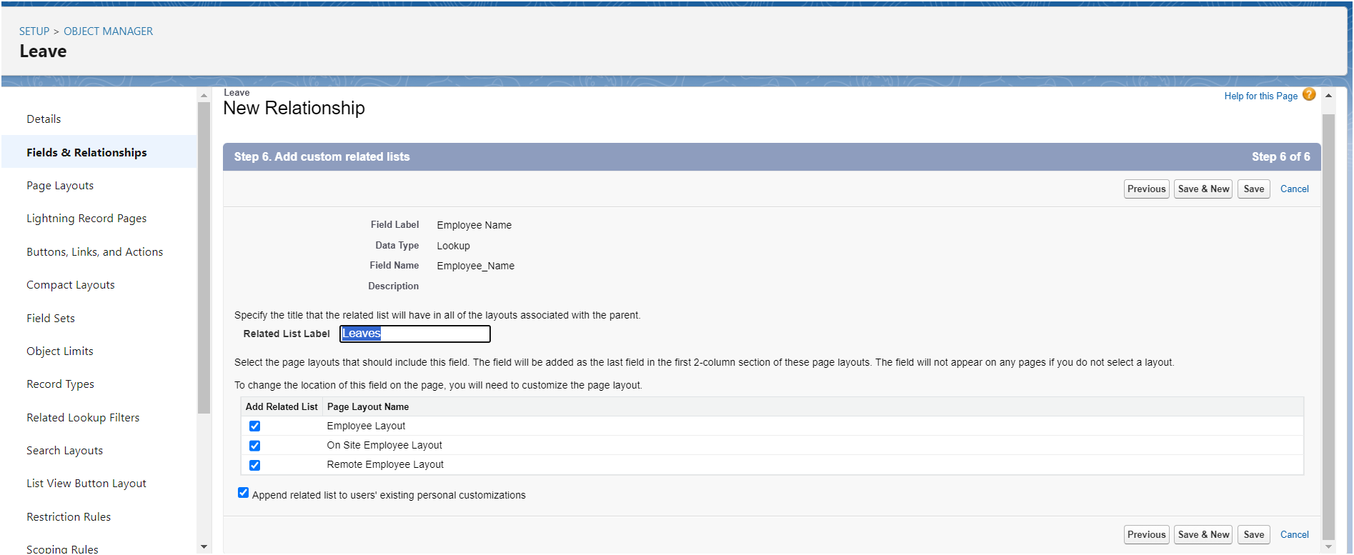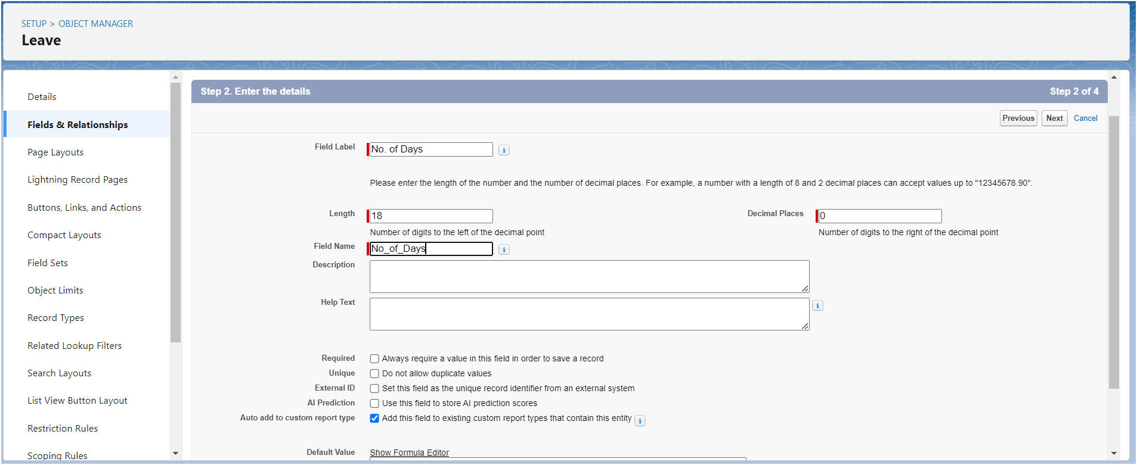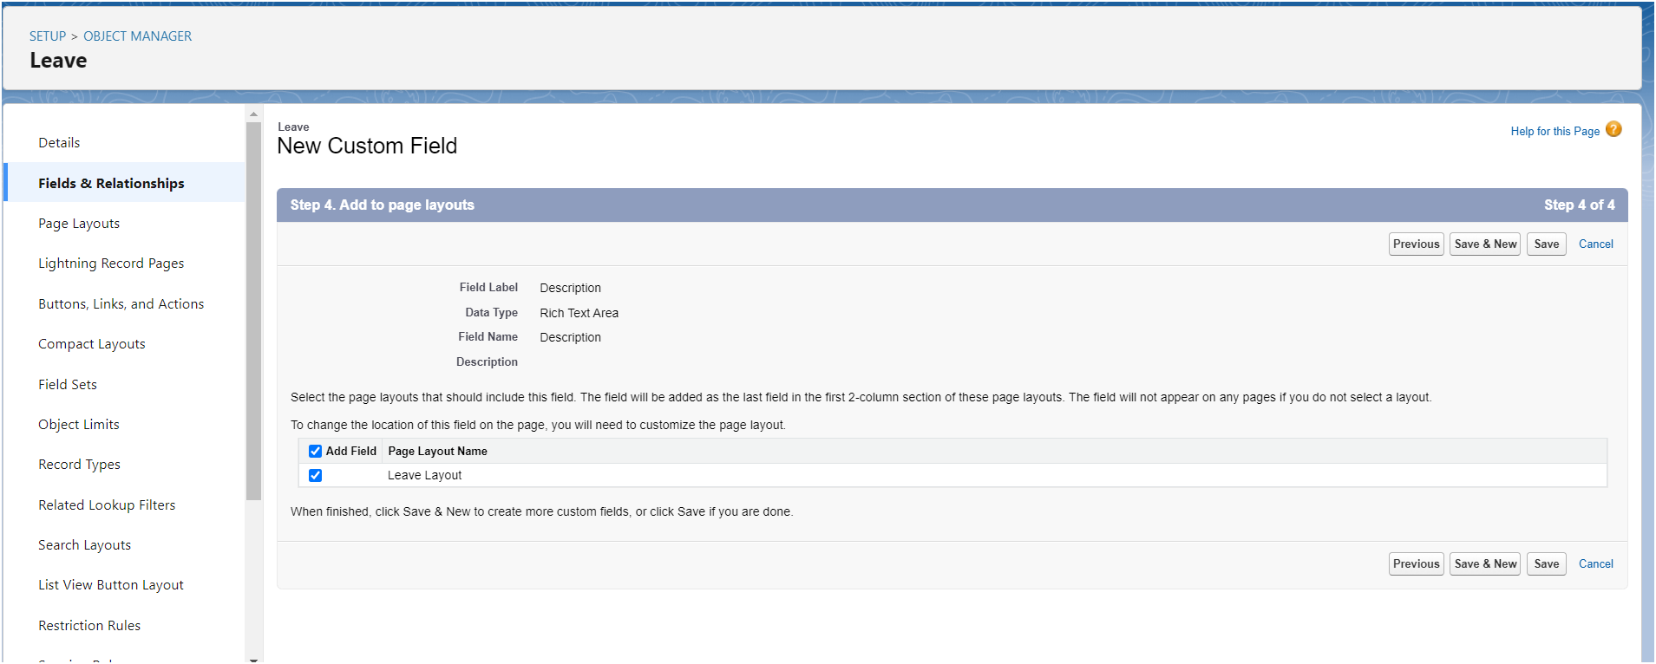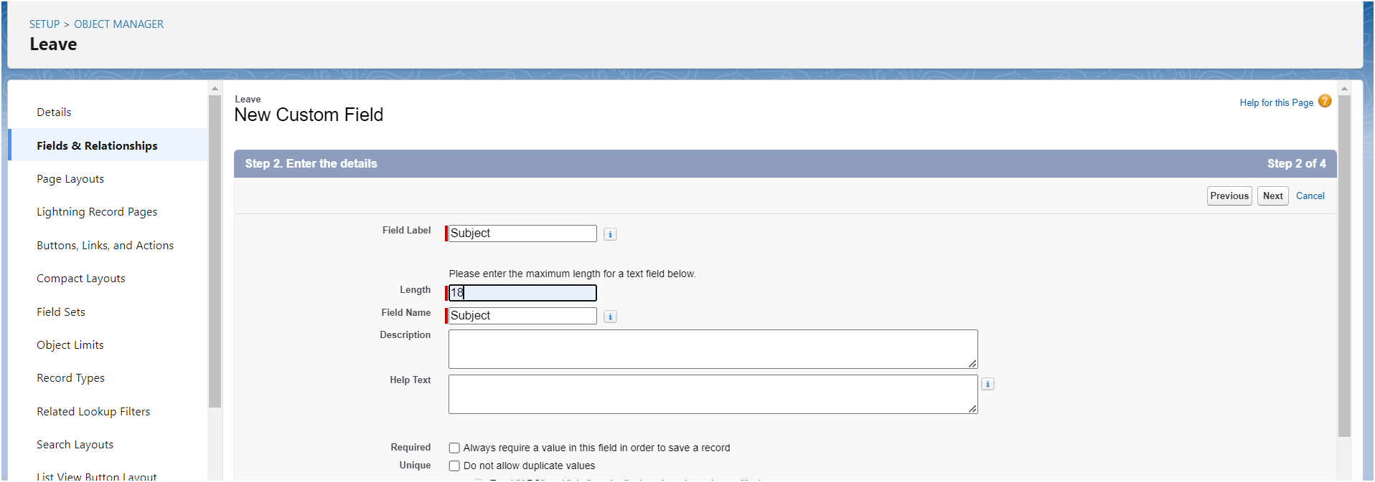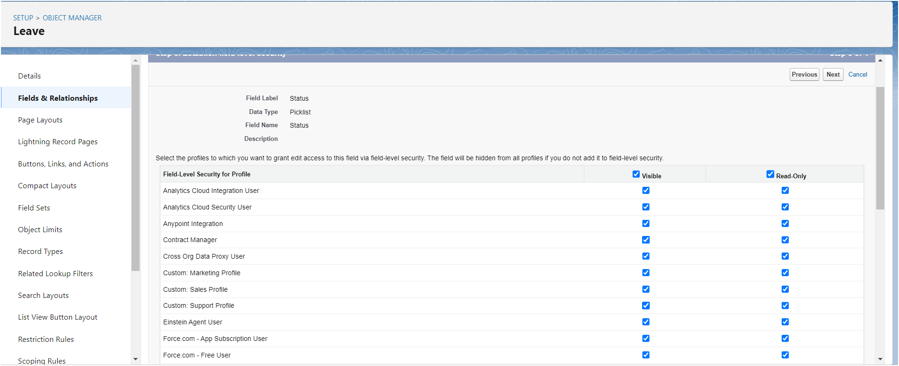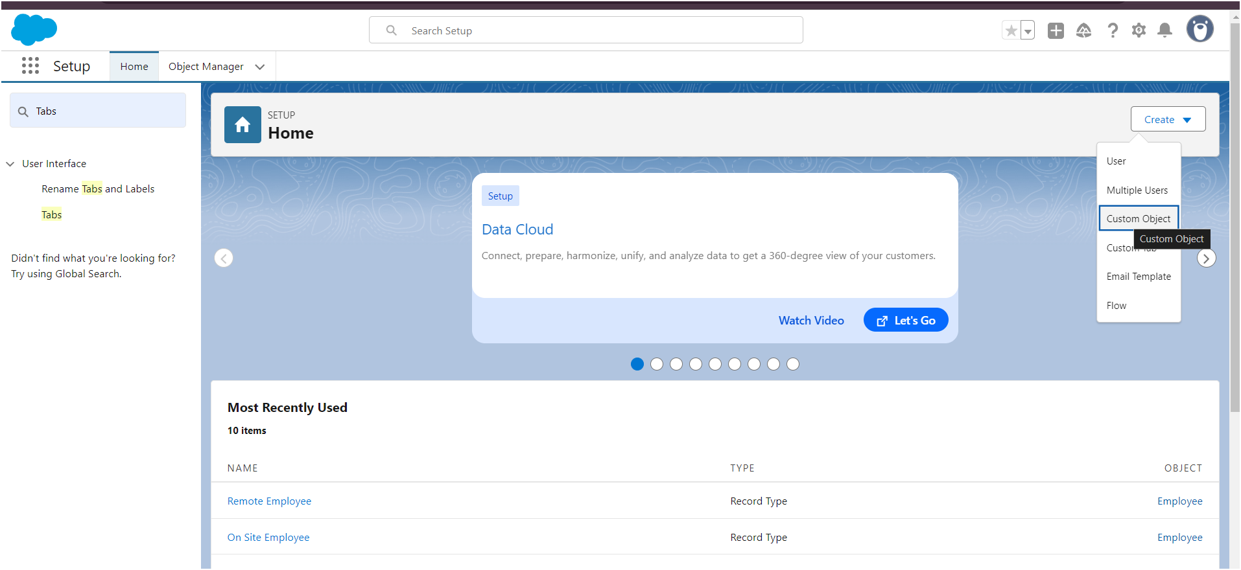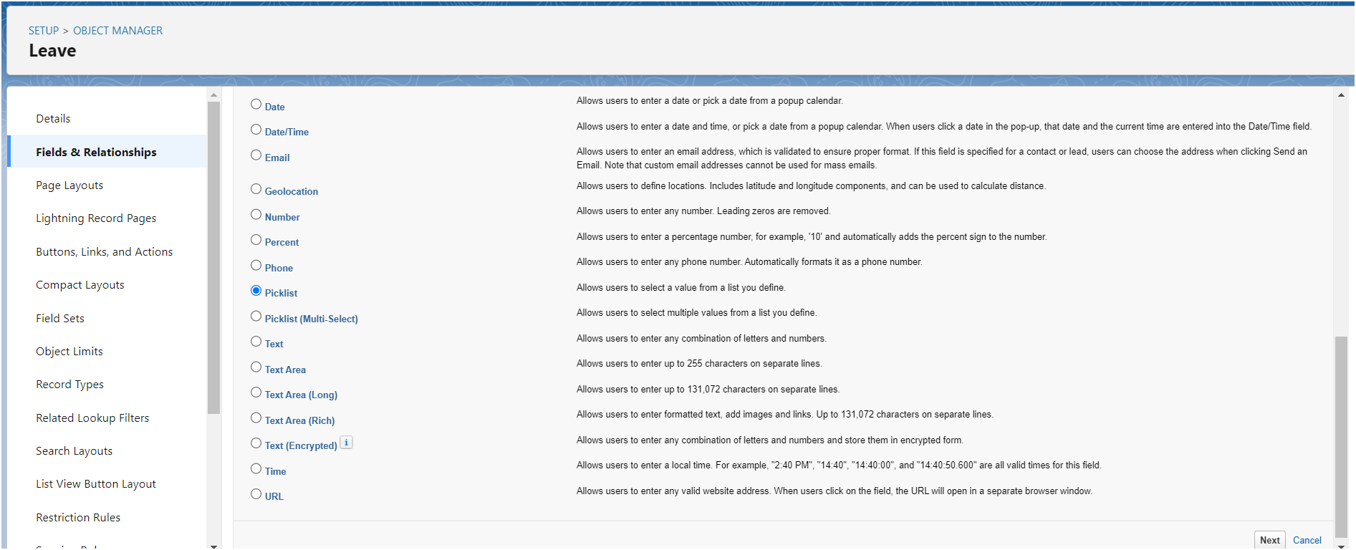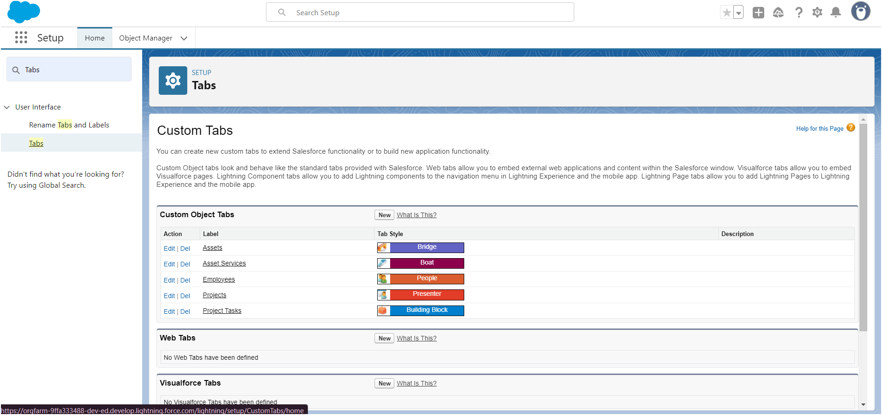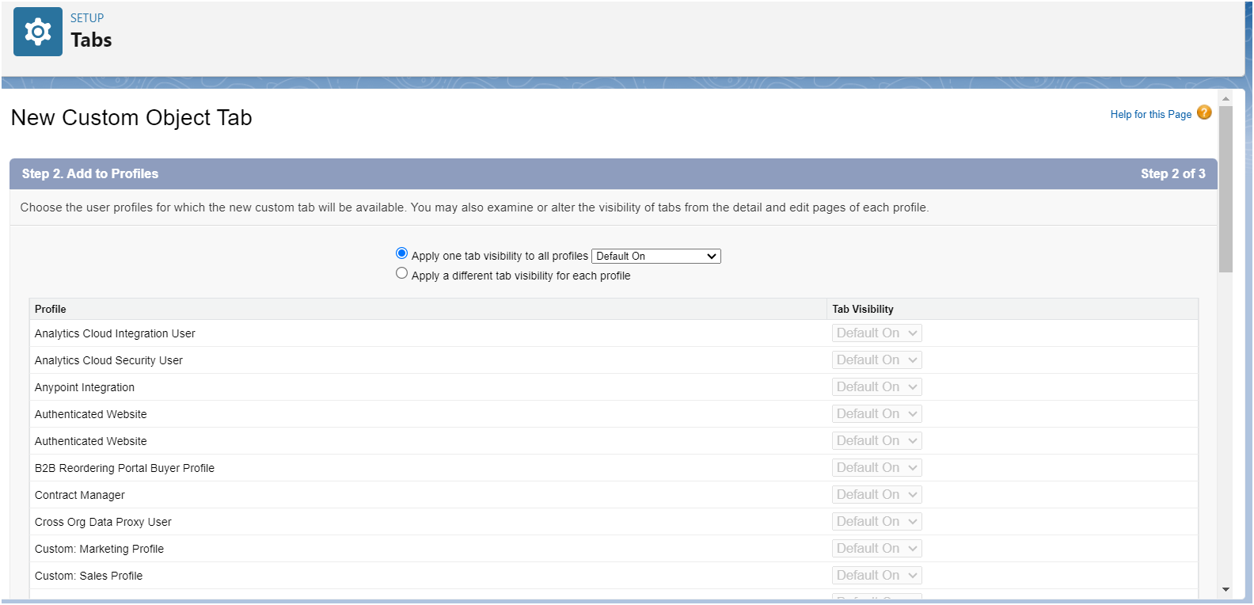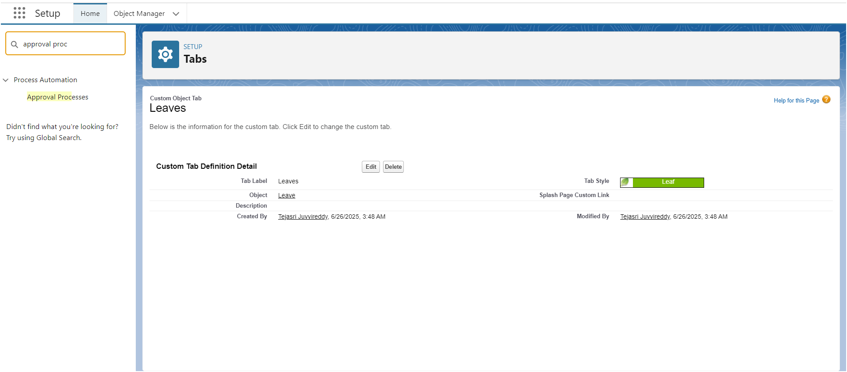

#### **Activity 2**

Create an Approval Process for Leave object.

1. Go to Setup --> type Approval Processes in quick find --> click on Approval Processes.
2. In the Manage Approval Processes For list, select Leave.
3. Click Create New Approval Process and select Use Jump Start Wizard.
4. Enter the following parameters

| Parameter | Value |
| --- | --- |
| Name | Leave Approval Request |
| Unique Name | Leave_Approval_Request(This automatically gets sent when you tab out of the Name field) |
| Approval Assignment Email Template | Leave blank |
| Add the Submit for Approval button and Approval History related list to all Travel Approval page layouts | Leave this selected/checked |
| Use Approver Field of Leave Owner | Leave unselected/unchecked. |
| Select Approver | select Automatically assign to approver(s) and for users select the name of the user with the Manager role. |

1. Click Save.
2. Click View Approval Process Detail Page.

#### **Activity 3**

Initial Submission Action:

1. Under initial submission action click on add new and then select field update.

2. Give name as “Approval Status to Submitted”.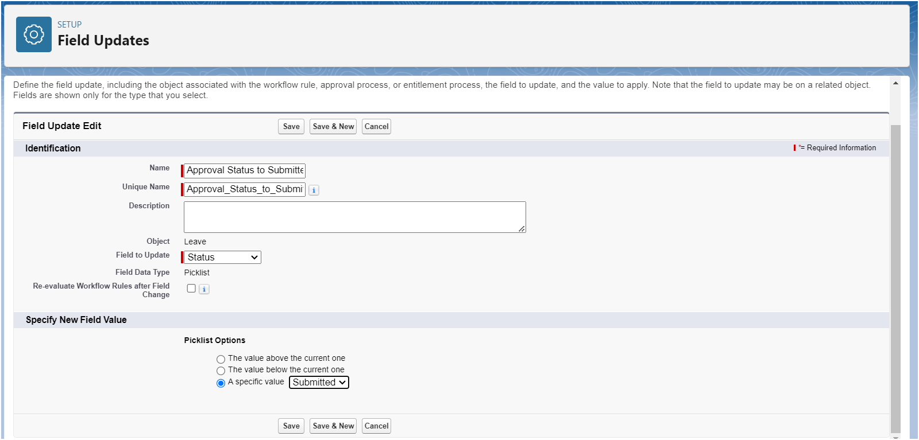

Select Status for the field to update.

Under specify new field value select “A specific value” and select submitted and click Save.

#### **Activity 4**

Approval Steps:

1. While you are still on Leave Approval Request detail page,  
   Under approval steps click the new approval step.
2. Give the name as “Approval from HR” and click on next.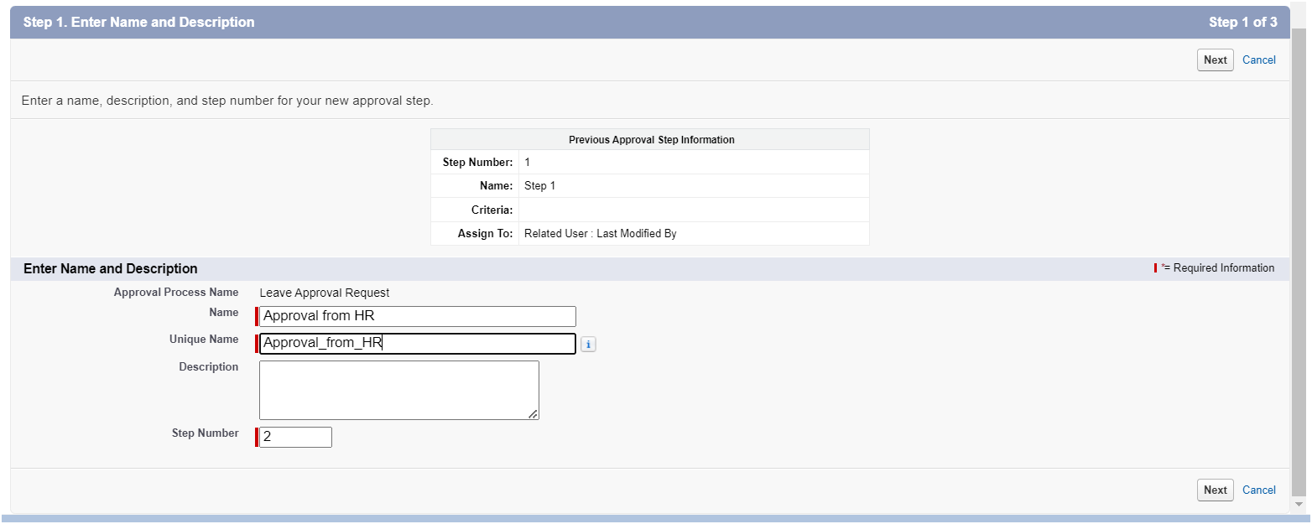

3. Under specify step criteria select “Enter this step if the following (Criteria are met)”,

Select field : “Leave: No. of Days”,

Operator : equals

Value : 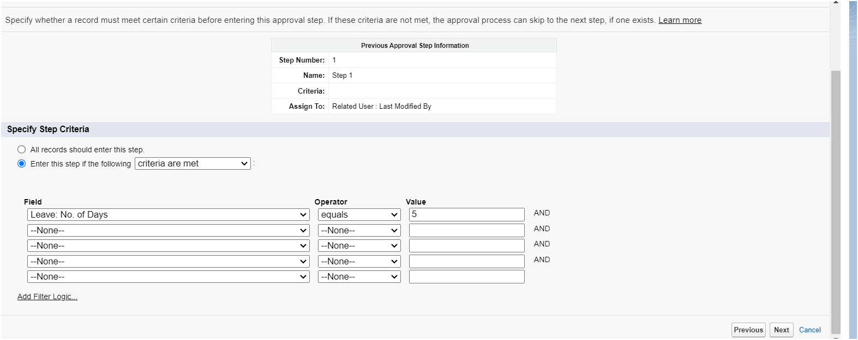

4. Click next.

5. Under select approver : select Automatically assign to approver(s) and for users select the name of the user with the HR role.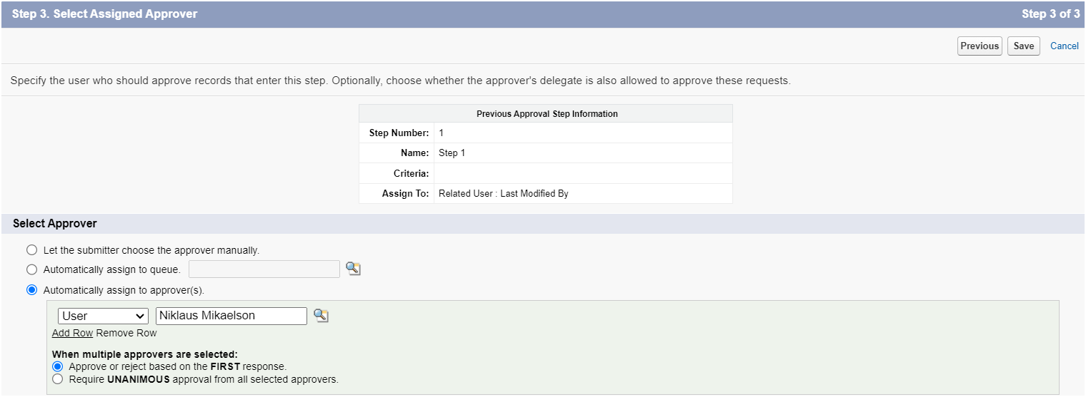

6.Click on Save.

7.No, I'll do this later. Take me to the approval process detail page to review what I've just created and click Go.

#### **Activity 5**

Final Approval Action:

1. Under initial submission action click on add new and then select field update.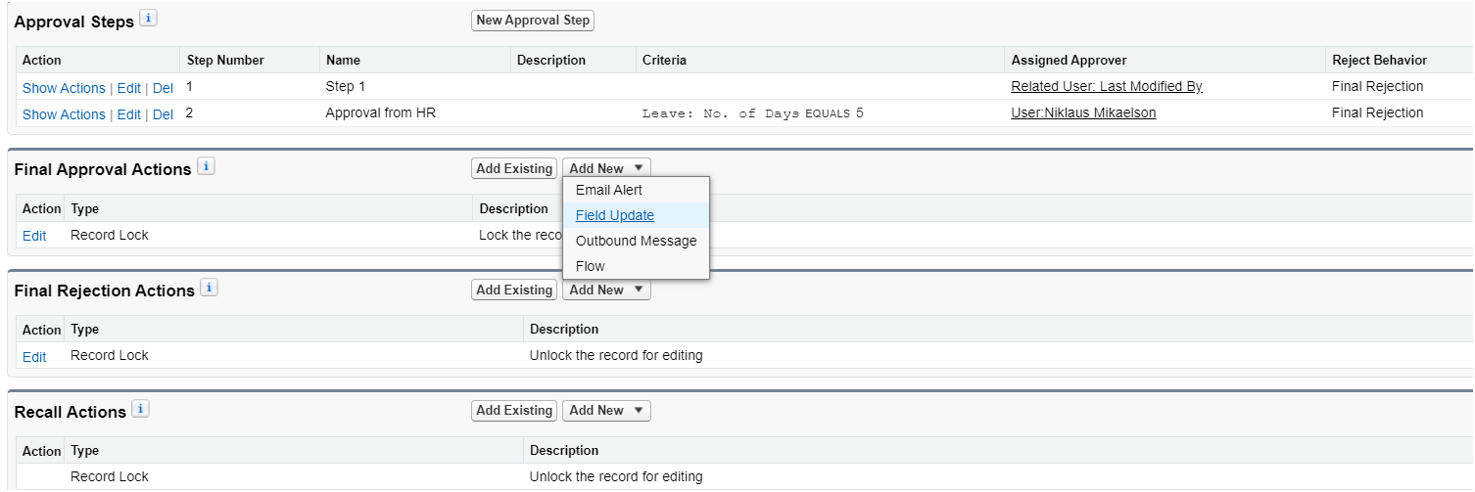

2. Give name as “Approval Status to Approved”.

Select Status for the field to update.

Under specify new field value select “A specific value” and select Approved and click Save.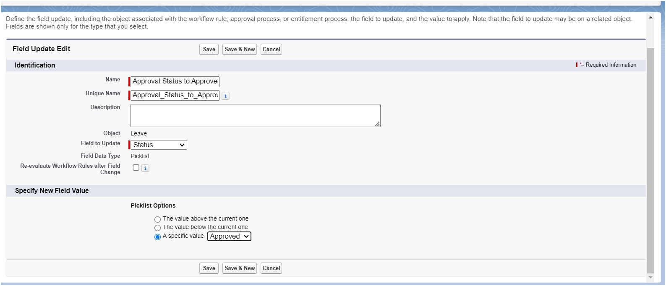

#### **Activity 6**

Final Rejection Action:

1. Under initial submission action click on add new and then select field update.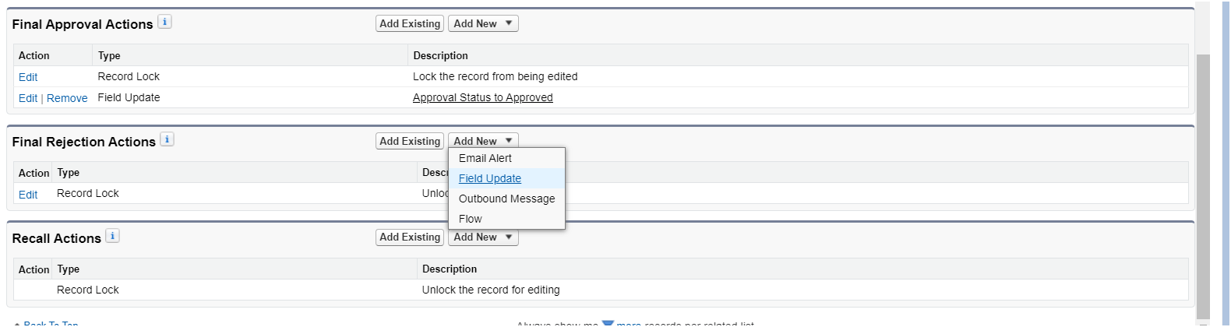

2. Give name as “Approval Status to Rejected”.

Select Status for the field to update.

Under specify new field value select “A specific value” and select Rejected and click Save.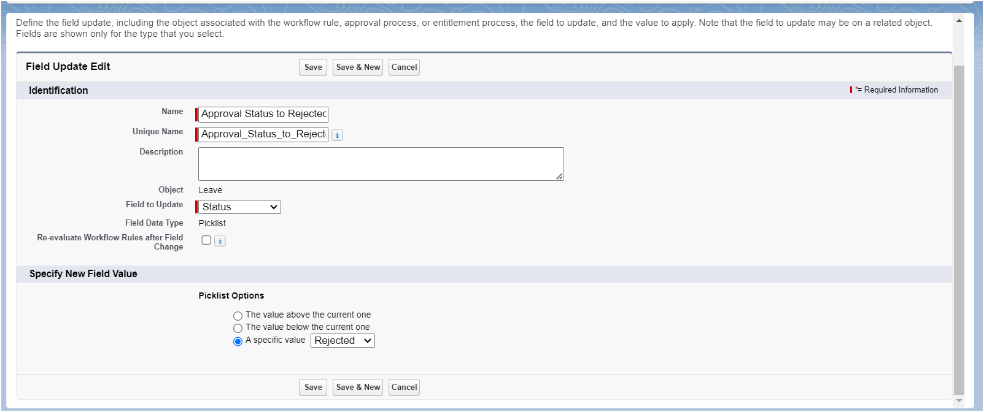

### **Milestone 18 - Apex Trigger**

#### **Use Case:**

The Manager at TheSmartBridge wants no duplicate names of employees should enter into the database. So he/she recalls you for the solution.

Write a code to achieve this requirement using Salesforce developer skills to fulfill the Managers requirement.

#### **Activity 1 : Create an Apex Trigger**

Create an Apex Trigger

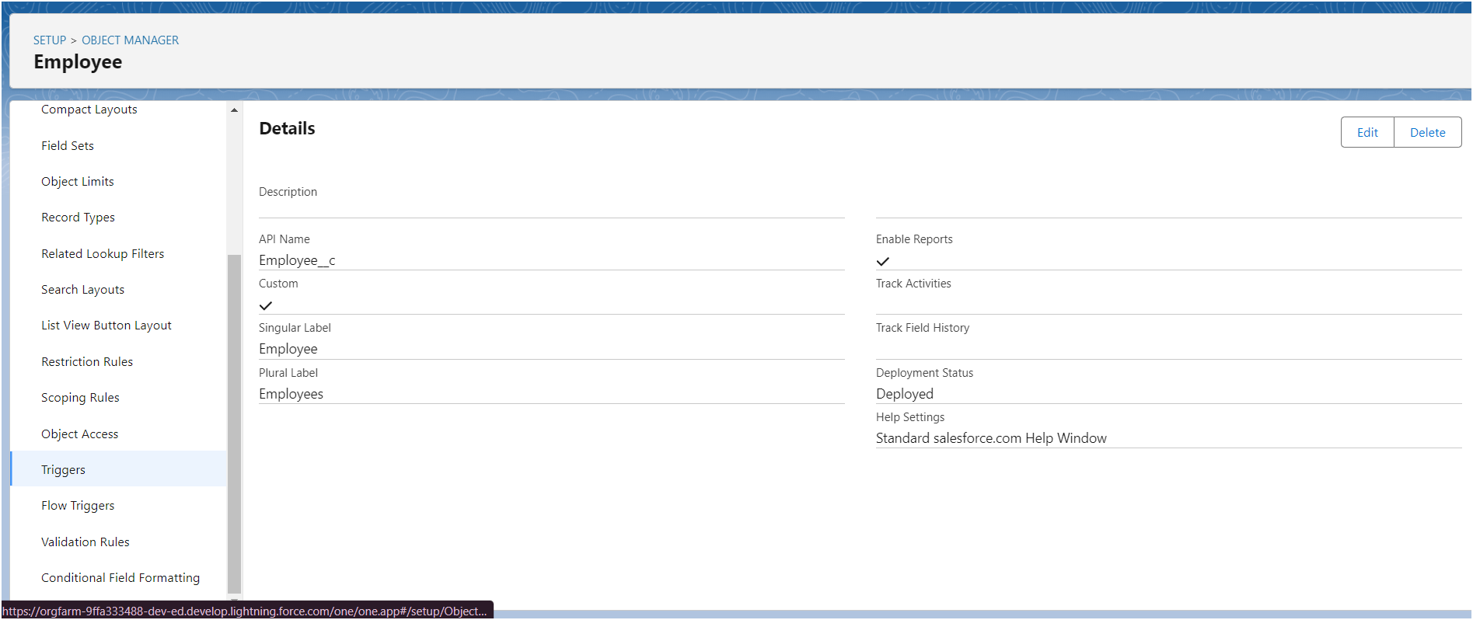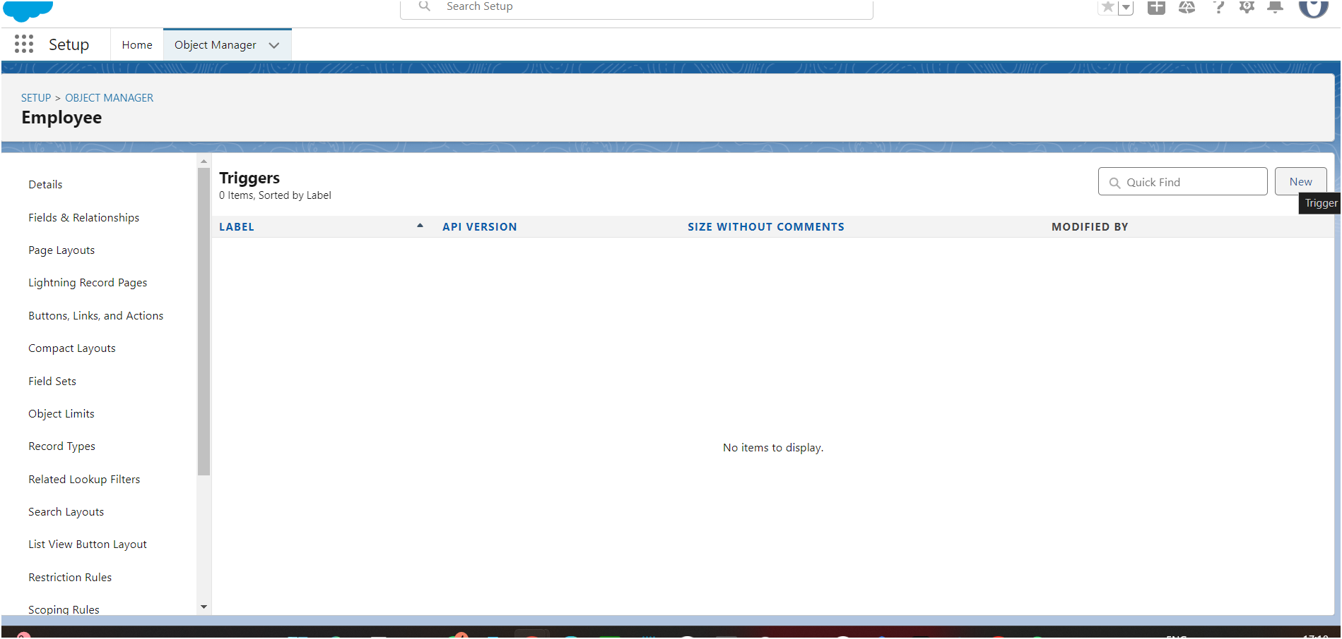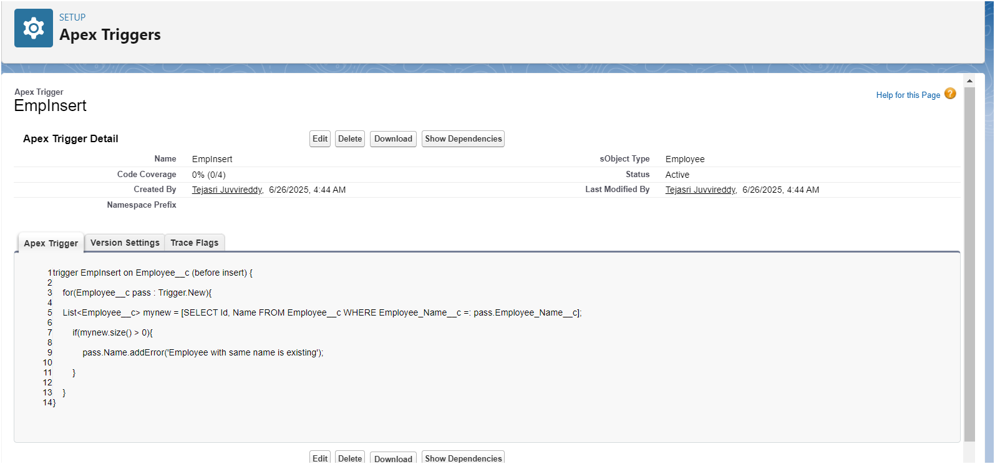

### **8.ADVANTAGES AND DISADVANTAGES**

### **Advantages**

**1. Automation & Efficiency**

* Automates key HR processes like onboarding/offboarding and compliance tracking
* Reduces manual errors and saves time for HR teams

**2. Modular Design**

* Flexible architecture with separate modules (Employee Mgmt, Compliance, Notifications)
* Easier to update or extend functionality as requirements evolve

**3. Role-Based Access**

* Custom dashboards for HR, Managers, Admins
* Promotes focused workflows and data privacy

**4. Powerful Reporting**

* Built-in reporting tools with export options to Excel/PDF
* Dashboards powered by Einstein Analytics offer deep workforce insights

**5. Scalable & Secure**

* Built on Salesforce’s cloud platform with AES-256 encryption and OAuth 2.0
* Easily handles growing employee data and concurrent users

**6. Integration Ready**

* API support allows smooth connection with Payroll & Attendance systems
* Future-proofs the system for additional tools

**7. Guided UX for Users**

* Tooltips, onboarding walkthroughs, help widgets
* Improves adoption and reduces training needs

### **Disadvantages**

**1. Dependency on Salesforce Ecosystem**

* Fully reliant on Salesforce infrastructure and pricing tiers
* Customization may require skilled Apex developers

**2. Initial Learning Curve**

* New admins/users might find setup and dashboards complex at first
* Requires training to fully leverage features

**3. Limited Offline Capability**

* As a cloud-based platform, it needs reliable internet access
* Offline access to data is restricted

**4. Cost Overhead for Add-ons**

* Features like Einstein Analytics or AI chatbots may come at extra cost
* Can be a budget challenge for small organizations

**5. Configuration vs. Customization Balance**

* Too much customization can affect upgrade compatibility
* Needs thoughtful planning during development

### **9. CONCLUSION**

### **Conclusion**

The *Workforce Administration Solution* developed on the Salesforce platform successfully addresses the key challenges faced by HR departments in managing workforce data, ensuring compliance, and streamlining employee lifecycle operations. Through its modular architecture and automation-driven features, the solution eliminates manual inefficiencies, enhances reporting accuracy, and delivers a role-based user experience tailored for HR, Managers, and Admins.

By leveraging Salesforce tools like Lightning Components, Apex, and Einstein Analytics, the project not only meets the functional and non-functional requirements but also paves the way for scalability, security, and integration with third-party systems. From intuitive onboarding to robust compliance tracking and AI-powered support, the solution exemplifies a modern, user-centric approach to workforce administration.

This project demonstrates the power of combining low-code development with cloud technology to create an adaptable and future-ready HR system. It showcases your ability to translate business needs into technical solutions—well done!

### **10.APPENDIX**

"C:\Users\TEJASRI\Downloads\Employee - Data - Employee - Data.csv"

THANK YOU !